
PROJECT REPORT
Of
FINXORA
Proprietor: FINXORA
For Term Loan of 5,00,000.00 /- and CC of 4,00,000.00 /-

COMPANY PROFILE
I. Company Information
Name of the Company/Firm | FINXORA
Proprietor Name | FINXORA
Constitution | proprietorship
Address | Ward no 11, Ganj Basoda, Dist. Vidisha, Madhya Pradesh, 464221, India
PAN No. | AABPB1234C
Industry | SERVICE PROVIDING
Type of Business | SERVICE PROVIDER
Business Starting Date | 01-Apr-2026
Type of Loan | PMEGP Loan

II. Project & Financial Overview
Report Period | 2026 - 2030
Currency | INR
Amount In | Actual
Total Project Cost | INR 10,00,000.00
Term Loan | INR 5,00,000.00
Term Loan Duration | 5 years
Term Loan Interest Rate (%) | 11%
Term Loan EMI (per month) | INR 10,871.21
Working Capital Loan | INR 4,00,000.00
WC Loan Interest Rate (%) | 11%
Own Contribution | INR 1,00,000.00

III. Financial Indicators
Particulars | Value
Average DSCR | 8.61
Average Current Ratio | 2.30

Ratio Analysis
Particulars | 2026-2027  (estimated) | 2027-2028  (projected) | 2028-2029  (projected) | 2029-2030  (projected) | 2030-2031  (projected)
Liquidity Ratios
Current Ratio | 1.51 | 1.92 | 2.29 | 2.64 | 3.14
Quick Ratio (Acid Test) | 1.35 | 1.76 | 2.14 | 2.48 | 2.98
Profitability Ratios
Gross Profit Ratio (%) | 36.79 | 39.42 | 39.13 | 38.87 | 38.63
Net Profit Ratio (%) | 21.59 | 23.43 | 23.66 | 23.83 | 23.89
Return on Capital Employed (%) | 182.60 | 124.39 | 88.20 | 68.71 | 54.03
Return on Equity (%) | 760.23 | 176.98 | 97.07 | 68.71 | 54.03
Leverage Ratios
Debt-Equity Ratio | 7.16 | 1.21 | 0.49 | 0.25 | 0.18
Debt to Total Assets (%) | 38.37 | 25.71 | 16.96 | 11.14 | 8.89
Interest Coverage Ratio (Times) | 16.32 | 11.72 | 14.52 | 18.71 | 25.54
Debt Service Coverage Ratio (DSCR) | N.A. | N.A. | N.A. | N.A. | N.A.
Solvency Ratios
Proprietary Ratio | 0.05 | 0.21 | 0.35 | 0.45 | 0.50
Solvency Ratio (%) | 0.96 | 1.92 | 3.43 | 5.57 | 8.91
TOL / TNW Ratio | 12.66 | 2.48 | 1.22 | 0.78 | 0.60
Fixed Asset Coverage Ratio | 1.38 | 1.76 | 3.19 | 0.00 | 0.00
Debt / EBITDA (x) | 0.80 | 0.57 | 0.43 | 0.32 | 0.29
Contribution Ratio (%) | 0.00 | 0.00 | 0.00 | 0.00 | 0.00

Liquidity Ratios  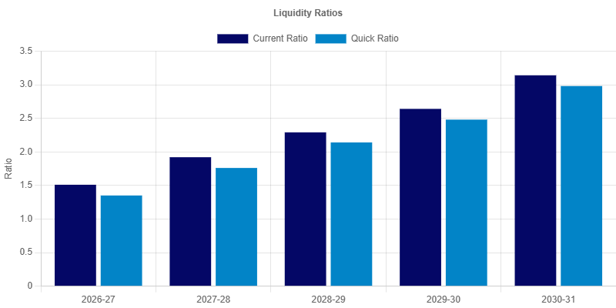  Analysis:  Liquidity ratios monitor the firm's ability to settle short-term liabilities. The Current Ratio, starting at 1.51:1 and reaching 3.14:1 by the final year, indicates a healthy buffer of current assets. The Quick Ratio follows a similar positive trend, ensuring that the firm can meet its obligations even without relying on inventory liquidation. | Profitability Ratios  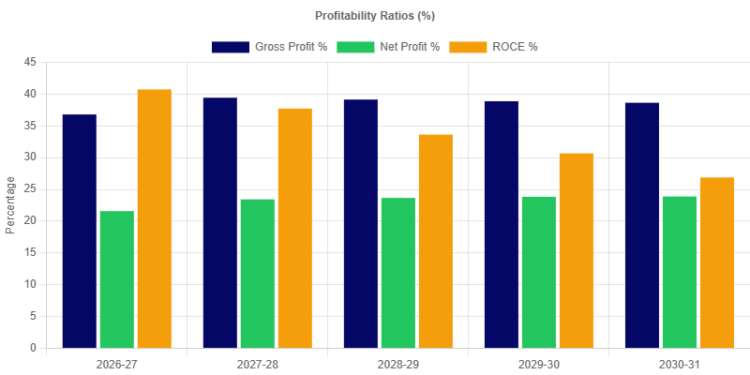  Analysis:  Profitability ratios reflect the operational efficiency of the project. The Gross Profit margin begins at 36.79%, while the Net Profit margin starts at 21.59%. The consistency or growth in these margins over the years demonstrates the firm's capability to manage costs and generate returns for the stakeholders.
Solvency Ratios  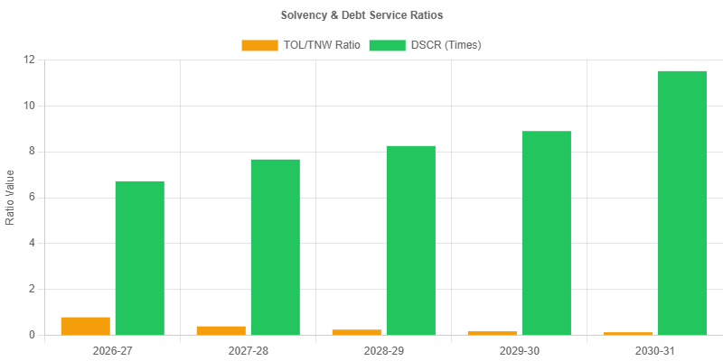  Analysis:  Solvency ratios provide a long-term perspective on the firm's health. They indicate the project's ability to sustain operations and meet long-term commitments, ensuring viability beyond the initial projection period. | Leverage Ratios  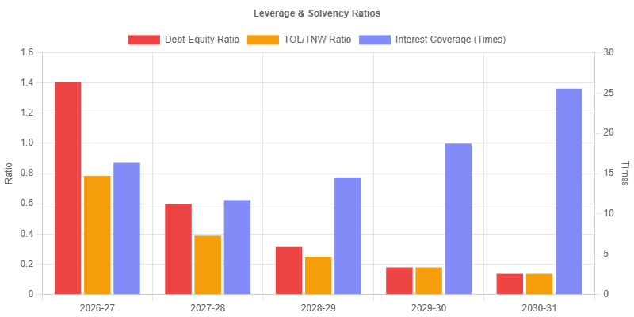  Analysis:  Leverage ratios evaluate the project's capital structure and dependence on debt. The Debt-Equity ratio of 7.16:1 in the initial year shows the balance between borrowed funds and owner's equity. A stable or decreasing ratio over time typically indicates a lower risk profile and greater financial independence.
Working Capital Turnover  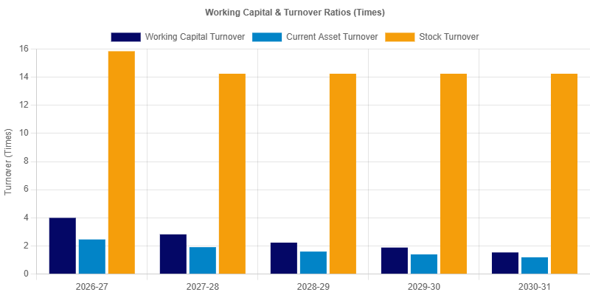  Analysis:  Efficiency ratios (Turnover Ratios) indicate how effectively the firm is utilizing its assets. High turnover figures suggest optimal inventory management and efficient use of working capital, resulting in better overall productivity. | Efficiency Ratios  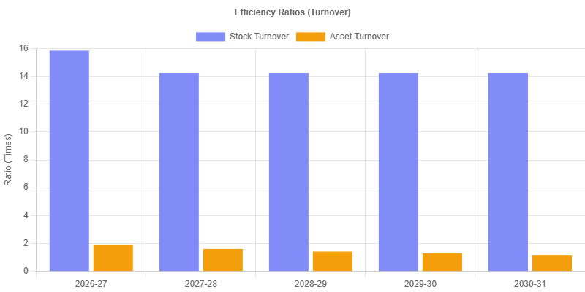  Analysis:  Efficiency ratios (Turnover Ratios) indicate how effectively the firm is utilizing its assets. High turnover figures suggest optimal inventory management and efficient use of working capital, resulting in better overall productivity.

DSCR
Particulars | 2026-2027  (estimated) | 2027-2028  (projected) | 2028-2029  (projected) | 2029-2030  (projected) | 2030-2031  (projected)
Receipts
a).Net Profit | 7,60,225.52 | 9,03,002.52 | 9,98,125.90 | 11,01,294.31 | 12,09,384.32
b).Depreciation | 65,000.00 | 56,250.00 | 48,712.50 | 42,215.62 | 36,612.28
c).Interest on termloan | 49,615.24 | 40,260.61 | 29,823.47 | 18,178.57 | 5,285.77
Total | 8,74,840.76 | 9,99,513.13 | 10,76,661.87 | 11,61,688.50 | 12,51,282.37
Repayments
a).Loan Principal | 80,839.30 | 90,193.93 | 1,00,631.06 | 1,12,275.97 | 1,03,426.34
b).Interest on termloan | 49,615.24 | 40,260.61 | 29,823.47 | 18,178.57 | 5,285.77
Total | 1,30,454.54 | 1,30,454.54 | 1,30,454.54 | 1,30,454.54 | 1,08,712.12
DSCR | 6.71 | 7.66 | 8.25 | 8.90 | 11.51
Average DSCR |  |  |  |  | 8.61

Dscr  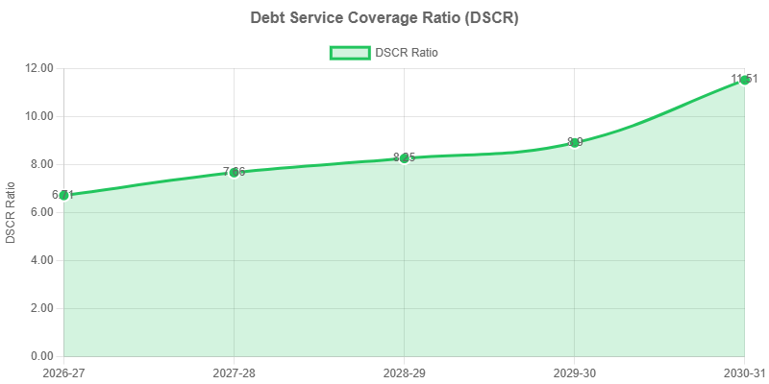  Analysis:  The Debt Service Coverage Ratio (DSCR) is a primary indicator of debt-repayment capacity. With an average DSCR of 8.61 over the 5-year period, the project demonstrates a strong ability to generate sufficient cash flows to meet both interest and principal obligations comfortably. | Balance Sheet Strength  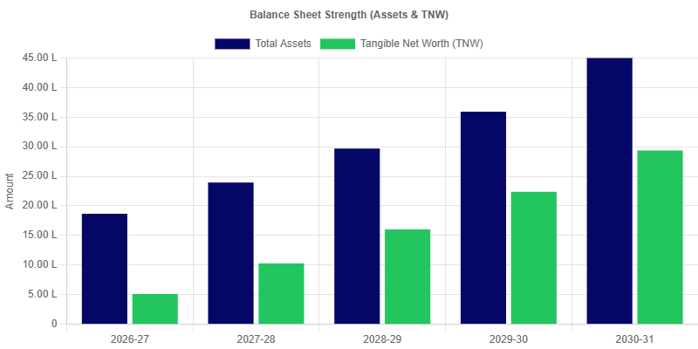  Analysis:  The Balance Sheet Strength chart illustrates the growth of Total Assets and Tangible Net Worth (TNW) over the projection period. In FY 2026-27, Total Assets are projected at 18,66,752.83 alongside a Tangible Net Worth of 5,10,225.52. By FY 2030-31, these are expected to reach 44,98,256.60 and 29,35,247.57 respectively. This trend signifies a strengthening financial position and increasing equity cushion for the firm.

Executive Summary
This Project Report outlines the establishment of a new rice mill by PIYUSH VISHWAKARMA in Ganj Basoda. PIYUSH VISHWAKARMA, a proprietorship, aims to capitalize on the growing demand for processed rice in the region and beyond. The project, aptly named 'RICE MILL', seeks to create a modern rice processing facility equipped with advanced technology to ensure high-quality output and efficient operations. The primary objectives are to establish a commercially viable rice mill, produce high-quality rice products, generate employment opportunities, and contribute to the agricultural economy of the region. Key highlights include a detailed market analysis, a comprehensive operational plan, a thorough financial projection demonstrating viability, and a robust risk assessment and mitigation strategy.

Company Background
PIYUSH VISHWAKARMA, operating as a proprietorship, is based in Ganj Basoda. While a relatively new entity, PIYUSH VISHWAKARMA possesses a strong understanding of the local agricultural landscape and the rice trading industry. The proprietor's experience and network within the farming community will be instrumental in securing a reliable supply of paddy. The company's vision is to become a trusted and reliable supplier of high-quality rice products to both local and regional markets. This project represents the firm's commitment to investing in modern infrastructure and technology to enhance its operational capabilities and market competitiveness. The selection of Ganj Basoda as the location is strategic, given its proximity to rice-growing regions and its accessibility to transportation networks.

Project Scope and Objectives
The RICE MILL project encompasses the establishment of a complete rice processing facility, from paddy procurement to packaging and distribution of finished rice products. The scope includes land acquisition (if necessary), construction of the mill building, installation of machinery and equipment, establishment of a quality control laboratory, and development of a distribution network. The primary objectives are to: (1) Achieve a processing capacity of within the first year of operation; (2) Produce rice that meets or exceeds industry quality standards; (3) Establish a strong brand reputation for quality and reliability; (4) Generate a positive return on investment within ; and (5) Create sustainable employment opportunities for the local community.

Technical Specifications and Methodology
The rice mill will incorporate modern processing technology to ensure efficiency and quality. The key equipment will include paddy cleaners, de-huskers, polishers, graders, and packaging machines. The selection of equipment will prioritize energy efficiency, minimal waste generation, and ease of maintenance. The processing methodology will involve a multi-stage process: cleaning and pre-treatment of paddy, de-husking to remove the outer shell, polishing to enhance the appearance and texture of the rice, grading to separate rice grains based on size and quality, and finally, packaging to preserve freshness and prevent contamination. A quality control laboratory will be established to monitor the quality of paddy and finished rice at each stage of the process, ensuring compliance with established standards.

Operational Plan
The operational plan covers all aspects of the rice mill's daily functioning. This includes paddy procurement, processing, quality control, packaging, storage, and distribution. Paddy will be sourced directly from local farmers and through established agricultural suppliers. A robust inventory management system will be implemented to minimize storage losses and ensure a consistent supply of raw materials. The mill will operate on a . The workforce will consist of skilled machine operators, quality control technicians, packaging staff, and administrative personnel. A comprehensive training program will be developed to ensure that all employees are proficient in their respective roles and responsibilities. The operational plan also includes a detailed maintenance schedule for all machinery and equipment to minimize downtime and ensure optimal performance.

Market Analysis and Opportunity
The market for processed rice is substantial and growing, driven by increasing population and changing dietary preferences. The demand for high-quality rice is particularly strong in urban areas and export markets. PIYUSH VISHWAKARMA is strategically positioned to capitalize on this opportunity by producing rice that meets the specific needs of target markets. The company will conduct thorough market research to identify consumer preferences, pricing trends, and competitive dynamics. The marketing strategy will focus on building brand awareness, establishing strong relationships with distributors and retailers, and promoting the quality and nutritional value of the rice. Competitive advantages include the mill's modern technology, its proximity to paddy-growing regions, and its commitment to quality and customer satisfaction.

Financial Analysis
The total project cost is estimated at INR 1,000,000. This includes the cost of land (if applicable), building construction, machinery and equipment, working capital, and pre-operative expenses. The loan amount being requested is INR 500,000. The remaining funds will be sourced from the proprietor's personal savings and potentially from other financial institutions. Detailed financial projections, including income statements, balance sheets, and cash flow statements, have been prepared for the next five years (2026 onwards). These projections demonstrate the project's financial viability and its ability to generate sufficient revenue to repay the loan and provide a reasonable return on investment. Key financial indicators include a positive net present value (NPV), a favorable internal rate of return (IRR), and a manageable debt-service coverage ratio (DSCR).

Conclusion and Recommendations
The RICE MILL project represents a viable and promising investment opportunity for PIYUSH VISHWAKARMA. The project aligns with the company's vision of becoming a leading supplier of high-quality rice products. The market analysis indicates a strong demand for processed rice, and the operational plan outlines a clear path to achieving efficient and profitable operations. The financial projections demonstrate the project's financial viability and its ability to generate a positive return on investment. It is recommended that PIYUSH VISHWAKARMA proceed with the implementation of the project, securing the necessary financing and adhering to the planned timeline. Continuous monitoring of market conditions, operational performance, and financial results is essential to ensure the project's long-term success.

Revenue & expenses
Particulars | Monthly Amount
Sales & Revenue
Sales of Goods | 2,76,800.00
Sales of Service | 16,666.67
Total Sales Revenue | 2,93,466.67
Purchases
Purchase of Goods | 1,98,000.00
Total Purchases | 1,98,000.00
Administrative Expenses
Salaries & Wages | 15,000.00
Rent | 6,000.00
Utilities (Electricity, Water, etc.) | 2,500.00
Office Supplies & Stationery | 2,083.33
Communication (Phone, Internet) | 900.00
Travel & Conveyance | 5,000.00
Repairs & Maintenance | 2,000.00
Total Administrative Expenses | 33,483.33

Profit & Loss Account
Particulars | 2026-2027  (estimated) | 2027-2028  (projected) | 2028-2029  (projected) | 2029-2030  (projected) | 2030-2031  (projected)
SALES
Sales of Goods | 33,21,600.00 | 36,53,760.00 | 40,19,136.00 | 44,21,049.60 | 48,63,154.56
Sales of Service | 2,00,000.00 | 2,00,000.04 | 2,00,000.04 | 2,00,000.04 | 2,00,000.04
Total Sales | 35,21,600.00 | 38,53,760.04 | 42,19,136.04 | 46,21,049.64 | 50,63,154.60
Closing Stock | 1,50,000.00 | 1,65,000.00 | 1,81,500.00 | 1,99,650.00 | 2,19,615.00
Opening Stock | 0.00 | 1,50,000.00 | 1,65,000.00 | 1,81,500.00 | 1,99,650.00
PURCHASES
Purchase of Goods | 23,76,000.00 | 23,49,600.00 | 25,84,560.00 | 28,43,016.00 | 31,27,317.60
Total Purchases | 23,76,000.00 | 23,49,600.00 | 25,84,560.00 | 28,43,016.00 | 31,27,317.60
DIRECT EXPENSES
GROSS PROFIT | 12,95,600.00 | 15,19,160.04 | 16,51,076.04 | 17,96,183.64 | 19,55,802.00
INDIRECT EXPENSES
Salaries & Wages | 1,80,000.00 | 1,98,000.00 | 2,17,800.00 | 2,39,580.00 | 2,63,538.00
Rent | 72,000.00 | 79,200.00 | 87,120.00 | 95,832.00 | 1,05,415.20
Utilities (Electricity, Water, etc.) | 30,000.00 | 33,000.00 | 36,300.00 | 39,930.00 | 43,923.00
Office Supplies & Stationery | 25,000.00 | 27,499.96 | 30,249.96 | 33,274.96 | 36,602.46
Communication (Phone, Internet) | 10,800.00 | 11,880.00 | 13,068.00 | 14,374.80 | 15,812.28
Travel & Conveyance | 60,000.00 | 66,000.00 | 72,600.00 | 79,860.00 | 87,846.00
Repairs & Maintenance | 24,000.00 | 26,400.00 | 29,040.00 | 31,944.00 | 35,138.40
Depreciation | 65,000.00 | 56,250.00 | 48,712.50 | 42,215.63 | 36,612.28
Interest on WCL | 0.00 | 44,000.00 | 44,000.00 | 44,000.00 | 44,000.00
Interest on TL | 49,615.24 | 40,260.61 | 29,823.47 | 18,178.57 | 5,285.77
Total Indirect Expenses | 5,16,415.24 | 5,82,490.57 | 6,08,713.93 | 6,39,189.96 | 6,74,173.39
Profit Before Tax | 7,79,184.76 | 9,36,669.47 | 10,42,362.11 | 11,56,993.68 | 12,81,628.61
Provision for Income Tax (20%) | 18,959.24 | 33,666.95 | 44,236.21 | 55,699.37 | 72,244.29
NET PROFIT | 7,60,225.52 | 9,03,002.52 | 9,98,125.90 | 11,01,294.31 | 12,09,384.32

Cash Flow Statement
Particulars | 2026-2027  (estimated) | 2027-2028  (projected) | 2028-2029  (projected) | 2029-2030  (projected) | 2030-2031  (projected)
Cash Inflow
Capital | 1,00,000.00 | 0.00 | 0.00 | 0.00 | 0.00
Subsidy | 0.00 | 0.00 | 0.00 | 0.00 | 0.00
Termloan | 5,00,000.00 | 0.00 | 0.00 | 0.00 | 0.00
Working Capital Loan | 4,00,000.00 | 0.00 | 0.00 | 0.00 | 0.00
Increase in Current Liabilities | 5,50,000.00 | 1,00,000.00 | 1,00,000.00 | 1,00,000.00 | 1,02,000.00
Increase in Non-Current Liabilities | 0.00 | 0.00 | 0.00 | 0.00 | 0.00
Increase in Non-Term Liabilities | 0.00 | 0.00 | 0.00 | 0.00 | 2,11,009.03
Increase in Other Term Liabilities | 0.00 | 0.00 | 0.00 | 0.00 | 0.00
Decrease in Current Assets | 0.00 | 1,99,664.97 | 39,027.62 | 0.00 | 0.00
Decrease in Non-Current Assets | 0.00 | 0.00 | 0.00 | 0.00 | 0.00
Decrease in Investments | 0.00 | 0.00 | 0.00 | 0.00 | 0.00
Profit before tax with interest | 8,28,800.00 | 10,20,930.08 | 11,16,185.58 | 12,19,172.25 | 13,30,914.38
Depreciation | 65,000.00 | 56,250.00 | 48,712.50 | 42,215.63 | 36,612.28
Total Cash Inflow | 24,43,800.00 | 13,76,845.05 | 13,03,925.70 | 13,61,387.88 | 16,80,535.69
Cash Outflow
Fixed Assets | 5,00,000.00 | 0.00 | 0.00 | 0.00 | 0.00
Increase in Current Assets | 4,20,192.59 | 0.00 | 0.00 | 18,150.00 | 19,965.00
Increase in Non-Current Assets | 0.00 | 0.00 | 0.00 | 0.00 | 0.00
Increase in Investments | 0.00 | 0.00 | 0.00 | 0.00 | 0.00
Interest on TL | 49,615.24 | 40,260.61 | 29,823.47 | 18,178.57 | 5,285.77
Interest on WCL | 0.00 | 44,000.00 | 44,000.00 | 44,000.00 | 44,000.00
Decrease in Term loan | 80,839.30 | 90,193.93 | 1,00,631.06 | 1,12,275.97 | 1,03,426.34
Decrease in Working Capital Loan | 0.00 | 0.00 | 0.00 | 0.00 | 0.00
Drawing | 3,50,000.00 | 3,85,000.00 | 4,23,500.00 | 4,65,850.00 | 5,12,435.00
Provision for Income Tax | 18,959.24 | 33,666.95 | 44,236.21 | 55,699.37 | 72,244.29
Decrease in Current Liabilities | 0.00 | 0.00 | 0.00 | 0.00 | 0.00
Decrease in Non-Current Liabilities | 0.00 | 0.00 | 0.00 | 0.00 | 0.00
Decrease in Other Term Liabilities | 0.00 | 0.00 | 0.00 | 0.00 | 0.00
Decrease in Non-Term Liabilities | 0.00 | 0.00 | 0.00 | 0.00 | 0.00
Total Cash Outflow | 14,19,606.37 | 5,93,121.49 | 6,42,190.74 | 7,14,153.91 | 7,57,356.40
Opening balance | 0.00 | 10,11,560.24 | 17,95,283.80 | 24,57,018.75 | 31,04,252.72
Net Cashflow | 10,11,560.24 | 7,83,723.56 | 6,61,734.95 | 6,47,233.97 | 9,23,179.28
Closing balance | 10,11,560.24 | 17,95,283.80 | 24,57,018.75 | 31,04,252.72 | 40,27,432.00
Difference | 12,633.39 | 0.00 | 0.01 | -0.00 | 0.01

Balance Sheet
Particulars | 2026-2027  (estimated) | 2027-2028  (projected) | 2028-2029  (projected) | 2029-2030  (projected) | 2030-2031  (projected)
CAPITAL ACCOUNT
Capital | 1,00,000.00 | 5,10,225.52 | 10,28,228.04 | 16,02,853.94 | 22,38,298.25
Profit & Loss A/c | 7,60,225.52 | 9,03,002.52 | 9,98,125.90 | 11,01,294.31 | 12,09,384.32
Drawings (Withdrawal) | 3,50,000.00 | 3,85,000.00 | 4,23,500.00 | 4,65,850.00 | 5,12,435.00
NET WORTH | 5,10,225.52 | 10,28,228.04 | 16,02,853.94 | 22,38,298.25 | 29,35,247.57
LOAN LIABILITIES
Working Capital Loan | 4,00,000.00 | 4,00,000.00 | 4,00,000.00 | 4,00,000.00 | 4,00,000.00
TOTAL LOAN LIABILITIES | 4,00,000.00 | 4,00,000.00 | 4,00,000.00 | 4,00,000.00 | 4,00,000.00
CURRENT LIABILITIES
Sundry Creditor (Trade) | 5,50,000.00 | 6,50,000.00 | 7,50,000.00 | 8,50,000.00 | 9,52,000.00
TOTAL CURRENT LIABILITIES | 5,50,000.00 | 6,50,000.00 | 7,50,000.00 | 8,50,000.00 | 9,52,000.00
TERM LIABILITIES
Term Loan | 3,16,333.38 | 2,15,702.32 | 1,03,426.34 | 0.00 | 0.00
Current Portion of Term Loan | 90,193.93 | 1,00,631.06 | 1,12,275.97 | 1,03,426.34 | 0.00
TOTAL TERM LIABILITIES | 4,06,527.31 | 3,16,333.38 | 2,15,702.31 | 1,03,426.34 | 0.00
NON TERM LIABILITIES
Non Term Liability | 0.00 | 0.00 | 0.00 | 0.00 | 2,11,009.03
TOTAL NON TERM LIABILITIES | 0.00 | 0.00 | 0.00 | 0.00 | 2,11,009.03
NON CURRENT LIABILITIES
TOTAL EQUITY + LIABILITY | 18,66,752.83 | 23,94,561.42 | 29,68,556.25 | 35,91,724.59 | 44,98,256.60
FIXED ASSETS
Gross Block | 5,00,000.00 | 4,35,000.00 | 3,78,750.00 | 3,30,037.50 | 2,87,821.88
Depreciation to date | 65,000.00 | 56,250.00 | 48,712.50 | 42,215.63 | 36,612.28
NET BLOCK | 4,35,000.00 | 3,78,750.00 | 3,30,037.50 | 2,87,821.87 | 2,51,209.60
CURRENT ASSETS
Cash & Cash Equivalents | 10,11,560.24 | 17,95,283.80 | 24,57,018.75 | 31,04,252.72 | 40,27,432.00
Inventory | 1,50,000.00 | 1,65,000.00 | 1,81,500.00 | 1,99,650.00 | 2,19,615.00
Sundry Debtors | 2,70,192.59 | 55,527.62 | 0.00 | 0.00 | 0.00
TOTAL CURRENT ASSETS | 14,31,752.83 | 20,15,811.42 | 26,38,518.75 | 33,03,902.72 | 42,47,047.00
NON CURRENT ASSETS
TOTAL ASSETS | 18,66,752.83 | 23,94,561.42 | 29,68,556.25 | 35,91,724.59 | 44,98,256.60

Depreciation
Particulars | 2026-2027  (estimated) | 2027-2028  (projected) | 2028-2029  (projected) | 2029-2030  (projected) | 2030-2031  (projected)
Furniture & Fixtures | 0.00 | 1,80,000.00 | 1,62,000.00 | 1,45,800.00 | 1,31,220.00
Total During the Year | 2,00,000.00 | 0.00 | 0.00 | 0.00 | 0.00
Less Depreciation | 20,000.00 | 18,000.00 | 16,200.00 | 14,580.00 | 13,122.00
Written down value | 1,80,000.00 | 1,62,000.00 | 1,45,800.00 | 1,31,220.00 | 1,18,098.00
Plant & Machinery | 0.00 | 2,55,000.00 | 2,16,750.00 | 1,84,237.50 | 1,56,601.88
Total During the Year | 3,00,000.00 | 0.00 | 0.00 | 0.00 | 0.00
Less Depreciation | 45,000.00 | 38,250.00 | 32,512.50 | 27,635.63 | 23,490.28
Written down value | 2,55,000.00 | 2,16,750.00 | 1,84,237.50 | 1,56,601.88 | 1,33,111.60
Opening | 0.00 | 4,35,000.00 | 3,78,750.00 | 3,30,037.50 | 2,87,821.88
Total During the Year | 5,00,000.00 | 0.00 | 0.00 | 0.00 | 0.00
Gross Block | 5,00,000.00 | 4,35,000.00 | 3,78,750.00 | 3,30,037.50 | 2,87,821.88
Total less depreciation | 65,000.00 | 56,250.00 | 48,712.50 | 42,215.63 | 36,612.28
Total written down value | 4,35,000.00 | 3,78,750.00 | 3,30,037.50 | 2,87,821.88 | 2,51,209.60

Breakeven Point
Particulars | 2026-2027  (estimated) | 2027-2028  (projected) | 2028-2029  (projected) | 2029-2030  (projected) | 2030-2031  (projected)
Sales Analysis
Total Sales Revenue | 35,21,600.00 | 38,53,760.04 | 42,19,136.04 | 46,21,049.64 | 50,63,154.60
Cost Analysis
Fixed Costs | 5,16,415.24 | 5,82,490.57 | 6,08,713.93 | 6,39,189.96 | 6,74,173.39
Variable Costs | 22,26,000.00 | 23,34,600.00 | 25,68,060.00 | 28,24,866.00 | 31,07,352.60
Total Costs | 27,42,415.24 | 29,17,090.57 | 31,76,773.93 | 34,64,055.96 | 37,81,525.99
Contribution Analysis
Contribution Margin | 12,95,600.00 | 15,19,160.04 | 16,51,076.04 | 17,96,183.64 | 19,55,802.00
Contribution Ratio (%) | 36.79 | 39.42 | 39.13 | 38.87 | 38.63
Break-Even Analysis
Break-even Value | 14,03,680.08 | 14,77,644.77 | 15,55,498.85 | 16,44,446.85 | 17,45,291.24
Break-even Point (%) | 39.86 | 38.34 | 36.87 | 35.59 | 34.47
Margin of Safety (Value) | 21,17,919.92 | 23,76,115.27 | 26,63,637.19 | 29,76,602.79 | 33,17,863.36
Margin of Safety (%) | 60.14 | 61.66 | 63.13 | 64.41 | 65.53

EMI Repayment Schedule for Term Loan
Month | Payment Date | Opening Bal. | EMI | Principal | Interest | Closing Bal.
1 | 01 Feb 2026 | 5,00,000.00 | 10,871.21 | 6,287.88 | 4,583.33 | 4,93,712.12
2 | 01 Mar 2026 | 4,93,712.12 | 10,871.21 | 6,345.52 | 4,525.69 | 4,87,366.60
3 | 01 Apr 2026 | 4,87,366.60 | 10,871.21 | 6,403.68 | 4,467.53 | 4,80,962.92
4 | 01 May 2026 | 4,80,962.92 | 10,871.21 | 6,462.38 | 4,408.83 | 4,74,500.54
5 | 01 Jun 2026 | 4,74,500.54 | 10,871.21 | 6,521.62 | 4,349.59 | 4,67,978.91
6 | 01 Jul 2026 | 4,67,978.91 | 10,871.21 | 6,581.40 | 4,289.81 | 4,61,397.51
7 | 01 Aug 2026 | 4,61,397.51 | 10,871.21 | 6,641.73 | 4,229.48 | 4,54,755.77
8 | 01 Sept 2026 | 4,54,755.77 | 10,871.21 | 6,702.62 | 4,168.59 | 4,48,053.16
9 | 01 Oct 2026 | 4,48,053.16 | 10,871.21 | 6,764.06 | 4,107.15 | 4,41,289.10
10 | 01 Nov 2026 | 4,41,289.10 | 10,871.21 | 6,826.06 | 4,045.15 | 4,34,463.04
11 | 01 Dec 2026 | 4,34,463.04 | 10,871.21 | 6,888.63 | 3,982.58 | 4,27,574.40
12 | 01 Jan 2027 | 4,27,574.40 | 10,871.21 | 6,951.78 | 3,919.43 | 4,20,622.62
13 | 01 Feb 2027 | 4,20,622.62 | 10,871.21 | 7,015.50 | 3,855.71 | 4,13,607.12
14 | 01 Mar 2027 | 4,13,607.12 | 10,871.21 | 7,079.81 | 3,791.40 | 4,06,527.31
15 | 01 Apr 2027 | 4,06,527.31 | 10,871.21 | 7,144.71 | 3,726.50 | 3,99,382.60
16 | 01 May 2027 | 3,99,382.60 | 10,871.21 | 7,210.20 | 3,661.01 | 3,92,172.39
17 | 01 Jun 2027 | 3,92,172.39 | 10,871.21 | 7,276.30 | 3,594.91 | 3,84,896.09
18 | 01 Jul 2027 | 3,84,896.09 | 10,871.21 | 7,343.00 | 3,528.21 | 3,77,553.10
19 | 01 Aug 2027 | 3,77,553.10 | 10,871.21 | 7,410.31 | 3,460.90 | 3,70,142.79
20 | 01 Sept 2027 | 3,70,142.79 | 10,871.21 | 7,478.24 | 3,392.98 | 3,62,664.55
21 | 01 Oct 2027 | 3,62,664.55 | 10,871.21 | 7,546.79 | 3,324.43 | 3,55,117.77
22 | 01 Nov 2027 | 3,55,117.77 | 10,871.21 | 7,615.97 | 3,255.25 | 3,47,501.80
23 | 01 Dec 2027 | 3,47,501.80 | 10,871.21 | 7,685.78 | 3,185.43 | 3,39,816.02
24 | 01 Jan 2028 | 3,39,816.02 | 10,871.21 | 7,756.23 | 3,114.98 | 3,32,059.79
25 | 01 Feb 2028 | 3,32,059.79 | 10,871.21 | 7,827.33 | 3,043.88 | 3,24,232.46
26 | 01 Mar 2028 | 3,24,232.46 | 10,871.21 | 7,899.08 | 2,972.13 | 3,16,333.38
27 | 01 Apr 2028 | 3,16,333.38 | 10,871.21 | 7,971.49 | 2,899.72 | 3,08,361.89
28 | 01 May 2028 | 3,08,361.89 | 10,871.21 | 8,044.56 | 2,826.65 | 3,00,317.33
29 | 01 Jun 2028 | 3,00,317.33 | 10,871.21 | 8,118.30 | 2,752.91 | 2,92,199.03
30 | 01 Jul 2028 | 2,92,199.03 | 10,871.21 | 8,192.72 | 2,678.49 | 2,84,006.31
31 | 01 Aug 2028 | 2,84,006.31 | 10,871.21 | 8,267.82 | 2,603.39 | 2,75,738.49
32 | 01 Sept 2028 | 2,75,738.49 | 10,871.21 | 8,343.61 | 2,527.60 | 2,67,394.88
33 | 01 Oct 2028 | 2,67,394.88 | 10,871.21 | 8,420.09 | 2,451.12 | 2,58,974.79
34 | 01 Nov 2028 | 2,58,974.79 | 10,871.21 | 8,497.28 | 2,373.94 | 2,50,477.51
35 | 01 Dec 2028 | 2,50,477.51 | 10,871.21 | 8,575.17 | 2,296.04 | 2,41,902.34
36 | 01 Jan 2029 | 2,41,902.34 | 10,871.21 | 8,653.77 | 2,217.44 | 2,33,248.57
37 | 01 Feb 2029 | 2,33,248.57 | 10,871.21 | 8,733.10 | 2,138.11 | 2,24,515.47
38 | 01 Mar 2029 | 2,24,515.47 | 10,871.21 | 8,813.15 | 2,058.06 | 2,15,702.32
39 | 01 Apr 2029 | 2,15,702.32 | 10,871.21 | 8,893.94 | 1,977.27 | 2,06,808.38
40 | 01 May 2029 | 2,06,808.38 | 10,871.21 | 8,975.47 | 1,895.74 | 1,97,832.91
41 | 01 Jun 2029 | 1,97,832.91 | 10,871.21 | 9,057.74 | 1,813.47 | 1,88,775.16
42 | 01 Jul 2029 | 1,88,775.16 | 10,871.21 | 9,140.77 | 1,730.44 | 1,79,634.39
43 | 01 Aug 2029 | 1,79,634.39 | 10,871.21 | 9,224.56 | 1,646.65 | 1,70,409.83
44 | 01 Sept 2029 | 1,70,409.83 | 10,871.21 | 9,309.12 | 1,562.09 | 1,61,100.71
45 | 01 Oct 2029 | 1,61,100.71 | 10,871.21 | 9,394.46 | 1,476.76 | 1,51,706.25
46 | 01 Nov 2029 | 1,51,706.25 | 10,871.21 | 9,480.57 | 1,390.64 | 1,42,225.68
47 | 01 Dec 2029 | 1,42,225.68 | 10,871.21 | 9,567.48 | 1,303.74 | 1,32,658.21
48 | 01 Jan 2030 | 1,32,658.21 | 10,871.21 | 9,655.18 | 1,216.03 | 1,23,003.03
49 | 01 Feb 2030 | 1,23,003.03 | 10,871.21 | 9,743.68 | 1,127.53 | 1,13,259.34
50 | 01 Mar 2030 | 1,13,259.34 | 10,871.21 | 9,833.00 | 1,038.21 | 1,03,426.34
51 | 01 Apr 2030 | 1,03,426.34 | 10,871.21 | 9,923.14 | 948.07 | 93,503.21
52 | 01 May 2030 | 93,503.21 | 10,871.21 | 10,014.10 | 857.11 | 83,489.11
53 | 01 Jun 2030 | 83,489.11 | 10,871.21 | 10,105.89 | 765.32 | 73,383.21
54 | 01 Jul 2030 | 73,383.21 | 10,871.21 | 10,198.53 | 672.68 | 63,184.68
55 | 01 Aug 2030 | 63,184.68 | 10,871.21 | 10,292.02 | 579.19 | 52,892.66
56 | 01 Sept 2030 | 52,892.66 | 10,871.21 | 10,386.36 | 484.85 | 42,506.30
57 | 01 Oct 2030 | 42,506.30 | 10,871.21 | 10,481.57 | 389.64 | 32,024.73
58 | 01 Nov 2030 | 32,024.73 | 10,871.21 | 10,577.65 | 293.56 | 21,447.08
59 | 01 Dec 2030 | 21,447.08 | 10,871.21 | 10,674.61 | 196.60 | 10,772.46
60 | 01 Jan 2031 | 10,772.46 | 10,871.21 | 10,772.46 | 98.75 | 0.00

EXPLANATIONS & CONCLUSION
Assumptions
The entire projection is based on the assumption that the sales for 5 years will be as follows:
31/03/2027 | 31/03/2028 | 31/03/2029 | 31/03/2030 | 31/03/2031
35,21,600.00 | 38,53,760.04 | 42,19,136.04 | 46,21,049.64 | 50,63,154.60
Revenue From Sales: 35,21,600.00
Also total revenue & expense for firm during projection years will be as follows:
31/03/2027 | 31/03/2028 | 31/03/2029 | 31/03/2030 | 31/03/2031
5,16,415.24 | 5,82,490.57 | 6,08,713.93 | 6,39,189.96 | 6,74,173.39
Loan Assumptions
- Term Loan: Principal 5,00,000.00, Interest 11%, Duration 5 years
- Working Capital Loan: Principal 4,00,000.00, Interest 11%
The depreciation is as follows:
Particulars | Rate
Furniture & Fixtures | 10%
Plant & Machinery | 15%
- Cost of Machinery is based on direct purchase from the market on deepest study
- Value of raw materials & utility charges as per the current market conditions
- All other assumptions are calculated based on the basis of experience of the promoter and deep study on the working of similar model
Conclusion
When we take a close look at the Debt Service Coverage Ratio (DSCR), the avg: DSCR is 8.61 : 1, which is at a higher proposition and proposes a stable venture.
The Profit and Loss shows a steady growth in profit throughout the year and the firm has a higher Current Ratio (average) of 2.30, this shows the current assets and current liabilities are managed & balanced well.

