
PROJECT REPORT
Of
FINXORA AGRO FOODS PRIVATE LIMITED
GST No.: 23AAACF0000A1Z5
UDYAM No.: UDYAM-MP-00-0000000
For Term Loan of 1,36,20,000.00 /- and CC of 29,70,000.00 /-

INDEX

COMPANY PROFILE
I. Company Information
Name of the Company/Firm | FINXORA AGRO FOODS PRIVATE LIMITED
Director 1 | Aarav Mehta (Male, General)
Director 2 | Neha Kapoor (Female, General)
Constitution | private_limited
Address | Plot 12, Industrial Area, Indore, Madhya Pradesh 452001
PAN No. | AAACF0000A
Date of Incorporation/Birth | 01-Apr-2026
Industry | Rice mill and flour processing unit
Type of Business | manufacturing
Business Starting Date | 01-Apr-2026
Type of Loan | TERM-LOAN Loan
Father/Spouse/Guardian Name | Dev Mehta
Marital Status | Married
Educational Qualification | Graduate with sector training
Profession/Occupation | Rice mill and flour processing unit
Contact Number | 0000000000
Email | sample@finxora.com
Aadhaar No. | 0000 0000 0000
Business description | Rice mill and flour processing unit serving institutional and retail customers in Indore and neighbouring districts of Madhya Pradesh. Operations combine documented customer orders, supplier evaluation, quality checks and regular collection follow-up. Management reviews stock, receivables and cash flow monthly to maintain service standards and timely debt repayment.
Incorporation / establishment | 01-Apr-2026
Bank and branch | XYZ Bank Ltd., Indore Main Branch
Proposed facilities | Cash credit Rs. 29.7 lakh and term loan Rs. 151.2 lakh
Ownership / management | Aarav Mehta: 50% (director); Neha Kapoor: 50% (director)
Market and operations | Diversified local customers; documented orders; monthly stock and debtor review.
Capital subsidy assumption | Rs. 15 lakh capital subsidy assumed after 36 months, reducing EMI; eligibility and release remain subject to approval. Repayment should be assessed without relying on timely subsidy receipt.

II. Project & Financial Overview
Report Period | 2026 - 2030
Currency | INR
Amount In | Actual
Total Project Cost | INR 3,09,70,000.00
Term Loan Bank | XYZ Bank Ltd.
Term Loan | INR 1,51,20,000.00
TL Subsidy | INR 15,00,000.00
Term Loan (Net of Subsidy) | INR 1,36,20,000.00
Term Loan Duration | 5 years
Term Loan Interest Rate (%) | 9.5%
Term Loan Installment (monthly) | INR 3,10,946.42
Repayment Frequency | Monthly
WC (CC/OD) Bank | XYZ Bank Ltd.
Working Capital Loan | INR 29,70,000.00
WC Loan Interest Rate (%) | 10%
Own Contribution | INR 1,28,80,000.00

III. Financial Indicators
Particulars | Value
Average DSCR | 2.64
Average Current Ratio | 1.98
Debt-Equity Ratio (Year 1) | 0.82
Break-Even Point % (Year 1) | 59.54%

Ratio Analysis
Particulars | 2026-2027  (projected) | 2027-2028  (projected) | 2028-2029  (projected) | 2029-2030  (projected) | 2030-2031  (projected)
Liquidity Ratios
Current Ratio | 1.28 | 1.55 | 1.66 | 2.12 | 3.28
Quick Ratio (Acid Test) | 0.74 | 1.01 | 1.17 | 1.58 | 2.53
Profitability Ratios
Gross Profit Ratio (%) | 26.24 | 26.24 | 26.24 | 26.24 | 26.24
Net Profit Ratio (%) | 7.86 | 9.25 | 10.47 | 11.35 | 12.15
EBDIT Margin (%) | 20.00 | 20.00 | 20.00 | 20.00 | 20.00
Return on Capital Employed (%) | 15.07 | 17.79 | 20.35 | 20.14 | 18.88
Return on Equity (%) | 24.78 | 23.96 | 22.66 | 20.14 | 18.88
Leverage Ratios
Debt-Equity Ratio | 0.82 | 0.48 | 0.22 | 0.08 | 0.06
Debt to Total Assets (%) | 37.07 | 26.39 | 14.00 | 5.90 | 5.24
Interest Coverage Ratio (Times) | 4.36 | 5.94 | 8.55 | 15.34 | 27.79
Debt Service Coverage Ratio (DSCR) | 3.23 | 2.30 | 2.42 | 2.09 | 3.16
Solvency Ratios
Proprietary Ratio | 0.45 | 0.55 | 0.65 | 0.76 | 0.83
Solvency Ratio (%) | 1.14 | 1.39 | 1.68 | 2.24 | 3.11
TOL / TNW Ratio | 1.21 | 0.81 | 0.54 | 0.31 | 0.20
Fixed Asset Coverage Ratio | 2.23 | 2.79 | 5.83 | 0.00 | 0.00
Debt / EBITDA (x) | 1.30 | 0.92 | 0.50 | 0.22 | 0.20
Contribution Ratio (%) | 41.59 | 41.59 | 41.59 | 41.59 | 41.59

Liquidity Ratios  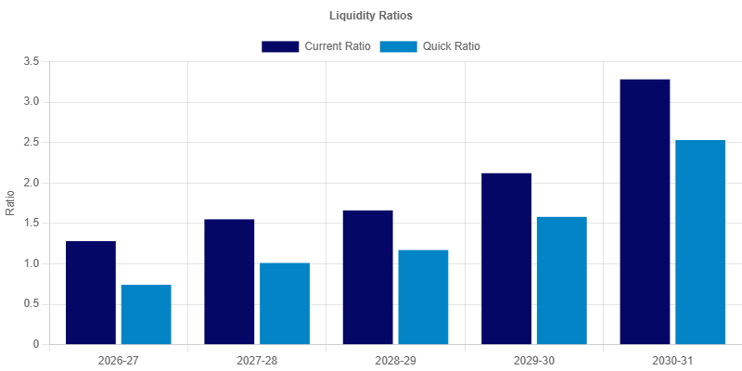  Analysis:  Liquidity ratios monitor the firm's ability to settle short-term liabilities. The Current Ratio, starting at 1.28:1 and reaching 3.28:1 by the final year, indicates a healthy buffer of current assets. The Quick Ratio follows a similar positive trend, ensuring that the firm can meet its obligations even without relying on inventory liquidation. | Profitability Ratios  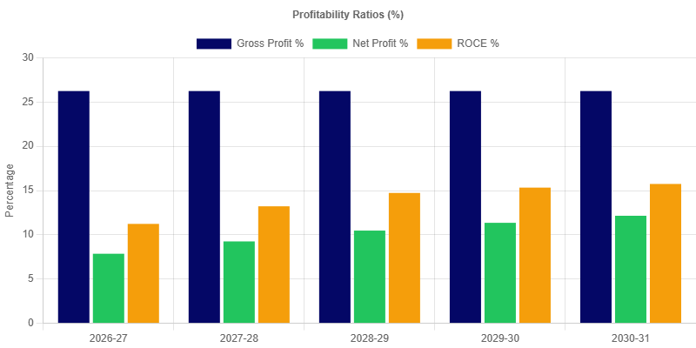  Analysis:  Profitability ratios reflect the operational efficiency of the project. The Gross Profit margin begins at 26.24%, while the Net Profit margin starts at 7.86%. The consistency or growth in these margins over the years demonstrates the firm's capability to manage costs and generate returns for the stakeholders.
Solvency Ratios  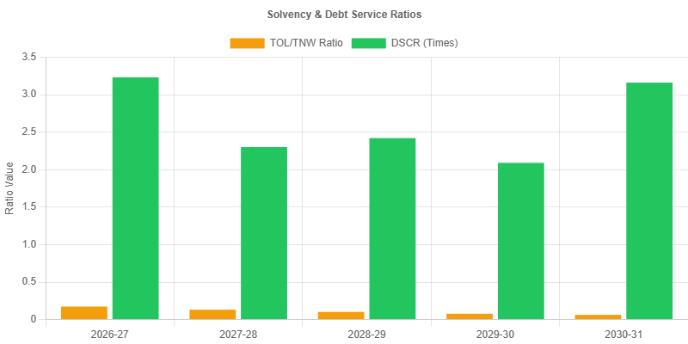  Analysis:  Solvency ratios provide a long-term perspective on the firm's health. They indicate the project's ability to sustain operations and meet long-term commitments, ensuring viability beyond the initial projection period. | Leverage Ratios  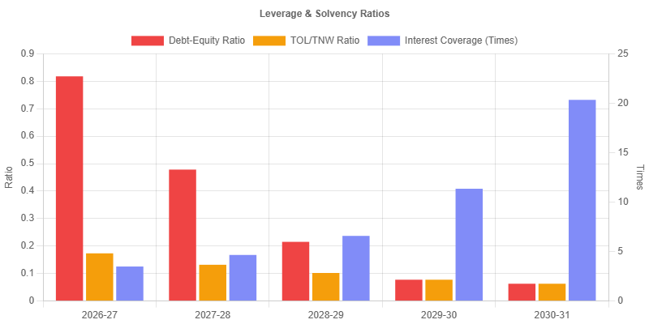  Analysis:  Leverage ratios evaluate the project's capital structure and dependence on debt. The Debt-Equity ratio of 0.82:1 in the initial year shows the balance between borrowed funds and owner's equity. A stable or decreasing ratio over time typically indicates a lower risk profile and greater financial independence.
Working Capital Turnover  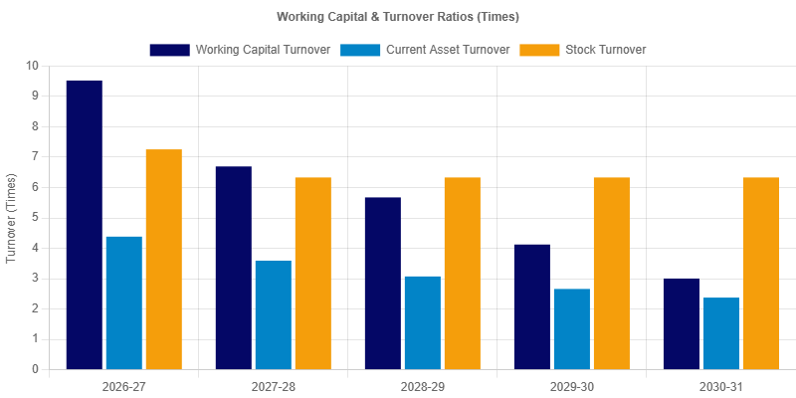  Analysis:  Efficiency ratios (Turnover Ratios) indicate how effectively the firm is utilizing its assets. High turnover figures suggest optimal inventory management and efficient use of working capital, resulting in better overall productivity. | Efficiency Ratios  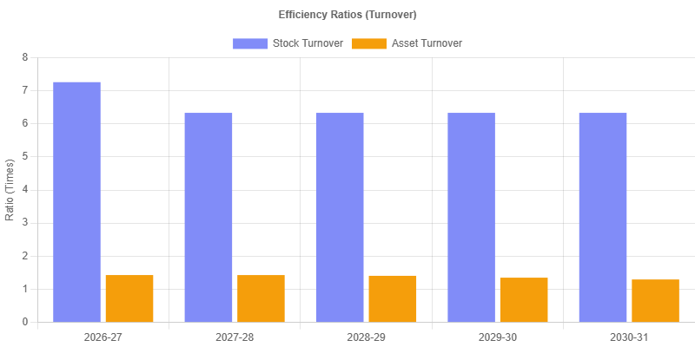  Analysis:  Efficiency ratios (Turnover Ratios) indicate how effectively the firm is utilizing its assets. High turnover figures suggest optimal inventory management and efficient use of working capital, resulting in better overall productivity.

DSCR
Particulars | 2026-2027  (projected) | 2027-2028  (projected) | 2028-2029  (projected) | 2029-2030  (projected) | 2030-2031  (projected)
Receipts
a).Net Profit | 42,42,909.48 | 53,95,005.05 | 65,96,894.27 | 77,22,469.26 | 89,25,197.55
b).Depreciation | 33,60,000.00 | 28,98,000.00 | 25,01,100.00 | 21,59,955.00 | 18,66,579.75
c).Interest on termloan | 14,09,338.54 | 11,78,452.64 | 8,84,298.01 | 4,49,030.10 | 1,64,506.29
Total | 90,12,248.02 | 94,71,457.69 | 99,82,292.28 | 1,03,31,454.36 | 1,09,56,283.59
Repayments
a).Loan Principal | 13,80,011.16 | 29,40,567.27 | 32,32,411.47 | 45,01,823.09 | 32,99,746.78
b).Interest on termloan | 14,09,338.54 | 11,78,452.64 | 8,84,298.01 | 4,49,030.10 | 1,64,506.29
Total | 27,89,349.70 | 41,19,019.91 | 41,16,709.48 | 49,50,853.19 | 34,64,253.07
DSCR | 3.23 | 2.30 | 2.42 | 2.09 | 3.16
Average DSCR |  |  |  |  | 2.64

Dscr  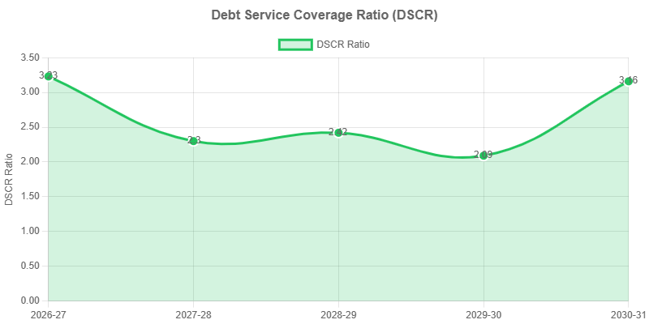  Analysis:  The Debt Service Coverage Ratio (DSCR) is a primary indicator of debt-repayment capacity. With an average DSCR of 2.64 over the 5-year period, the project demonstrates a strong ability to generate sufficient cash flows to meet both interest and principal obligations comfortably. | Balance Sheet Strength  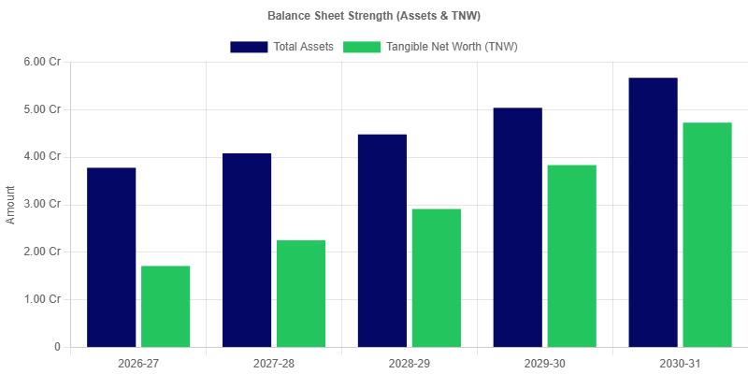  Analysis:  The Balance Sheet Strength chart illustrates the growth of Total Assets and Tangible Net Worth (TNW) over the projection period. In FY 2026-27, Total Assets are projected at 3,77,77,388.15 alongside a Tangible Net Worth of 1,71,22,909.48. By FY 2030-31, these are expected to reach 5,66,91,640.05 and 4,72,62,475.61 respectively. This trend signifies a strengthening financial position and increasing equity cushion for the firm.

Turnover Method of Lending
Particulars | 2026-2027  (projected) | 2027-2028  (projected) | 2028-2029  (projected) | 2029-2030  (projected) | 2030-2031  (projected)
A. Turnover (Net Sales) | 5,40,00,000.00 | 5,83,20,000.00 | 6,29,85,600.00 | 6,80,24,448.00 | 7,34,66,403.84
B. 25.00% of (A) | 1,35,00,000.00 | 1,45,80,000.00 | 1,57,46,400.00 | 1,70,06,112.00 | 1,83,66,600.96
C. Margin Required at 5.00% of (A) | 27,00,000.00 | 29,16,000.00 | 31,49,280.00 | 34,01,222.40 | 36,73,320.19
D. Margin (NWC) | 27,00,291.72 | 57,42,048.86 | 81,29,851.93 | 1,35,28,167.44 | 2,14,95,534.99
E. (B - C) | 1,08,00,000.00 | 1,16,64,000.00 | 1,25,97,120.00 | 1,36,04,889.60 | 1,46,93,280.77
F. (B - D) | 1,07,99,708.28 | 88,37,951.14 | 76,16,548.07 | 34,77,944.56 | -31,28,934.03
G. Permissible Bank Finance under Turnover Method (B - C) | 1,08,00,000.00 | 1,16,64,000.00 | 1,25,97,120.00 | 1,36,04,889.60 | 1,46,93,280.77
H. Proposed / Existing Bank Borrowing | 29,70,000.00 | 29,70,000.00 | 29,70,000.00 | 29,70,000.00 | 29,70,000.00
I. Drawing Power | 73,85,960.35 | 76,91,307.01 | 80,35,969.54 | 82,05,665.81 | 86,36,671.96
J. Excess Borrowing over Turnover Method Finance | 0.00 | 0.00 | 0.00 | 0.00 | 0.00

Maximum Permissible Bank Finance (MPBF)
Particulars | 2026-2027  (projected) | 2027-2028  (projected) | 2028-2029  (projected) | 2029-2030  (projected) | 2030-2031  (projected)
FIRST METHOD OF LENDING
1. Total Current Assets | 1,23,20,789.05 | 1,62,36,714.97 | 2,05,07,952.06 | 2,55,69,874.71 | 3,09,24,699.44
2. Other Current Liabilities (Other than Bank Borrowing) | 66,50,497.33 | 75,24,666.11 | 94,08,100.13 | 90,71,707.27 | 64,59,164.45
3. Working Capital Gap | 56,70,291.72 | 87,12,048.86 | 1,10,99,851.93 | 1,64,98,167.44 | 2,44,65,534.99
4. Min stipulated Net Working Capital (25% of Working Capital Gap) | 14,17,572.93 | 21,78,012.21 | 27,74,962.98 | 41,24,541.86 | 61,16,383.75
5. Actual / Projected Net Working Capital | 27,00,291.72 | 57,42,048.86 | 81,29,851.93 | 1,35,28,167.44 | 2,14,95,534.99
6. Item 3 minus item 4 | 42,52,718.79 | 65,34,036.64 | 83,24,888.95 | 1,23,73,625.58 | 1,83,49,151.24
7. Item 3 minus item 5 | 29,70,000.00 | 29,70,000.00 | 29,70,000.00 | 29,70,000.00 | 29,70,000.00
8. Maximum Permissible Bank Finance (lower of 6 or 7) | 29,70,000.00 | 29,70,000.00 | 29,70,000.00 | 29,70,000.00 | 29,70,000.00
9. Excess Borrowing Representing shortfall in NWC | 0.00 | 0.00 | 0.00 | 0.00 | 0.00
SECOND METHOD OF LENDING
1. Total Current Assets | 1,23,20,789.05 | 1,62,36,714.97 | 2,05,07,952.06 | 2,55,69,874.71 | 3,09,24,699.44
2. Other Current Liabilities (Other than Bank Borrowing) | 66,50,497.33 | 75,24,666.11 | 94,08,100.13 | 90,71,707.27 | 64,59,164.45
3. Working Capital Gap | 56,70,291.72 | 87,12,048.86 | 1,10,99,851.93 | 1,64,98,167.44 | 2,44,65,534.99
4. Min stipulated Net Working Capital (25% of Total Current Assets) | 30,80,197.26 | 40,59,178.74 | 51,26,988.01 | 63,92,468.68 | 77,31,174.86
5. Actual / Projected Net Working Capital | 27,00,291.72 | 57,42,048.86 | 81,29,851.93 | 1,35,28,167.44 | 2,14,95,534.99
6. Item 3 minus item 4 | 25,90,094.46 | 46,52,870.12 | 59,72,863.91 | 1,01,05,698.76 | 1,67,34,360.13
7. Item 3 minus item 5 | 29,70,000.00 | 29,70,000.00 | 29,70,000.00 | 29,70,000.00 | 29,70,000.00
8. Maximum Permissible Bank Finance (lower of 6 or 7) | 25,90,094.46 | 29,70,000.00 | 29,70,000.00 | 29,70,000.00 | 29,70,000.00
9. Excess Borrowing Representing shortfall in NWC | 3,79,905.54 | 0.00 | 0.00 | 0.00 | 0.00

Executive Summary
FINXORA AGRO FOODS PRIVATE LIMITED proposes to establish a rice mill and flour processing unit business in Indore, Madhya Pradesh. Commercial commencement is planned for 1 April 2026, with the investment and funding structure set out in the project schedules. The project processes paddy into rice and wheat into flour, with processed rice contributing 65% and wheat flour 35% of planned sales. The quantity-and-rate schedules use Rs. 50 per kg for rice and Rs. 40 per kg for flour. Paddy and wheat purchases are linked to the sales plan using recovery assumptions of 67% and 90% respectively, so physical procurement must be monitored alongside monetary turnover.
Indore's grain-trading network and demand for regularly graded staples offer access to trade and institutional buyers. Local procurement and shorter transport routes can support competitive delivered costs. The project seeks differentiation through consistent grades, dependable packing weights and timely replenishment rather than an unsupported premium selling-price assumption.
The funding schedule provides a total outlay of Rs. 309.70 lakh, promoter contribution of Rs. 128.80 lakh, term finance of Rs. 151.20 lakh and cash credit of Rs. 29.70 lakh. The term facility is modelled at 9.5% over five years with a six-month moratorium; working-capital interest is modelled at 10%. Security documentation and final repayment terms remain subject to the bank's appraisal and sanction. For the first reporting year, FY 2026-27, the computed schedules show sales of Rs. 540.00 lakh and net profit of Rs. 42.43 lakh. The first-year current ratio is 1.85 times and the arithmetic average of the annual DSCR values in the repayment schedule is 2.64 times. Final-year sales are Rs. 734.66 lakh with net profit of Rs. 89.25 lakh; these highlights reproduce the report's calculations rather than a separate earnings estimate.

Company Background
Aarav Mehta has fourteen years of grain procurement and milling operations experience. Neha Kapoor has nine years of experience in food-business accounts, supplier settlement and inventory administration. The directors intend to combine procurement knowledge with batch-level costing, appointing an experienced mill supervisor before commercial production begins.
The employment plan provides for twenty-four production, packing and handling employees and seven supervisory, sales and office staff. Machinery installation, electrical connections, storage arrangements and food-safety permissions are to be completed before commencement on 1 April 2026. Training and trial batches must establish recovery performance before production is scaled to the forecast level. Responsibilities should be supported by written authority limits for purchases, customer credit and payments. Bank reconciliations and statutory compliance are to be reviewed monthly, and changes in key personnel should be accompanied by a documented handover.
Raw grain is tested for moisture, foreign matter and infestation before acceptance. Milling and packing controls cover recovery, grading, net weight, hygiene and batch traceability. Customer complaints are linked to retained batch records, and storage practices include pest control and regular inspection to protect both quality and recoverable inventory value. The reporting plan calls for consistent accounting policies, periodic physical verification and management review of exceptions. Forecast growth is an operating target and should be measured against demonstrated execution rather than treated as an assured result.

Project Scope and Implementation
The planned unit at Plot 12, Industrial Area, Indore provides cleaning, milling, grading and packing facilities with segregated raw-grain and finished-product storage. Planned installed combined output capacity is 2,000 tonnes annually on a single-shift basis, leaving headroom over first-year quantities in the revenue schedule. Grain receipt, process loss and finished output are reconciled for each production batch.
The employment plan provides for twenty-four production, packing and handling employees and seven supervisory, sales and office staff. Machinery installation, electrical connections, storage arrangements and food-safety permissions are to be completed before commencement on 1 April 2026. Training and trial batches must establish recovery performance before production is scaled to the forecast level.
Implementation should proceed through premises readiness, equipment procurement, installation, trial operation and controlled commercial launch. Supplier specifications and service support should be checked before placing orders. Promoter margin is to be introduced in step with disbursement; the bank should verify end use against invoices and the agreed project budget. Any commissioning delay requires a revised sales ramp and repayment forecast before full utilisation of the facilities.

Operational Plan
The planned unit at Plot 12, Industrial Area, Indore provides cleaning, milling, grading and packing facilities with segregated raw-grain and finished-product storage. Planned installed combined output capacity is 2,000 tonnes annually on a single-shift basis, leaving headroom over first-year quantities in the revenue schedule. Grain receipt, process loss and finished output are reconciled for each production batch.
The employment plan provides for twenty-four production, packing and handling employees and seven supervisory, sales and office staff. Machinery installation, electrical connections, storage arrangements and food-safety permissions are to be completed before commencement on 1 April 2026. Training and trial batches must establish recovery performance before production is scaled to the forecast level.
The project processes paddy into rice and wheat into flour, with processed rice contributing 65% and wheat flour 35% of planned sales. The quantity-and-rate schedules use Rs. 50 per kg for rice and Rs. 40 per kg for flour. Paddy and wheat purchases are linked to the sales plan using recovery assumptions of 67% and 90% respectively, so physical procurement must be monitored alongside monetary turnover. Monthly management review should compare orders, realised prices, direct costs and collections with the financial schedules. Stock and debtor statements must reconcile with the books before submission to the bank. Any adverse movement in margin or overdue accounts should lead to a revised cash-flow forecast and corrective action before additional credit commitments are accepted.

Market Analysis and Opportunity
The proposed customer groups are grain wholesalers, grocery distributors, local institutional kitchens and regional retailers. Bulk packs serve trade buyers while selected flour pack sizes support local retail distribution. The sales plan does not assume an exclusive offtake contract; initial orders and payment behaviour should establish repeat demand before additional credit is extended.
Indore's grain-trading network and demand for regularly graded staples offer access to trade and institutional buyers. Local procurement and shorter transport routes can support competitive delivered costs. The project seeks differentiation through consistent grades, dependable packing weights and timely replenishment rather than an unsupported premium selling-price assumption.
The forecast assumes disciplined expansion of existing product and service lines, supported by the annual growth and collection assumptions in the schedules. Local competition, customer bargaining power and input-cost changes require regular review of quotations. Before expanding into another territory or customer group, management should compare incremental gross contribution with delivery, staffing and credit costs and retain only business that supports the repayment plan.

Quality Assurance and Control
Raw grain is tested for moisture, foreign matter and infestation before acceptance. Milling and packing controls cover recovery, grading, net weight, hygiene and batch traceability. Customer complaints are linked to retained batch records, and storage practices include pest control and regular inspection to protect both quality and recoverable inventory value.
The planned unit at Plot 12, Industrial Area, Indore provides cleaning, milling, grading and packing facilities with segregated raw-grain and finished-product storage. Planned installed combined output capacity is 2,000 tonnes annually on a single-shift basis, leaving headroom over first-year quantities in the revenue schedule. Grain receipt, process loss and finished output are reconciled for each production batch. Operating records should link purchases or inputs to completed output and customer billing, allowing exceptions to be traced promptly. Responsibility for acceptance checks, stock custody and payment approval should be separated wherever staffing permits.
Management should retain supplier documents, maintenance records, customer complaints and corrective-action logs. Quality controls are intended to prevent avoidable returns and interruption as well as meet customer specifications. Periodic review of losses, rework and complaints should feed into costing and training; certifications or approvals should be claimed only after the applicable requirements have been met.

Risk Assessment and Mitigation
Seasonal grain prices, variable milling recovery and delayed plant commissioning can weaken cash accruals. Procurement is phased against production and sales commitments, with moisture and recovery tests informing purchase prices. Commissioning contingencies and supplier service support reduce start-up risk; the financing review should also test delayed subsidy receipt and slower initial sales.
Indore's grain-trading network and demand for regularly graded staples offer access to trade and institutional buyers. Local procurement and shorter transport routes can support competitive delivered costs. The project seeks differentiation through consistent grades, dependable packing weights and timely replenishment rather than an unsupported premium selling-price assumption. These strengths are balanced by the need to manage utilisation, cost discipline and collection performance. The projection should be stress-tested for lower sales, higher input prices and a longer collection cycle, with repayment reviewed against the resulting cash accruals rather than solely against the base-case margin.
Repayment capacity is assessed from operating cash accruals after the scheduled interest charge and with principal obligations considered in the debt-service schedule. Accounting profit alone does not establish available bank cash: inventory growth, receivable delays and capital expenditure can absorb accruals. Management should maintain a rolling cash forecast and reserve funds for instalments before discretionary expenditure or distributions. Insurance, supplier continuity arrangements and timely statutory renewals should be reviewed annually. The bank should receive prompt explanations for material deviations from the sanctioned operating assumptions.

Financial Analysis
For the first reporting year, FY 2026-27, the computed schedules show sales of Rs. 540.00 lakh and net profit of Rs. 42.43 lakh. The first-year current ratio is 1.85 times and the arithmetic average of the annual DSCR values in the repayment schedule is 2.64 times. Final-year sales are Rs. 734.66 lakh with net profit of Rs. 89.25 lakh; these highlights reproduce the report's calculations rather than a separate earnings estimate.
The funding schedule provides a total outlay of Rs. 309.70 lakh, promoter contribution of Rs. 128.80 lakh, term finance of Rs. 151.20 lakh and cash credit of Rs. 29.70 lakh. The term facility is modelled at 9.5% over five years with a six-month moratorium; working-capital interest is modelled at 10%. Security documentation and final repayment terms remain subject to the bank's appraisal and sanction.
Repayment capacity is assessed from operating cash accruals after the scheduled interest charge and with principal obligations considered in the debt-service schedule. Accounting profit alone does not establish available bank cash: inventory growth, receivable delays and capital expenditure can absorb accruals. Management should maintain a rolling cash forecast and reserve funds for instalments before discretionary expenditure or distributions. A Rs. 15.00 lakh capital subsidy is assumed after 36 months and applied to reduce EMI; eligibility and actual release must be verified, and delayed or absent receipt should be covered in the bank's sensitivity review. Monthly management review should compare orders, realised prices, direct costs and collections with the financial schedules. Stock and debtor statements must reconcile with the books before submission to the bank. Any adverse movement in margin or overdue accounts should lead to a revised cash-flow forecast and corrective action before additional credit commitments are accepted.

Conclusion and Recommendations
FINXORA AGRO FOODS PRIVATE LIMITED's proposal connects rice mill and flour processing unit activity with an identified operating plan, a defined promoter contribution and scheduled bank finance. Indore's grain-trading network and demand for regularly graded staples offer access to trade and institutional buyers. Local procurement and shorter transport routes can support competitive delivered costs. The project seeks differentiation through consistent grades, dependable packing weights and timely replenishment rather than an unsupported premium selling-price assumption. The computed liquidity and debt-service indicators support consideration of the proposal under the stated assumptions; they should be read with the detailed operating, balance-sheet and repayment schedules.
Seasonal grain prices, variable milling recovery and delayed plant commissioning can weaken cash accruals. Procurement is phased against production and sales commitments, with moisture and recovery tests informing purchase prices. Commissioning contingencies and supplier service support reduce start-up risk; the financing review should also test delayed subsidy receipt and slower initial sales. Prior to sanction or renewal, the bank should examine promoter contribution, premises arrangements, equipment quotations, customer demand, statutory permissions and the proposed security. Disbursement should follow documented end use and completion of the agreed conditions.
Management should provide periodic stock, debtor and operating statements and discuss material deviations with the lender. Expansion should remain within demonstrated operational capacity and available working capital. This assessment is conditional on execution of the operating plan and timely collections; it does not constitute a guarantee of sanction, future profit or uninterrupted debt service.
This is a sample report prepared with Finxora; the business and its figures are illustrative.

Sales & Purchase Breakdown
Sales
Sales - Monthly Bifurcation (Quantity x Rate)
Particulars | Unit | Quantity | Rate | Monthly Amount
Sales of Goods | — | — | — | 45,00,000.00
Processed rice | kg | 58,500.00 | 50.00 | 29,25,000.00
Wheat flour | kg | 39,375.00 | 40.00 | 15,75,000.00
Total Sales | — | — | — | 90,00,000.00
Sales - Yearly Projection (Year 1)
Particulars | Unit | Monthly Qty | Months | Annual Qty | Monthly Amount | Yearly Amount
Sales of Goods | — | — | 12 | — | 45,00,000.00 | 5,40,00,000.00
Processed rice | kg | 58,500.00 | 12 | 7,02,000.00 | 29,25,000.00 | 3,51,00,000.00
Wheat flour | kg | 39,375.00 | 12 | 4,72,500.00 | 15,75,000.00 | 1,89,00,000.00
Total Sales | — | — | 12 | — | 90,00,000.00 | 10,80,00,000.00
Sales - Yearly Projection (Year 2)
Particulars | Unit | Monthly Qty | Months | Annual Qty | Monthly Amount | Yearly Amount
Sales of Goods | — | — | 12 | — | 48,60,000.00 | 5,83,20,000.00
Processed rice | kg | 73,125.00 | 12 | 8,77,500.00 | 36,56,250.00 | 4,38,75,000.00
Wheat flour | kg | 49,218.75 | 12 | 5,90,625.00 | 19,68,750.00 | 2,36,25,000.00
Total Sales | — | — | 12 | — | 1,04,85,000.00 | 12,58,20,000.00
Sales - Yearly Projection (Year 3)
Particulars | Unit | Monthly Qty | Months | Annual Qty | Monthly Amount | Yearly Amount
Sales of Goods | — | — | 12 | — | 52,48,800.00 | 6,29,85,600.00
Processed rice | kg | 91,406.25 | 12 | 10,96,875.00 | 45,70,312.50 | 5,48,43,750.00
Wheat flour | kg | 61,523.44 | 12 | 7,38,281.25 | 24,60,937.50 | 2,95,31,250.00
Total Sales | — | — | 12 | — | 1,22,80,050.00 | 14,73,60,600.00
Sales - Yearly Projection (Year 4)
Particulars | Unit | Monthly Qty | Months | Annual Qty | Monthly Amount | Yearly Amount
Sales of Goods | — | — | 12 | — | 56,68,704.00 | 6,80,24,448.00
Processed rice | kg | 1,14,257.81 | 12 | 13,71,093.75 | 57,12,890.63 | 6,85,54,687.50
Wheat flour | kg | 76,904.30 | 12 | 9,22,851.56 | 30,76,171.88 | 3,69,14,062.50
Total Sales | — | — | 12 | — | 1,44,57,766.50 | 17,34,93,198.00
Sales - Yearly Projection (Year 5)
Particulars | Unit | Monthly Qty | Months | Annual Qty | Monthly Amount | Yearly Amount
Sales of Goods | — | — | 12 | — | 61,22,200.32 | 7,34,66,403.84
Processed rice | kg | 1,42,822.27 | 12 | 17,13,867.19 | 71,41,113.28 | 8,56,93,359.38
Wheat flour | kg | 96,130.37 | 12 | 11,53,564.45 | 38,45,214.84 | 4,61,42,578.13
Total Sales | — | — | 12 | — | 1,71,08,528.45 | 20,53,02,341.34
Purchase
Purchase - Monthly Bifurcation (Quantity x Rate)
Particulars | Unit | Quantity | Rate | Monthly Amount
Purchase of Goods | — | — | — | 31,31,506.85
Paddy (for Processed rice @ 67% recovery) | kg | 87,313.43 | 23.31 | 20,35,479.45
Wheat (for Wheat flour @ 90% recovery) | kg | 43,750.00 | 25.05 | 10,96,027.40
Total Purchase | — | — | — | 62,63,013.70
Purchase - Yearly Projection (Year 1)
Particulars | Unit | Monthly Qty | Months | Annual Qty | Monthly Amount | Yearly Amount
Purchase of Goods | — | — | 12 | — | 31,31,506.85 | 3,75,78,082.19
Paddy | kg | 87,313.43 | 12 | 10,47,761.19 | 20,35,479.45 | 2,44,25,753.40
Wheat | kg | 43,750.00 | 12 | 5,25,000.00 | 10,96,027.40 | 1,31,52,328.80
Total Purchase | — | — | 12 | — | 62,63,013.70 | 7,51,56,164.39
Purchase - Yearly Projection (Year 2)
Particulars | Unit | Monthly Qty | Months | Annual Qty | Monthly Amount | Yearly Amount
Purchase of Goods | — | — | 12 | — | 29,50,520.55 | 3,54,06,246.58
Paddy | kg | 1,00,410.45 | 12 | 12,04,925.37 | 23,40,801.37 | 2,80,89,616.41
Wheat | kg | 50,312.50 | 12 | 6,03,750.00 | 12,60,431.51 | 1,51,25,178.12
Total Purchase | — | — | 12 | — | 65,51,753.43 | 7,86,21,041.11
Purchase - Yearly Projection (Year 3)
Particulars | Unit | Monthly Qty | Months | Annual Qty | Monthly Amount | Yearly Amount
Purchase of Goods | — | — | 12 | — | 31,86,562.19 | 3,82,38,746.30
Paddy | kg | 1,15,472.01 | 12 | 13,85,664.18 | 26,91,921.57 | 3,23,03,058.87
Wheat | kg | 57,859.38 | 12 | 6,94,312.50 | 14,49,496.24 | 1,73,93,954.84
Total Purchase | — | — | 12 | — | 73,27,980.00 | 8,79,35,760.01
Purchase - Yearly Projection (Year 4)
Particulars | Unit | Monthly Qty | Months | Annual Qty | Monthly Amount | Yearly Amount
Purchase of Goods | — | — | 12 | — | 34,41,487.17 | 4,12,97,846.01
Paddy | kg | 1,32,792.82 | 12 | 15,93,513.80 | 30,95,709.81 | 3,71,48,517.70
Wheat | kg | 66,538.28 | 12 | 7,98,459.38 | 16,66,920.67 | 2,00,03,048.06
Total Purchase | — | — | 12 | — | 82,04,117.65 | 9,84,49,411.78
Purchase - Yearly Projection (Year 5)
Particulars | Unit | Monthly Qty | Months | Annual Qty | Monthly Amount | Yearly Amount
Purchase of Goods | — | — | 12 | — | 37,16,806.14 | 4,46,01,673.69
Paddy | kg | 1,52,711.74 | 12 | 18,32,540.88 | 35,60,066.28 | 4,27,20,795.36
Wheat | kg | 76,519.02 | 12 | 9,18,228.28 | 19,16,958.77 | 2,30,03,505.27
Total Purchase | — | — | 12 | — | 91,93,831.19 | 11,03,25,974.32

Revenue & expenses
Particulars | Monthly Amount
Sales & Revenue
Processed rice | 29,25,000.00
Wheat flour | 15,75,000.00
Total Sales Revenue | 45,00,000.00
Purchases
Paddy | 20,35,479.45
Wheat | 10,96,027.40
Total Purchases | 31,31,506.85
Administrative Expenses
Salaries & Wages | 1,08,000.00
Rent | 43,200.00
Utilities (Electricity, Water, etc.) | 28,800.00
Office Supplies & Stationery | 10,800.00
Communication (Phone, Internet) | 10,800.00
Travel & Conveyance | 21,600.00
Professional Fees | 14,400.00
Insurance | 14,400.00
Repairs & Maintenance | 21,600.00
Bank Charges | 7,200.00
Total Administrative Expenses | 2,80,800.00
Selling & Distribution Expenses
Advertising & Marketing | 36,000.00
Freight & Transportation | 36,000.00
Other Direct Expenses | 7,200.00
Power & Fuel | 1,35,000.00
Production wages | 3,15,000.00
Factory overheads | 90,000.00
Total Selling & Distribution Expenses | 6,19,200.00
Closing Stock
Closing Stock Value (yearly) | 51,78,082.19

Profit & Loss Account
Particulars | 2026-2027  (projected) | 2027-2028  (projected) | 2028-2029  (projected) | 2029-2030  (projected) | 2030-2031  (projected)
SALES
Manufactured product sales | 5,40,00,000.00 | 5,83,20,000.00 | 6,29,85,600.00 | 6,80,24,448.00 | 7,34,66,403.84
Total Sales | 5,40,00,000.00 | 5,83,20,000.00 | 6,29,85,600.00 | 6,80,24,448.00 | 7,34,66,403.84
Closing Stock | 51,78,082.19 | 55,92,328.77 | 60,39,715.07 | 65,22,892.27 | 70,44,723.66
Opening Stock | 0.00 | 51,78,082.19 | 55,92,328.77 | 60,39,715.07 | 65,22,892.27
PURCHASES
Raw material purchases | 3,75,78,082.19 | 3,54,06,246.58 | 3,82,38,746.30 | 4,12,97,846.01 | 4,46,01,673.69
Total Purchases | 3,75,78,082.19 | 3,54,06,246.58 | 3,82,38,746.30 | 4,12,97,846.01 | 4,46,01,673.69
DIRECT EXPENSES
Advertising & Marketing | 4,32,000.00 | 4,66,560.00 | 5,03,884.80 | 5,44,195.58 | 5,87,731.23
Freight & Transportation | 4,32,000.00 | 4,66,560.00 | 5,03,884.80 | 5,44,195.58 | 5,87,731.23
Other Direct Expenses | 86,400.00 | 93,312.00 | 1,00,776.96 | 1,08,839.12 | 1,17,546.25
Power & Fuel | 16,20,000.00 | 17,49,600.00 | 18,89,568.00 | 20,40,733.44 | 22,03,992.12
Production wages | 37,80,000.00 | 40,82,400.00 | 44,08,992.00 | 47,61,711.36 | 51,42,648.27
Factory overheads | 10,80,000.00 | 11,66,400.00 | 12,59,712.00 | 13,60,488.96 | 14,69,328.08
Total Direct Expenses | 74,30,400.00 | 80,24,832.00 | 86,66,818.56 | 93,60,164.04 | 1,01,08,977.18
GROSS PROFIT | 1,41,69,600.00 | 1,53,03,168.00 | 1,65,27,421.44 | 1,78,49,615.15 | 1,92,77,584.36
INDIRECT EXPENSES
Salaries & Wages | 12,96,000.00 | 13,99,680.00 | 15,11,654.40 | 16,32,586.75 | 17,63,193.69
Rent | 5,18,400.00 | 5,59,872.00 | 6,04,661.76 | 6,53,034.70 | 7,05,277.48
Utilities (Electricity, Water, etc.) | 3,45,600.00 | 3,73,248.00 | 4,03,107.84 | 4,35,356.47 | 4,70,184.98
Office Supplies & Stationery | 1,29,600.00 | 1,39,968.00 | 1,51,165.44 | 1,63,258.68 | 1,76,319.37
Communication (Phone, Internet) | 1,29,600.00 | 1,39,968.00 | 1,51,165.44 | 1,63,258.68 | 1,76,319.37
Travel & Conveyance | 2,59,200.00 | 2,79,936.00 | 3,02,330.88 | 3,26,517.35 | 3,52,638.74
Professional Fees | 1,72,800.00 | 1,86,624.00 | 2,01,553.92 | 2,17,678.23 | 2,35,092.49
Insurance | 1,72,800.00 | 1,86,624.00 | 2,01,553.92 | 2,17,678.23 | 2,35,092.49
Repairs & Maintenance | 2,59,200.00 | 2,79,936.00 | 3,02,330.88 | 3,26,517.35 | 3,52,638.74
Bank Charges | 86,400.00 | 93,312.00 | 1,00,776.96 | 1,08,839.12 | 1,17,546.25
Depreciation | 33,60,000.00 | 28,98,000.00 | 25,01,100.00 | 21,59,955.00 | 18,66,579.75
Interest on WCL | 2,97,000.00 | 2,97,000.00 | 2,97,000.00 | 2,97,000.00 | 2,97,000.00
Interest on TL | 14,09,338.54 | 11,78,452.64 | 8,84,298.01 | 4,49,030.10 | 1,64,506.29
Total Indirect Expenses | 84,35,938.54 | 80,12,620.64 | 76,12,699.45 | 71,50,710.66 | 69,12,389.64
EBDIT (PBDIT) | 1,08,00,000.00 | 1,16,64,000.00 | 1,25,97,120.00 | 1,36,04,889.59 | 1,46,93,280.76
Profit Before Tax | 57,33,661.46 | 72,90,547.36 | 89,14,721.99 | 1,06,98,904.49 | 1,23,65,194.72
Provision for Income Tax | 14,90,751.98 | 18,95,542.31 | 23,17,827.72 | 29,76,435.23 | 34,39,997.17
NET PROFIT | 42,42,909.48 | 53,95,005.05 | 65,96,894.27 | 77,22,469.26 | 89,25,197.55

Cash Flow Statement
Particulars | 2026-2027  (projected) | 2027-2028  (projected) | 2028-2029  (projected) | 2029-2030  (projected) | 2030-2031  (projected)
Cash Inflow
Capital | 1,28,80,000.00 | 0.00 | 0.00 | 0.00 | 0.00
Subsidy | 0.00 | 0.00 | 0.00 | 15,00,000.00 | 0.00
Termloan | 1,51,20,000.00 | 0.00 | 0.00 | 0.00 | 0.00
Working Capital Loan | 29,70,000.00 | 0.00 | 0.00 | 0.00 | 0.00
Increase in Current Liabilities | 37,09,930.06 | 5,82,324.58 | 6,14,022.40 | 8,65,683.45 | 6,87,203.96
Increase in Non-Current Liabilities | 0.00 | 0.00 | 0.00 | 0.00 | 0.00
Increase in Non-Term Liabilities | 0.00 | 0.00 | 0.00 | 0.00 | 0.00
Increase in Other Term Liabilities | 0.00 | 0.00 | 0.00 | 0.00 | 0.00
Decrease in Current Assets | 0.00 | 0.00 | 0.00 | 0.00 | 0.00
Decrease in Non-Current Assets | 0.00 | 0.00 | 0.00 | 0.00 | 0.00
Decrease in Investments | 0.00 | 0.00 | 0.00 | 0.00 | 0.00
Profit before tax with interest | 74,40,000.00 | 87,66,000.00 | 1,00,96,020.00 | 1,14,44,934.59 | 1,28,26,701.01
Depreciation | 33,60,000.00 | 28,98,000.00 | 25,01,100.00 | 21,59,955.00 | 18,66,579.75
Total Cash Inflow | 4,54,79,930.06 | 1,22,46,324.58 | 1,32,11,142.40 | 1,59,70,573.04 | 1,53,80,484.72
Cash Outflow
Fixed Assets | 2,80,00,000.00 | 0.00 | 0.00 | 0.00 | 0.00
Increase in Current Assets | 1,10,95,890.41 | 8,87,671.24 | 9,58,684.93 | 10,35,379.72 | 11,18,210.11
Increase in Non-Current Assets | 8,16,599.10 | 20,18,836.44 | 22,08,368.11 | 26,84,361.96 | 28,24,409.75
Increase in Investments | 0.00 | 0.00 | 0.00 | 0.00 | 0.00
Interest on TL | 14,09,338.54 | 11,78,452.64 | 8,84,298.01 | 4,49,030.10 | 1,64,506.29
Interest on WCL | 2,97,000.00 | 2,97,000.00 | 2,97,000.00 | 2,97,000.00 | 2,97,000.00
Decrease in Term loan | 11,45,451.39 | 29,40,567.27 | 32,32,411.47 | 45,01,823.09 | 32,99,746.78
Decrease in Working Capital Loan | 0.00 | 0.00 | 0.00 | 0.00 | 0.00
Drawing | 0.00 | 0.00 | 0.00 | 0.00 | 0.00
Provision for Income Tax | 14,90,751.98 | 18,95,542.31 | 23,17,827.72 | 29,76,435.23 | 34,39,997.17
Decrease in Current Liabilities | 0.00 | 0.00 | 0.00 | 0.00 | 0.00
Decrease in Non-Current Liabilities | 0.00 | 0.00 | 0.00 | 0.00 | 0.00
Decrease in Other Term Liabilities | 0.00 | 0.00 | 0.00 | 0.00 | 0.00
Decrease in Non-Term Liabilities | 0.00 | 0.00 | 0.00 | 0.00 | 0.00
Total Cash Outflow | 4,42,55,031.42 | 92,18,069.90 | 98,98,590.24 | 1,19,44,030.10 | 1,11,43,870.10
Opening balance | 0.00 | 12,24,898.64 | 42,53,153.32 | 75,65,705.48 | 1,15,92,248.41
Net Cashflow | 12,24,898.64 | 30,28,254.68 | 33,12,552.16 | 40,26,542.93 | 42,36,614.62
Closing balance | 12,24,898.64 | 42,53,153.32 | 75,65,705.48 | 1,15,92,248.41 | 1,58,28,863.03

Balance Sheet
Particulars | 2026-2027  (projected) | 2027-2028  (projected) | 2028-2029  (projected) | 2029-2030  (projected) | 2030-2031  (projected)
CAPITAL ACCOUNT
Capital | 1,28,80,000.00 | 1,28,80,000.00 | 1,28,80,000.00 | 1,28,80,000.00 | 1,43,80,000.00
Subsidy | 0.00 | 0.00 | 0.00 | 15,00,000.00 | 0.00
Accumulated Reserves & Surplus (Opening) | 0.00 | 42,42,909.48 | 96,37,914.53 | 1,62,34,808.80 | 2,39,57,278.06
Profit & Loss A/c | 42,42,909.48 | 53,95,005.05 | 65,96,894.27 | 77,22,469.26 | 89,25,197.55
NET WORTH | 1,71,22,909.48 | 2,25,17,914.53 | 2,91,14,808.80 | 3,83,37,278.06 | 4,72,62,475.61
LOAN LIABILITIES
Working Capital Loan | 29,70,000.00 | 29,70,000.00 | 29,70,000.00 | 29,70,000.00 | 29,70,000.00
TOTAL LOAN LIABILITIES | 29,70,000.00 | 29,70,000.00 | 29,70,000.00 | 29,70,000.00 | 29,70,000.00
CURRENT LIABILITIES
Sundry Creditor (Trade) | 22,19,178.08 | 23,96,712.33 | 25,88,449.32 | 27,95,525.26 | 30,19,167.28
Provision for Income Tax | 14,90,751.98 | 18,95,542.31 | 23,17,827.72 | 29,76,435.23 | 34,39,997.17
Current Portion of Term Loan | 29,40,567.27 | 32,32,411.47 | 45,01,823.09 | 32,99,746.78 | 0.00
TOTAL CURRENT LIABILITIES | 66,50,497.33 | 75,24,666.11 | 94,08,100.13 | 90,71,707.27 | 64,59,164.45
TERM LIABILITIES
Term Loan | 1,10,33,981.34 | 78,01,569.87 | 32,99,746.78 | 0.00 | 0.00
TOTAL TERM LIABILITIES | 1,10,33,981.34 | 78,01,569.87 | 32,99,746.78 | 0.00 | 0.00
NON CURRENT LIABILITIES
TOTAL EQUITY + LIABILITY | 3,77,77,388.15 | 4,08,14,150.51 | 4,47,92,655.71 | 5,03,78,985.33 | 5,66,91,640.06
FIXED ASSETS
Gross Block | 2,80,00,000.00 | 2,46,40,000.00 | 2,17,42,000.00 | 1,92,40,900.00 | 1,70,80,945.00
Depreciation to date | 33,60,000.00 | 28,98,000.00 | 25,01,100.00 | 21,59,955.00 | 18,66,579.75
NET BLOCK | 2,46,40,000.00 | 2,17,42,000.00 | 1,92,40,900.00 | 1,70,80,945.00 | 1,52,14,365.25
CURRENT ASSETS
Cash & Cash Equivalents | 12,24,898.64 | 42,53,153.32 | 75,65,705.48 | 1,15,92,248.41 | 1,58,28,863.03
Inventory | 51,78,082.19 | 55,92,328.77 | 60,39,715.07 | 65,22,892.27 | 70,44,723.66
Sundry Debtors | 59,17,808.22 | 63,91,232.88 | 69,02,531.51 | 74,54,734.03 | 80,51,112.75
TOTAL CURRENT ASSETS | 1,23,20,789.05 | 1,62,36,714.97 | 2,05,07,952.06 | 2,55,69,874.71 | 3,09,24,699.44
NON CURRENT ASSETS
Non Current Asset | 8,16,599.10 | 28,35,435.54 | 50,43,803.65 | 77,28,165.61 | 1,05,52,575.36
TOTAL NON CURRENT ASSETS | 8,16,599.10 | 28,35,435.54 | 50,43,803.65 | 77,28,165.61 | 1,05,52,575.36
TOTAL ASSETS | 3,77,77,388.15 | 4,08,14,150.51 | 4,47,92,655.71 | 5,03,78,985.32 | 5,66,91,640.05
Difference | 0.00 | 0.00 | 0.00 | 0.01 | 0.01

Depreciation
Particulars | 2026-2027  (projected) | 2027-2028  (projected) | 2028-2029  (projected) | 2029-2030  (projected) | 2030-2031  (projected)
Land | 28,00,000.00 | 28,00,000.00 | 28,00,000.00 | 28,00,000.00 | 28,00,000.00
During the Year (>= 180 days)
During the Year (< 180 days)
Total During the Year | 0.00 | 0.00 | 0.00 | 0.00 | 0.00
Total | 28,00,000.00 | 28,00,000.00 | 28,00,000.00 | 28,00,000.00 | 28,00,000.00
Less Depreciation | 0.00 | 0.00 | 0.00 | 0.00 | 0.00
Adjust (Dep) (Add/Less)
Written down value | 28,00,000.00 | 28,00,000.00 | 28,00,000.00 | 28,00,000.00 | 28,00,000.00
Building | 70,00,000.00 | 63,00,000.00 | 56,70,000.00 | 51,03,000.00 | 45,92,700.00
During the Year (>= 180 days)
During the Year (< 180 days)
Total During the Year | 0.00 | 0.00 | 0.00 | 0.00 | 0.00
Total | 70,00,000.00 | 63,00,000.00 | 56,70,000.00 | 51,03,000.00 | 45,92,700.00
Less Depreciation | 7,00,000.00 | 6,30,000.00 | 5,67,000.00 | 5,10,300.00 | 4,59,270.00
Adjust (Dep) (Add/Less)
Written down value | 63,00,000.00 | 56,70,000.00 | 51,03,000.00 | 45,92,700.00 | 41,33,430.00
Furniture & Fixtures | 14,00,000.00 | 12,60,000.00 | 11,34,000.00 | 10,20,600.00 | 9,18,540.00
During the Year (>= 180 days)
During the Year (< 180 days)
Total During the Year | 0.00 | 0.00 | 0.00 | 0.00 | 0.00
Total | 14,00,000.00 | 12,60,000.00 | 11,34,000.00 | 10,20,600.00 | 9,18,540.00
Less Depreciation | 1,40,000.00 | 1,26,000.00 | 1,13,400.00 | 1,02,060.00 | 91,854.00
Adjust (Dep) (Add/Less)
Written down value | 12,60,000.00 | 11,34,000.00 | 10,20,600.00 | 9,18,540.00 | 8,26,686.00
Plant & Machinery | 1,26,00,000.00 | 1,07,10,000.00 | 91,03,500.00 | 77,37,975.00 | 65,77,278.75
During the Year (>= 180 days)
During the Year (< 180 days)
Total During the Year | 0.00 | 0.00 | 0.00 | 0.00 | 0.00
Total | 1,26,00,000.00 | 1,07,10,000.00 | 91,03,500.00 | 77,37,975.00 | 65,77,278.75
Less Depreciation | 18,90,000.00 | 16,06,500.00 | 13,65,525.00 | 11,60,696.25 | 9,86,591.81
Adjust (Dep) (Add/Less)
Written down value | 1,07,10,000.00 | 91,03,500.00 | 77,37,975.00 | 65,77,278.75 | 55,90,686.94
Vehicles | 42,00,000.00 | 35,70,000.00 | 30,34,500.00 | 25,79,325.00 | 21,92,426.25
During the Year (>= 180 days)
During the Year (< 180 days)
Total During the Year | 0.00 | 0.00 | 0.00 | 0.00 | 0.00
Total | 42,00,000.00 | 35,70,000.00 | 30,34,500.00 | 25,79,325.00 | 21,92,426.25
Less Depreciation | 6,30,000.00 | 5,35,500.00 | 4,55,175.00 | 3,86,898.75 | 3,28,863.94
Adjust (Dep) (Add/Less)
Written down value | 35,70,000.00 | 30,34,500.00 | 25,79,325.00 | 21,92,426.25 | 18,63,562.31
Opening | 2,80,00,000.00 | 2,46,40,000.00 | 2,17,42,000.00 | 1,92,40,900.00 | 1,70,80,945.00
Total During the Year | 0.00 | 0.00 | 0.00 | 0.00 | 0.00
Gross Block | 2,80,00,000.00 | 2,46,40,000.00 | 2,17,42,000.00 | 1,92,40,900.00 | 1,70,80,945.00
Total less depreciation | 33,60,000.00 | 28,98,000.00 | 25,01,100.00 | 21,59,955.00 | 18,66,579.75
Total Adjust (Dep) (Add/Less) | 0.00 | 0.00 | 0.00 | 0.00 | 0.00
Total written down value | 2,46,40,000.00 | 2,17,42,000.00 | 1,92,40,900.00 | 1,70,80,945.00 | 1,52,14,365.25

Breakeven Point
Particulars | 2026-2027  (projected) | 2027-2028  (projected) | 2028-2029  (projected) | 2029-2030  (projected) | 2030-2031  (projected)
Sales Analysis
Total Sales Revenue | 5,40,00,000.00 | 5,83,20,000.00 | 6,29,85,600.00 | 6,80,24,448.00 | 7,34,66,403.84
Cost Analysis
Fixed Costs | 84,35,938.54 | 80,12,620.64 | 76,12,699.45 | 71,50,710.66 | 69,12,389.64
Variable Costs | 3,98,30,400.00 | 4,30,16,832.00 | 4,64,58,178.56 | 5,01,74,832.85 | 5,41,88,819.48
Total Costs | 4,82,66,338.54 | 5,10,29,452.64 | 5,40,70,878.01 | 5,73,25,543.51 | 6,11,01,209.12
Contribution Analysis
Contribution Margin | 1,41,69,600.00 | 1,53,03,168.00 | 1,65,27,421.44 | 1,78,49,615.15 | 1,92,77,584.36
Contribution Ratio (%) | 26.24 | 26.24 | 26.24 | 26.24 | 26.24
Break-Even Analysis
Break-even Value | 3,21,49,156.02 | 3,05,35,901.83 | 2,90,11,811.93 | 2,72,51,183.93 | 2,63,42,948.33
Break-even Point (%) | 59.54 | 52.36 | 46.06 | 40.06 | 35.86
Margin of Safety (Value) | 2,18,50,843.98 | 2,77,84,098.17 | 3,39,73,788.07 | 4,07,73,264.07 | 4,71,23,455.51
Margin of Safety (%) | 40.46 | 47.64 | 53.94 | 59.94 | 64.14

EMI Repayment Schedule for Term Loan
Month | Payment Date | Opening Bal. | EMI | Principal | Interest | Closing Bal.
1 | 01 Apr 2026 | 1,51,20,000.00 | 1,19,700.00 | 0.00 | 1,19,700.00 | 1,51,20,000.00
2 | 01 May 2026 | 1,51,20,000.00 | 1,19,700.00 | 0.00 | 1,19,700.00 | 1,51,20,000.00
3 | 01 Jun 2026 | 1,51,20,000.00 | 1,19,700.00 | 0.00 | 1,19,700.00 | 1,51,20,000.00
4 | 01 Jul 2026 | 1,51,20,000.00 | 1,19,700.00 | 0.00 | 1,19,700.00 | 1,51,20,000.00
5 | 01 Aug 2026 | 1,51,20,000.00 | 1,19,700.00 | 0.00 | 1,19,700.00 | 1,51,20,000.00
6 | 01 Sept 2026 | 1,51,20,000.00 | 1,19,700.00 | 0.00 | 1,19,700.00 | 1,51,20,000.00
7 | 01 Oct 2026 | 1,51,20,000.00 | 3,45,191.62 | 2,25,491.62 | 1,19,700.00 | 1,48,94,508.38
8 | 01 Nov 2026 | 1,48,94,508.38 | 3,45,191.62 | 2,27,276.76 | 1,17,914.86 | 1,46,67,231.62
9 | 01 Dec 2026 | 1,46,67,231.62 | 3,45,191.62 | 2,29,076.03 | 1,16,115.58 | 1,44,38,155.59
10 | 01 Jan 2027 | 1,44,38,155.59 | 3,45,191.62 | 2,30,889.55 | 1,14,302.07 | 1,42,07,266.04
11 | 01 Feb 2027 | 1,42,07,266.04 | 3,45,191.62 | 2,32,717.43 | 1,12,474.19 | 1,39,74,548.61
12 | 01 Mar 2027 | 1,39,74,548.61 | 3,45,191.62 | 2,34,559.77 | 1,10,631.84 | 1,37,39,988.84
13 | 01 Apr 2027 | 1,37,39,988.84 | 3,45,191.62 | 2,36,416.71 | 1,08,774.91 | 1,35,03,572.13
14 | 01 May 2027 | 1,35,03,572.13 | 3,45,191.62 | 2,38,288.34 | 1,06,903.28 | 1,32,65,283.79
15 | 01 Jun 2027 | 1,32,65,283.79 | 3,45,191.62 | 2,40,174.79 | 1,05,016.83 | 1,30,25,109.00
16 | 01 Jul 2027 | 1,30,25,109.00 | 3,45,191.62 | 2,42,076.17 | 1,03,115.45 | 1,27,83,032.83
17 | 01 Aug 2027 | 1,27,83,032.83 | 3,45,191.62 | 2,43,992.61 | 1,01,199.01 | 1,25,39,040.23
18 | 01 Sept 2027 | 1,25,39,040.23 | 3,45,191.62 | 2,45,924.22 | 99,267.40 | 1,22,93,116.01
19 | 01 Oct 2027 | 1,22,93,116.01 | 3,45,191.62 | 2,47,871.12 | 97,320.50 | 1,20,45,244.89
20 | 01 Nov 2027 | 1,20,45,244.89 | 3,45,191.62 | 2,49,833.43 | 95,358.19 | 1,17,95,411.47
21 | 01 Dec 2027 | 1,17,95,411.47 | 3,45,191.62 | 2,51,811.28 | 93,380.34 | 1,15,43,600.19
22 | 01 Jan 2028 | 1,15,43,600.19 | 3,45,191.62 | 2,53,804.78 | 91,386.83 | 1,12,89,795.41
23 | 01 Feb 2028 | 1,12,89,795.41 | 3,45,191.62 | 2,55,814.07 | 89,377.55 | 1,10,33,981.34
24 | 01 Mar 2028 | 1,10,33,981.34 | 3,45,191.62 | 2,57,839.27 | 87,352.35 | 1,07,76,142.07
25 | 01 Apr 2028 | 1,07,76,142.07 | 3,45,191.62 | 2,59,880.49 | 85,311.12 | 1,05,16,261.58
26 | 01 May 2028 | 1,05,16,261.58 | 3,45,191.62 | 2,61,937.88 | 83,253.74 | 1,02,54,323.70
27 | 01 Jun 2028 | 1,02,54,323.70 | 3,45,191.62 | 2,64,011.55 | 81,180.06 | 99,90,312.14
28 | 01 Jul 2028 | 99,90,312.14 | 3,45,191.62 | 2,66,101.65 | 79,089.97 | 97,24,210.50
29 | 01 Aug 2028 | 97,24,210.50 | 3,45,191.62 | 2,68,208.28 | 76,983.33 | 94,56,002.21
30 | 01 Sept 2028 | 94,56,002.21 | 3,45,191.62 | 2,70,331.60 | 74,860.02 | 91,85,670.61
31 | 01 Oct 2028 | 91,85,670.61 | 3,45,191.62 | 2,72,471.73 | 72,719.89 | 89,13,198.89
32 | 01 Nov 2028 | 89,13,198.89 | 3,45,191.62 | 2,74,628.79 | 70,562.82 | 86,38,570.10
33 | 01 Dec 2028 | 86,38,570.10 | 3,45,191.62 | 2,76,802.94 | 68,388.68 | 83,61,767.16
34 | 01 Jan 2029 | 83,61,767.16 | 3,45,191.62 | 2,78,994.29 | 66,197.32 | 80,82,772.86
35 | 01 Feb 2029 | 80,82,772.86 | 3,45,191.62 | 2,81,203.00 | 63,988.62 | 78,01,569.87
36 | 01 Mar 2029 | 78,01,569.87 | 3,45,191.62 | 2,83,429.19 | 61,762.43 | 75,18,140.68
37 | 01 Apr 2029 | 60,18,140.68 | 2,76,319.88 | 2,28,676.26 | 47,643.61 | 57,89,464.41
38 | 01 May 2029 | 57,89,464.41 | 2,76,319.88 | 2,30,486.62 | 45,833.26 | 55,58,977.79
39 | 01 Jun 2029 | 55,58,977.79 | 2,76,319.88 | 2,32,311.30 | 44,008.57 | 53,26,666.49
40 | 01 Jul 2029 | 53,26,666.49 | 2,76,319.88 | 2,34,150.43 | 42,169.44 | 50,92,516.06
41 | 01 Aug 2029 | 50,92,516.06 | 2,76,319.88 | 2,36,004.13 | 40,315.75 | 48,56,511.93
42 | 01 Sept 2029 | 48,56,511.93 | 2,76,319.88 | 2,37,872.49 | 38,447.39 | 46,18,639.44
43 | 01 Oct 2029 | 46,18,639.44 | 2,76,319.88 | 2,39,755.65 | 36,564.23 | 43,78,883.79
44 | 01 Nov 2029 | 43,78,883.79 | 2,76,319.88 | 2,41,653.71 | 34,666.16 | 41,37,230.07
45 | 01 Dec 2029 | 41,37,230.07 | 2,76,319.88 | 2,43,566.81 | 32,753.07 | 38,93,663.27
46 | 01 Jan 2030 | 38,93,663.27 | 2,76,319.88 | 2,45,495.04 | 30,824.83 | 36,48,168.22
47 | 01 Feb 2030 | 36,48,168.22 | 2,76,319.88 | 2,47,438.55 | 28,881.33 | 34,00,729.68
48 | 01 Mar 2030 | 34,00,729.68 | 2,76,319.88 | 2,49,397.43 | 26,922.44 | 31,51,332.24
49 | 01 Apr 2030 | 31,51,332.24 | 2,76,319.88 | 2,51,371.83 | 24,948.05 | 28,99,960.41
50 | 01 May 2030 | 28,99,960.41 | 2,76,319.88 | 2,53,361.86 | 22,958.02 | 26,46,598.55
51 | 01 Jun 2030 | 26,46,598.55 | 2,76,319.88 | 2,55,367.64 | 20,952.24 | 23,91,230.92
52 | 01 Jul 2030 | 23,91,230.92 | 2,76,319.88 | 2,57,389.30 | 18,930.58 | 21,33,841.62
53 | 01 Aug 2030 | 21,33,841.62 | 2,76,319.88 | 2,59,426.97 | 16,892.91 | 18,74,414.65
54 | 01 Sept 2030 | 18,74,414.65 | 2,76,319.88 | 2,61,480.76 | 14,839.12 | 16,12,933.89
55 | 01 Oct 2030 | 16,12,933.89 | 2,76,319.88 | 2,63,550.82 | 12,769.06 | 13,49,383.07
56 | 01 Nov 2030 | 13,49,383.07 | 2,76,319.88 | 2,65,637.26 | 10,682.62 | 10,83,745.81
57 | 01 Dec 2030 | 10,83,745.81 | 2,76,319.88 | 2,67,740.22 | 8,579.65 | 8,16,005.59
58 | 01 Jan 2031 | 8,16,005.59 | 2,76,319.88 | 2,69,859.83 | 6,460.04 | 5,46,145.75
59 | 01 Feb 2031 | 5,46,145.75 | 2,76,319.88 | 2,71,996.22 | 4,323.65 | 2,74,149.53
60 | 01 Mar 2031 | 2,74,149.53 | 2,76,319.88 | 2,74,149.53 | 2,170.35 | 0.00

EXPLANATIONS & CONCLUSION
Assumptions
The entire projection is based on the assumption that the sales for 5 years will be as follows:
31/03/2027 | 31/03/2028 | 31/03/2029 | 31/03/2030 | 31/03/2031
5,40,00,000.00 | 5,83,20,000.00 | 6,29,85,600.00 | 6,80,24,448.00 | 7,34,66,403.84
Revenue From Sales: 5,40,00,000.00
Also total revenue & expense for firm during projection years will be as follows:
31/03/2027 | 31/03/2028 | 31/03/2029 | 31/03/2030 | 31/03/2031
1,58,66,338.54 | 1,60,37,452.64 | 1,62,79,518.01 | 1,65,10,874.70 | 1,70,21,366.82
Loan Assumptions
- Term Loan: Principal 1,51,20,000.00, Interest 9.5%, Duration 5 years, TL Subsidy 15,00,000.00, Net TL 1,36,20,000.00
- Working Capital Loan: Principal 29,70,000.00, Interest 10%
The depreciation is as follows:
Particulars | Rate
Building | 10%
Furniture & Fixtures | 10%
Plant & Machinery | 15%
Vehicles | 15%
- Cost of Machinery is based on direct purchase from the market on deepest study
- Value of raw materials & utility charges as per the current market conditions
- All other assumptions are calculated based on the basis of experience of the promoter and deep study on the working of similar model
Conclusion
When we take a close look at the Debt Service Coverage Ratio (DSCR), the avg: DSCR is 2.64 : 1, which is at a higher proposition and proposes a stable venture.
The Profit and Loss shows a steady growth in profit throughout the year and the firm has a higher Current Ratio (average) of 1.98, this shows the current assets and current liabilities are managed & balanced well.

