
Credit Monitoring Analysis (C M A)
Of
FINXORA
Proprietor: FINXORA
For Term Loan of 5,00,000.00 /- and CC of 5,00,000.00 /-

COMPANY PROFILE
I. Company Information
Name of the Company/Firm | FINXORA
Proprietor Name | FINXORA
Constitution | proprietorship
Address | Ward no 11, Ganj Basoda, Dist. Vidisha, Madhya Pradesh, 464221, India
PAN No. | AABPB1234C
Date of Incorporation/Birth | 20-Feb-2025
Industry | SERVICE PROVIDING
Type of Business | SERVICE PROVIDING

II. Project & Financial Overview
Report Period | 2024 - 2028
Currency | INR
Amount In | Actual
Total Project Cost | INR 15,00,000.00
Term Loan | INR 5,00,000.00
Term Loan Interest Rate (%) | 10.85%
Term Loan EMI (per month) | INR 10,833.85
Working Capital Loan | INR 5,00,000.00
WC Loan Interest Rate (%) | 11%
Own Contribution | INR 5,00,000.00

Introduction
AVINASH CYCLE STORES, located in Bihariganj, Madhepura, is a well-established trading business focused on the distribution and sale of bicycles and related accessories. This Credit Monitoring Analysis (CMA) report provides a comprehensive assessment of the firm's financial standing, operational efficiency, and market position. The purpose of this report is to evaluate AVINASH CYCLE STORES' ability to secure and effectively utilize a loan of INR 500,000 to support its ongoing operations and expansion plans. The project cost is estimated at INR 500,000. This analysis will delve into the key aspects of the business, including market dynamics, operational strategies, and financial performance, to provide a clear understanding of the company's creditworthiness.

Market Analysis
The bicycle trading sector in the Bihariganj, Madhepura area presents a dynamic landscape, driven by factors such as increasing awareness of health and fitness, rising fuel costs, and growing environmental consciousness. AVINASH CYCLE STORES operates within a region where bicycles serve as a primary mode of transportation for many, particularly in rural and semi-urban areas. The market is characterized by a mix of local and national players, offering a wide range of bicycle models, from basic commuter bikes to more advanced sports and electric bicycles. The demand for bicycles is also influenced by seasonal factors, with peak sales typically occurring during festivals and school openings. The competitive landscape includes other local bicycle retailers and distributors, as well as online marketplaces that are gradually gaining traction. AVINASH CYCLE STORES' success hinges on its ability to effectively cater to the specific needs and preferences of the local market, offering a diverse product range, competitive pricing, and superior customer service.

Operational Strategy
AVINASH CYCLE STORES' operational strategy is centered around efficient procurement, inventory management, and sales and distribution. The firm sources its bicycles and accessories from reputable manufacturers and suppliers, ensuring quality and competitive pricing. Effective inventory management is crucial to minimize holding costs and prevent stockouts, especially during peak seasons. The sales and distribution strategy involves a combination of direct sales through the retail outlet in Bihariganj, Madhepura, and potential expansion into nearby areas. The store layout and merchandising are designed to attract customers and showcase the range of products available. Customer service is a key differentiator, with knowledgeable staff providing assistance and guidance to customers in selecting the right bicycle and accessories. After-sales service, including repairs and maintenance, is also offered to build customer loyalty and generate repeat business. The loan of INR 500,000 will be instrumental in optimizing the inventory levels and enhancing the overall operational efficiency of AVINASH CYCLE STORES.

Management and Expertise
The success of AVINASH CYCLE STORES is significantly influenced by the expertise and experience of its management team. The key personnel possess a deep understanding of the local market, bicycle industry trends, and customer preferences. Their experience in trading operations, financial management, and customer relationship management is crucial for driving the growth and profitability of the business. The management team is responsible for strategic planning, procurement, sales and marketing, and day-to-day operations. They also play a vital role in building and maintaining relationships with suppliers, customers, and other stakeholders. Continuous training and development programs are essential to keep the management team abreast of the latest industry trends and best practices. The leadership's vision and commitment to providing quality products and services are essential for sustaining AVINASH CYCLE STORES' competitive advantage.

Financial Performance and Projections
AVINASH CYCLE STORES has demonstrated consistent financial performance over the past few years, with steady revenue growth and healthy profit margins. The firm's financial statements reflect a strong track record of sales and efficient cost management. The proposed loan of INR 500,000 is expected to further enhance the financial performance of the business by enabling it to optimize inventory levels, expand its product range, and improve its marketing efforts. Financial projections indicate that the loan will generate a significant return on investment, with increased sales and profitability over the next few years. The firm's ability to effectively manage its working capital and maintain a healthy cash flow is crucial for ensuring its long-term financial stability. Regular monitoring of key financial metrics, such as revenue, cost of goods sold, operating expenses, and net profit, is essential for tracking progress and identifying potential areas for improvement.

Conclusion
AVINASH CYCLE STORES is a well-managed and financially stable trading business with a strong presence in the Bihariganj, Madhepura area. The firm's operational efficiency, customer-centric approach, and experienced management team are key strengths that contribute to its success. The proposed loan of INR 500,000 will provide the necessary capital to optimize inventory levels, expand the product range, and enhance marketing efforts, leading to increased sales and profitability. The future outlook for AVINASH CYCLE STORES is positive, with significant potential for growth and expansion in the bicycle trading sector. The firm's commitment to providing quality products and services, coupled with its strong financial performance, makes it a creditworthy borrower and a valuable asset to the local community.

Operating Statement
Particulars | 2024-2025  (audited) | 2025-2026  (provisional) | 2026-2027  (estimated) | 2027-2028  (projected) | 2028-2029  (projected)
1. Gross Sales
(i) Sales & Services | 39,58,600.00 | 45,76,141.60 | 57,47,633.85 | 63,22,397.24 | 69,54,636.96
(ii) Export Sales | 0.00 | 0.00 | 0.00 | 0.00 | 0.00
(iii) Add other revenue income | 0.00 | 0.00 | 0.00 | 0.00 | 0.00
Total | 39,58,600.00 | 45,76,141.60 | 57,47,633.85 | 63,22,397.24 | 69,54,636.96
2. Less excise duty | 0.00 | 0.00 | 0.00 | 0.00 | 0.00
Deduct other items | 0.00 | 0.00 | 0.00 | 0.00 | 0.00
3. Net Sales (item 1 - item 2) | 39,58,600.00 | 45,76,141.60 | 57,47,633.85 | 63,22,397.24 | 69,54,636.96
4. % age rise (+) or fall (-) in net sales | 0.00 | 15.60 | 25.60 | 10.00 | 10.00
5. Cost of Sales
(i) Raw Material | 0.00 | 0.00 | 0.00 | 0.00 | 0.00
Raw Material - (a) Imported | 0.00 | 0.00 | 0.00 | 0.00 | 0.00
Raw Material - (b) Indigenous | 0.00 | 0.00 | 0.00 | 0.00 | 0.00
(ii) Other Consumables | 28,20,095.00 | 35,44,577.41 | 44,86,726.09 | 49,15,657.10 | 54,07,222.81
Other Consumables - (a) Imported | 0.00 | 0.00 | 0.00 | 0.00 | 0.00
Other Consumables - (b) Indigenous | 28,20,095.00 | 35,44,577.41 | 44,86,726.09 | 49,15,657.10 | 54,07,222.81
(iii) Packing Material | 0.00 | 0.00 | 0.00 | 0.00 | 0.00
Packing Material - (a) Imported | 0.00 | 0.00 | 0.00 | 0.00 | 0.00
Packing Material - (b) Indigenous | 0.00 | 0.00 | 0.00 | 0.00 | 0.00
(iv) Power and Fuel | 0.00 | 0.00 | 0.00 | 0.00 | 0.00
(v) Direct Labour | 0.00 | 0.00 | 0.00 | 0.00 | 0.00
(vi) Other mfg. expenses | 56,820.00 | 65,683.92 | 78,820.70 | 94,584.84 | 1,13,501.81
(vii) Depreciation | 65,585.00 | 56,577.15 | 48,837.49 | 42,184.08 | 36,461.47
(viii) Sub Total (i to vii) | 29,42,500.00 | 36,66,838.48 | 46,14,384.28 | 50,52,426.02 | 55,57,186.09
(ix) Add: Opening stocks-in-Process | 0.00 | 0.00 | 0.00 | 0.00 | 0.00
(x) Deduct: Closing stocks-in-Process | 0.00 | 0.00 | 0.00 | 0.00 | 0.00
(xi) Cost of Production | 29,42,500.00 | 36,66,838.48 | 46,14,384.28 | 50,52,426.02 | 55,57,186.09
(xii) Add : Opening Stock of Finished Goods | 5,58,960.00 | 2,65,480.00 | 3,07,133.81 | 3,70,096.24 | 4,07,105.86
(xiii) Deduct: Closing stocks of Finished Goods | 2,65,480.00 | 3,07,133.81 | 3,70,096.24 | 4,07,105.86 | 4,47,816.45
Sub-Total (Total Cost of Sales) | 32,35,980.00 | 36,25,184.67 | 45,51,421.85 | 50,15,416.40 | 55,16,475.50
6. Selling, general and administrative exp.
Selling and Admin Expenses | 1,59,820.00 | 1,84,815.85 | 2,03,297.44 | 2,23,627.18 | 2,45,989.90
Total Selling, general and administrative exp. | 1,59,820.00 | 1,84,815.85 | 2,03,297.44 | 2,23,627.18 | 2,45,989.90
7. Sub Total (5+6)(Total Cost of Sales) | 33,95,800.00 | 38,10,000.52 | 47,54,719.29 | 52,39,043.58 | 57,62,465.40
8. Operating Profit before Interest (3-7) | 5,62,800.00 | 7,66,141.08 | 9,92,914.56 | 10,83,353.66 | 11,92,171.56
9. Interest on WC | 0.00 | 55,000.00 | 55,000.00 | 55,000.00 | 55,000.00
Interest on TL | 0.00 | 42,576.80 | 42,865.95 | 32,926.60 | 21,853.55
10. Operating profit after interest (8-9) | 5,62,800.00 | 6,68,564.28 | 8,95,048.61 | 9,95,427.06 | 11,15,318.01
11. (i) Add other non-operating income
(a) Other Income | 0.00 | 0.00 | 0.00 | 0.00 | 0.00
(b) | 0.00 | 0.00 | 0.00 | 0.00 | 0.00
(c) | 0.00 | 0.00 | 0.00 | 0.00 | 0.00
(d) | 0.00 | 0.00 | 0.00 | 0.00 | 0.00
I - Sub Total (Income) | 0.00 | 0.00 | 0.00 | 0.00 | 0.00
(ii) Deduct other non-operation expenses
(a) | 0.00 | 0.00 | 0.00 | 0.00 | 0.00
(b) | 0.00 | 0.00 | 0.00 | 0.00 | 0.00
(c) | 0.00 | 0.00 | 0.00 | 0.00 | 0.00
(d) | 0.00 | 0.00 | 0.00 | 0.00 | 0.00
II - Sub Total (expenses) | 0.00 | 0.00 | 0.00 | 0.00 | 0.00
III - Net of other non-operation income/exp. (I - II) | 0.00 | 0.00 | 0.00 | 0.00 | 0.00
12. Profit before tax [10+11(iii)] | 5,62,800.00 | 6,68,564.28 | 8,95,048.61 | 9,95,427.06 | 11,15,318.01
13. Provision for taxes | 0.00 | 0.00 | 0.00 | 0.00 | 0.00
Deferred | 0.00 | 0.00 | 0.00 | 0.00 | 0.00
14. Net Profit/loss (12-13) | 5,62,800.00 | 6,68,564.28 | 8,95,048.61 | 9,95,427.06 | 11,15,318.01
15. (a) Equity dividend paid - amount | 0.00 | 0.00 | 0.00 | 0.00 | 0.00
16. Retained Profit | 5,62,800.00 | 6,68,564.28 | 8,95,048.61 | 9,95,427.06 | 11,15,318.01
17. Retained Profit/Net Profit (% Age) | 100.00 | 100.00 | 100.00 | 100.00 | 100.00
NP Ratio | 14.22 | 14.61 | 15.57 | 15.74 | 16.04

Balance Sheet
Particulars | 2024-2025  (audited) | 2025-2026  (provisional) | 2026-2027  (estimated) | 2027-2028  (projected) | 2028-2029  (projected)
CURRENT LIABILITIES
1. Borrowing from Banks
(i) From Applicant Bank | 0.00 | 0.00 | 0.00 | 0.00 | 0.00
(ii) From Other Bank | 0.00 | 0.00 | 0.00 | 0.00 | 0.00
(iii) (of which OCC discount) | 0.00 | 0.00 | 0.00 | 0.00 | 0.00
Sub Total(a) | 0.00 | 0.00 | 0.00 | 0.00 | 0.00
2. Short Term Borrowings From Others | 0.00 | 0.00 | 0.00 | 0.00 | 0.00
3. Sundry Creditor (Trade) | 1,52,690.00 | 1,76,509.64 | 1,94,160.60 | 2,13,576.66 | 2,34,934.33
4. Advance payments from customers/deposits from dealers | 0.00 | 0.00 | 0.00 | 0.00 | 0.00
5. Provision for taxation | 0.00 | 0.00 | 0.00 | 0.00 | 0.00
6. Dividend payable | 0.00 | 0.00 | 0.00 | 0.00 | 0.00
7. Other statutory liabilities (plus within one year) | 0.00 | 0.00 | 0.00 | 0.00 | 0.00
8. Deposits/repayments of term loans (plus within one year) | 0.00 | 87,140.20 | 97,079.55 | 1,08,152.60 | 1,20,488.66
9. Other current liabilities | 0.00 | 0.00 | 0.00 | 0.00 | 0.00
(a) Other current liabilities | 0.00 | 0.00 | 0.00 | 0.00 | 0.00
(b) | 0.00 | 0.00 | 0.00 | 0.00 | 0.00
(c) | 0.00 | 0.00 | 0.00 | 0.00 | 0.00
(d) | 0.00 | 0.00 | 0.00 | 0.00 | 0.00
Sub Total (b) | 1,52,690.00 | 2,63,649.84 | 2,91,240.15 | 3,21,729.26 | 3,55,422.99
10. TOTAL CURRENT LIABILITIES | 1,52,690.00 | 2,63,649.84 | 2,91,240.15 | 3,21,729.26 | 3,55,422.99
TERM LIABILITIES
11.Debentures | 0.00 | 0.00 | 0.00 | 0.00 | 0.00
12.Preference shares | 0.00 | 0.00 | 0.00 | 0.00 | 0.00
13.Term loans(excl. old installments payable within one year) | 0.00 | 3,47,098.14 | 2,50,018.59 | 1,41,865.99 | 21,377.33
14.Deferred Payment Credits | 0.00 | 0.00 | 0.00 | 0.00 | 0.00
15.Long Term Advances (repayable after one year) | 0.00 | 0.00 | 0.00 | 0.00 | 0.00
16.Other Term liabilities | 2,58,940.00 | 2,26,572.50 | 1,98,250.94 | 1,73,469.57 | 1,51,785.87
17. TOTAL TERM LIABILITIES | 2,58,940.00 | 5,73,670.64 | 4,48,269.53 | 3,15,335.56 | 1,73,163.20
18. TOTAL OUTSIDE LIABILITIES (10+17) | 4,11,630.00 | 8,37,320.48 | 7,39,509.68 | 6,37,064.82 | 5,28,586.19
NET WORTH
19. Capital | 12,58,000.00 | 14,70,800.00 | 16,89,364.28 | 20,89,412.89 | 25,40,339.95
20.Other Income | 0.00 | 0.00 | 0.00 | 0.00 | 0.00
21.Share application money | 0.00 | 0.00 | 0.00 | 0.00 | 0.00
22.Other reserves (subsidy) | 0.00 | 0.00 | 0.00 | 0.00 | 0.00
23.Surplus or deficit in Profit and loss A/c | 5,62,800.00 | 6,68,564.28 | 8,95,048.61 | 9,95,427.06 | 11,15,318.01
24.Drawings (Withdrawal) | 3,50,000.00 | 4,50,000.00 | 4,95,000.00 | 5,44,500.00 | 5,98,950.00
25. NET WORTH | 14,70,800.00 | 16,89,364.28 | 20,89,412.89 | 25,40,339.95 | 30,56,707.96
26. TOTAL LIABILITIES [18+25] | 18,82,430.00 | 25,26,684.76 | 28,28,922.57 | 31,77,404.77 | 35,85,294.15
CURRENT ASSETS
26.Cash and bank balances | 2,65,890.00 | 3,07,368.84 | 3,64,816.08 | 4,35,955.22 | 5,34,045.14
27. Investments (other than long term Investments)
(i) Government and other Trustee Securities | 0.00 | 0.00 | 0.00 | 0.00 | 0.00
(ii)Fixed deposits with Banks | 3,25,000.00 | 3,25,000.00 | 3,25,000.00 | 3,25,000.00 | 3,25,000.00
28.(i) Receivables (Debtors < 6 months) other than deferred and exports(including bills purchased and discounted by banks) | 1,72,505.00 | 7,47,546.26 | 9,31,288.09 | 11,62,189.43 | 14,10,961.97
(ii)Export receivables((including bills purchased and discounted by banks) | 0.00 | 0.00 | 0.00 | 0.00 | 0.00
29. Instalments of deferred receivables(due within one year) | 0.00 | 0.00 | 0.00 | 0.00 | 0.00
30. Inventory
(i) Raw Materials( including stores and other items used in the process of manufacture)
(a) Imported Raw Materials | 0.00 | 0.00 | 0.00 | 0.00 | 0.00
(b) Indigenous Raw Materials | 0.00 | 0.00 | 0.00 | 0.00 | 0.00
(ii) Stocks-in-Process | 0.00 | 0.00 | 0.00 | 0.00 | 0.00
(iii) Finished Goods | 2,65,480.00 | 3,07,133.81 | 3,70,096.24 | 4,07,105.86 | 4,47,816.45
(iv) Other Consumables
(a) Imported Consumables | 0.00 | 0.00 | 0.00 | 0.00 | 0.00
(b) Indigenous Consumables | 0.00 | 0.00 | 0.00 | 0.00 | 0.00
(v) Packing Material
(a) Imported Packing Material | 0.00 | 0.00 | 0.00 | 0.00 | 0.00
(b) Indigenous Packing Material | 0.00 | 0.00 | 0.00 | 0.00 | 0.00
Sub-Total Inventory | 2,65,480.00 | 3,07,133.81 | 3,70,096.24 | 4,07,105.86 | 4,47,816.45
31.Advances to suppliers of raw material, stores and expenses | 4,26,580.00 | 4,69,238.00 | 5,16,161.80 | 5,67,777.98 | 6,24,555.78
32.Advance payment of taxes | 0.00 | 0.00 | 0.00 | 0.00 | 0.00
33. Other current Assets
(a) Excise deposits | 0.00 | 0.00 | 0.00 | 0.00 | 0.00
(b) Int. receivable | 0.00 | 0.00 | 0.00 | 0.00 | 0.00
(c) Misc. | 0.00 | 0.00 | 0.00 | 0.00 | 0.00
Sub-Total Other Current Assets | 0.00 | 0.00 | 0.00 | 0.00 | 0.00
34. TOTAL CURRENT ASSETS [total of 26 to 33] | 14,55,455.00 | 21,56,286.91 | 25,07,362.21 | 28,98,028.49 | 33,42,379.34
FIXED ASSETS
35.Gross Block | 4,92,560.00 | 4,26,975.00 | 3,70,397.85 | 3,21,560.36 | 2,79,376.28
36.Depreciation to date | 65,585.00 | 56,577.15 | 48,837.49 | 42,184.08 | 36,461.47
37. NET BLOCK (35-36) | 4,26,975.00 | 3,70,397.85 | 3,21,560.36 | 2,79,376.28 | 2,42,914.81
OTHER NON-CURRENT ASSETS
38. Investments/book debts/advances/deposits which are not Current Assets
(a) Investments made in subsidiary companies/affiliates | 0.00 | 0.00 | 0.00 | 0.00 | 0.00
(b) Others | 0.00 | 0.00 | 0.00 | 0.00 | 0.00
(c) Advances to suppliers of capital goods and contractors | 0.00 | 0.00 | 0.00 | 0.00 | 0.00
(d) Deferred receivables (incl.inst due beyond one yr) | 0.00 | 0.00 | 0.00 | 0.00 | 0.00
(e) Debtors | 0.00 | 0.00 | 0.00 | 0.00 | 0.00
(f) Security Deposit | 0.00 | 0.00 | 0.00 | 0.00 | 0.00
Sub-Total Investments etc. | 0.00 | 0.00 | 0.00 | 0.00 | 0.00
39.Non-consumable stores and spares | 0.00 | 0.00 | 0.00 | 0.00 | 0.00
40.Other non-current assets | 0.00 | 0.00 | 0.00 | 0.00 | 0.00
41. TOTAL OTHER NON-CURRENT ASSETS | 0.00 | 0.00 | 0.00 | 0.00 | 0.00
42. Intangible assets(patents, goodwill, prelim. expenses, bad/doubtful exp.not provided for, etc.) | 0.00 | 0.00 | 0.00 | 0.00 | 0.00
43. TOTAL ASSETS [34+37+41+42] | 18,82,430.00 | 25,26,684.76 | 28,28,922.57 | 31,77,404.77 | 35,85,294.15
44. TANGIBLE NET WORTH [25-42] | 14,70,800.00 | 16,89,364.28 | 20,89,412.89 | 25,40,339.95 | 30,56,707.96
45. NET WORKING CAPITAL [(17+25)-(37+41+42)] | 13,02,765.00 | 18,92,637.07 | 22,16,122.06 | 25,76,299.23 | 29,86,956.35
46. Current Ratio [34/10] | 9.53 | 8.18 | 8.61 | 9.01 | 9.40
47. Total Outside Liabilities/Tangible Net Worth [18/44] | 0.28 | 0.50 | 0.35 | 0.25 | 0.17
48. Total Term Liabilities/Tangible Net Worth [17/44] | 0.18 | 0.34 | 0.21 | 0.12 | 0.06
Difference [26-43] | 0.00 | 0.00 | 0.00 | 0.00 | 0.00

Depreciation Chart
Particulars | Rate | 2024-2025  (audited) | 2025-2026  (provisional) | 2026-2027  (estimated) | 2027-2028  (projected) | 2028-2029  (projected)
Land | 0% | 0.00 | 0.00 | 0.00 | 0.00 | 0.00
Less Depreciation |  | 0.00 | 0.00 | 0.00 | 0.00 | 0.00
Written Down Value |  | 0.00 | 0.00 | 0.00 | 0.00 | 0.00
During the Year (>= 180 days) |  | 0.00 | 0.00 | 0.00 | 0.00 | 0.00
During the Year (< 180 days) |  | 0.00 | 0.00 | 0.00 | 0.00 | 0.00
Total During the Year |  | 0.00 | 0.00 | 0.00 | 0.00 | 0.00
Total |  | 0.00 | 0.00 | 0.00 | 0.00 | 0.00
Less Depreciation |  | 0.00 | 0.00 | 0.00 | 0.00 | 0.00
Written down value |  | 0.00 | 0.00 | 0.00 | 0.00 | 0.00
Building | 5% | 0.00 | 0.00 | 0.00 | 0.00 | 0.00
Less Depreciation |  | 0.00 | 0.00 | 0.00 | 0.00 | 0.00
Written Down Value |  | 0.00 | 0.00 | 0.00 | 0.00 | 0.00
During the Year (>= 180 days) |  | 0.00 | 0.00 | 0.00 | 0.00 | 0.00
During the Year (< 180 days) |  | 0.00 | 0.00 | 0.00 | 0.00 | 0.00
Total During the Year |  | 0.00 | 0.00 | 0.00 | 0.00 | 0.00
Total |  | 0.00 | 0.00 | 0.00 | 0.00 | 0.00
Less Depreciation |  | 0.00 | 0.00 | 0.00 | 0.00 | 0.00
Written down value |  | 0.00 | 0.00 | 0.00 | 0.00 | 0.00
Furniture & Fixtures | 10% | 1,65,980.00 | 1,49,382.00 | 1,34,443.80 | 1,20,999.42 | 1,08,899.48
Less Depreciation |  | 16,598.00 | 14,938.20 | 13,444.38 | 12,099.94 | 10,889.95
Written Down Value |  | 1,49,382.00 | 1,34,443.80 | 1,20,999.42 | 1,08,899.48 | 98,009.53
During the Year (>= 180 days) |  | 0.00 | 0.00 | 0.00 | 0.00 | 0.00
During the Year (< 180 days) |  | 0.00 | 0.00 | 0.00 | 0.00 | 0.00
Total During the Year |  | 0.00 | 0.00 | 0.00 | 0.00 | 0.00
Total |  | 1,65,980.00 | 1,49,382.00 | 1,34,443.80 | 1,20,999.42 | 1,08,899.48
Less Depreciation |  | 16,598.00 | 14,938.20 | 13,444.38 | 12,099.94 | 10,889.95
Written down value |  | 1,49,382.00 | 1,34,443.80 | 1,20,999.42 | 1,08,899.48 | 98,009.53
Plant & Machinery | 15% | 3,26,580.00 | 2,77,593.00 | 2,35,954.05 | 2,00,560.94 | 1,70,476.80
Less Depreciation |  | 48,987.00 | 41,638.95 | 35,393.11 | 30,084.14 | 25,571.52
Written Down Value |  | 2,77,593.00 | 2,35,954.05 | 2,00,560.94 | 1,70,476.80 | 1,44,905.28
During the Year (>= 180 days) |  | 0.00 | 0.00 | 0.00 | 0.00 | 0.00
During the Year (< 180 days) |  | 0.00 | 0.00 | 0.00 | 0.00 | 0.00
Total During the Year |  | 0.00 | 0.00 | 0.00 | 0.00 | 0.00
Total |  | 3,26,580.00 | 2,77,593.00 | 2,35,954.05 | 2,00,560.94 | 1,70,476.80
Less Depreciation |  | 48,987.00 | 41,638.95 | 35,393.11 | 30,084.14 | 25,571.52
Written down value |  | 2,77,593.00 | 2,35,954.05 | 2,00,560.94 | 1,70,476.80 | 1,44,905.28
Opening |  | 4,92,560.00 | 4,26,975.00 | 3,70,397.85 | 3,21,560.36 | 2,79,376.28
Total During the Year |  | 0.00 | 0.00 | 0.00 | 0.00 | 0.00
Total less depreciation |  | 65,585.00 | 56,577.15 | 48,837.49 | 42,184.08 | 36,461.47
Total written down value |  | 4,26,975.00 | 3,70,397.85 | 3,21,560.36 | 2,79,376.28 | 2,42,914.81

Comparative Statement
Particulars | 2024-2025  (audited) | 2025-2026  (provisional) | 2026-2027  (estimated) | 2027-2028  (projected) | 2028-2029  (projected)
A. CURRENT ASSETS
1. Raw Materials( including stores and other used in the process of mfg)
(a) Imported
Amount | 0.00 | 0.00 | 0.00 | 0.00 | 0.00
(b) Indigenous :
Amount | 0.00 | 0.00 | 0.00 | 0.00 | 0.00
2. Other Consumables
(a) Imported
Amount | 0.00 | 0.00 | 0.00 | 0.00 | 0.00
(b) Indigenous :
Amount | 0.00 | 0.00 | 0.00 | 0.00 | 0.00
3. Packing Material
(a) Imported
Amount | 0.00 | 0.00 | 0.00 | 0.00 | 0.00
(b) Indigenous :
Amount | 0.00 | 0.00 | 0.00 | 0.00 | 0.00
4. Stocks-in-process
Amount | 0.00 | 0.00 | 0.00 | 0.00 | 0.00
5. Finished goods:
Amount | 2,65,480.00 | 3,07,133.81 | 3,70,096.24 | 4,07,105.86 | 4,47,816.45
6. Receivables other than export and deferred receivables(Including bill purchased and discounted by banks)
Amount | 1,72,505.00 | 7,47,546.26 | 9,31,288.09 | 11,62,189.43 | 14,10,961.97
7. Export receivables(include bill purchased and discount)
Amount | 0.00 | 0.00 | 0.00 | 0.00 | 0.00
8. Advances to Supplier | 4,26,580.00 | 4,69,238.00 | 5,16,161.80 | 5,67,777.98 | 6,24,555.78
9. Other Current Assets (specify major Items)
Cash and Bank Balance | 2,65,890.00 | 3,07,368.84 | 3,64,816.08 | 4,35,955.22 | 5,34,045.14
Investment except long term | 3,25,000.00 | 3,25,000.00 | 3,25,000.00 | 3,25,000.00 | 3,25,000.00
Installment of Deferred receivables | 0.00 | 0.00 | 0.00 | 0.00 | 0.00
Advance Payment of Taxes | 0.00 | 0.00 | 0.00 | 0.00 | 0.00
Other | 0.00 | 0.00 | 0.00 | 0.00 | 0.00
10. TOTAL CURRENT ASSETS | 14,55,455.00 | 21,56,286.91 | 25,07,362.21 | 28,98,028.49 | 33,42,379.34
B. CURRENT LIABILITIES
(Other than bank borrowings for WC)
11. Creditors for purchase of raw materials, stores and consumable spares | 1,52,690.00 | 1,76,509.64 | 1,94,160.60 | 2,13,576.66 | 2,34,934.33
12. Advance from Customers/ SD | 0.00 | 0.00 | 0.00 | 0.00 | 0.00
13. Statutory liabilities | 0.00 | 0.00 | 0.00 | 0.00 | 0.00
14. Other Current liabilities-specify major items |  | 87,140.20 | 97,079.55 | 1,08,152.60 | 1,20,488.66
(a) S.T. borrowings others | 0.00 | 0.00 | 0.00 | 0.00 | 0.00
(b) Dividend Payable | 0.00 | 0.00 | 0.00 | 0.00 | 0.00
(c) Installment of TL,DGP and Public Deposits | 0.00 | 87,140.20 | 97,079.55 | 1,08,152.60 | 1,20,488.66
(d) Other
(a) Other current liabilities | 0.00 | 0.00 | 0.00 | 0.00 | 0.00
(b) | 0.00 | 0.00 | 0.00 | 0.00 | 0.00
(c) | 0.00 | 0.00 | 0.00 | 0.00 | 0.00
(d) | 0.00 | 0.00 | 0.00 | 0.00 | 0.00
15. TOTAL CURRENT LIABILITIES | 1,52,690.00 | 2,63,649.84 | 2,91,240.15 | 3,21,729.26 | 3,55,422.99

Ratio Analysis
Particulars | 2024-2025  (audited) | 2025-2026  (provisional) | 2026-2027  (estimated) | 2027-2028  (projected) | 2028-2029  (projected)
GROSS PROFIT RATIO | 19.91 | 22.02 | 21.66 | 21.34 | 21.20
NET PROFIT RATIO | 14.22 | 14.61 | 15.57 | 15.74 | 16.04
STOCK
Stock | 2,65,480.00 | 3,07,133.81 | 3,70,096.24 | 4,07,105.86 | 4,47,816.45
Add: Debtors | 1,72,505.00 | 7,47,546.26 | 9,31,288.09 | 11,62,189.43 | 14,10,961.97
Less: Creditors | 1,52,690.00 | 1,76,509.64 | 1,94,160.60 | 2,13,576.66 | 2,34,934.33
NET PAID STOCK | 2,85,295.00 | 8,78,170.43 | 11,07,223.73 | 13,55,718.63 | 16,23,844.09
Margin
DP | 2,85,295.00 | 8,78,170.43 | 11,07,223.73 | 13,55,718.63 | 16,23,844.09
Bank Loan | 0.00 | 0.00 | 0.00 | 0.00 | 0.00
Export Debtors
Margin
DP | 0.00 | 0.00 | 0.00 | 0.00 | 0.00
Total DP | 2,85,295.00 | 8,78,170.43 | 11,07,223.73 | 13,55,718.63 | 16,23,844.09
CURRENT RATIO | 9.53 | 8.18 | 8.61 | 9.01 | 9.40
MPBF | 0.00 | 0.00 | 0.00 | 0.00 | 0.00
Total of Liabilities | 18,82,430.00 | 25,26,684.76 | 28,28,922.57 | 31,77,404.77 | 35,85,294.15
Total of Assets | 18,82,430.00 | 25,26,684.76 | 28,28,922.57 | 31,77,404.77 | 35,85,294.15
Difference in B/S | 0.00 | 0.00 | 0.00 | 0.00 | 0.00
TOL/TNW | 0.28 | 0.50 | 0.35 | 0.25 | 0.17
TTL/TNW | 0.18 | 0.34 | 0.21 | 0.12 | 0.06
KEY RATIO
Growth in Net Sales (%) | N/A | 15.60 | 25.60 | 10.00 | 10.00
Growth in Net Profit (%) | N/A | 18.79 | 33.88 | 11.21 | 12.04
Growth in Net Worth (%) | N/A | 14.86 | 23.68 | 21.58 | 20.33
LIQUIDITY RATIO
Current Ratio | 9.53 | 8.18 | 8.61 | 9.01 | 9.40
Quick Ratio | 7.79 | 7.01 | 7.34 | 7.74 | 8.14
EFFICIENCY RATIO
Stock TurnOver Ratio | 29.82 | 15.98 | 16.97 | 16.27 | 16.27
Total Assets TurnOver Ratio | 2.10 | 1.81 | 2.03 | 1.99 | 1.94
Fixed Assets TurnOver Ratio | 9.27 | 12.35 | 17.87 | 22.63 | 28.63
Current Assets TurnOver Ratio | 2.72 | 2.12 | 2.29 | 2.18 | 2.08
Working Capital TurnOver Ratio | 3.04 | 2.42 | 2.59 | 2.45 | 2.33
Capital TurnOver Ratio | 2.69 | 2.71 | 2.75 | 2.49 | 2.28
PROFITABILITY RATIO
Expenses Ratio (%) | 0.00 | 0.00 | 0.00 | 0.00 | 0.00
Manufacturing Expenses Ratio (%) | 1.44 | 1.44 | 1.37 | 1.50 | 1.63
Indirect Expenses Ratio (%) | 0.00 | 0.00 | 0.00 | 0.00 | 0.00
Finance Expenses Ratio (%) | 0.00 | 2.13 | 1.70 | 1.39 | 1.11
Non Operating Expenses Ratio (%) | 0.00 | 0.00 | 0.00 | 0.00 | 0.00
Net Profit Ratio (%) | 14.22 | 14.61 | 15.57 | 15.74 | 16.04
Return on Capital Employed (%) | 38.26 | 39.57 | 42.84 | 39.18 | 36.49
SOLVENCY RATIO
Debt-Equity Ratio | 0.18 | 0.34 | 0.21 | 0.12 | 0.06
Interest coverage ratio | 0.00 | 8.43 | 10.64 | 12.80 | 15.99
DSCR (Debt Service Coverage Ratio) | 0.00 | 18.03 | 6.23 | 6.92 | 7.74
ADDITIONAL INFORMATION
Tangible Net Worth | 14,70,800.00 | 16,89,364.28 | 20,89,412.89 | 25,40,339.95 | 30,56,707.96
Total Long Term Liabilities | 2,58,940.00 | 5,73,670.64 | 4,48,269.53 | 3,15,335.56 | 1,73,163.20
Net Block of Fixed assets | 4,26,975.00 | 3,70,397.85 | 3,21,560.36 | 2,79,376.28 | 2,42,914.81
Total Non Current Assets | 0.00 | 0.00 | 0.00 | 0.00 | 0.00
Net Working Capital | 13,02,765.00 | 18,92,637.07 | 22,16,122.06 | 25,76,299.23 | 29,86,956.35
Other Income | 0.00 | 0.00 | 0.00 | 0.00 | 0.00
Total Sales | 39,58,600.00 | 45,76,141.60 | 57,47,633.85 | 63,22,397.24 | 69,54,636.96
Net Profit After Tax | 5,62,800.00 | 6,68,564.28 | 8,95,048.61 | 9,95,427.06 | 11,15,318.01
Cash Accruals | 2,65,890.00 | 3,07,368.84 | 3,64,816.08 | 4,35,955.22 | 5,34,045.14

Graphical Analysis
Sales And Profitability  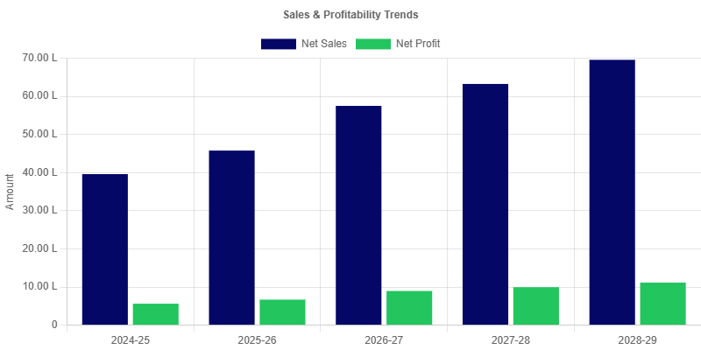 | Balance Sheet Strength  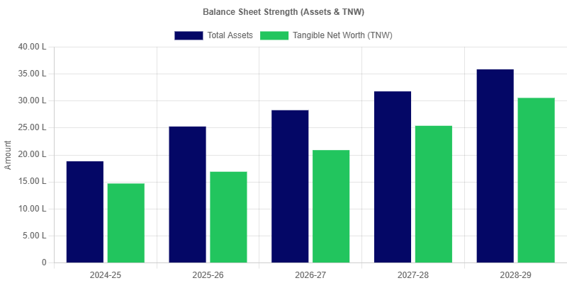
Liquidity Ratios  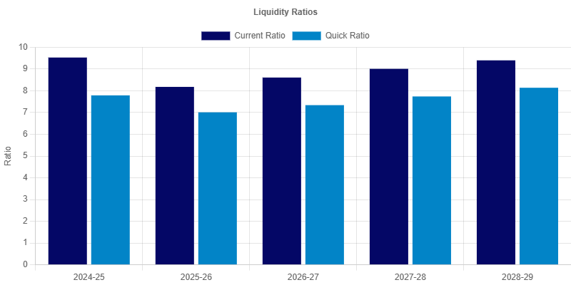 | Profitability Ratios  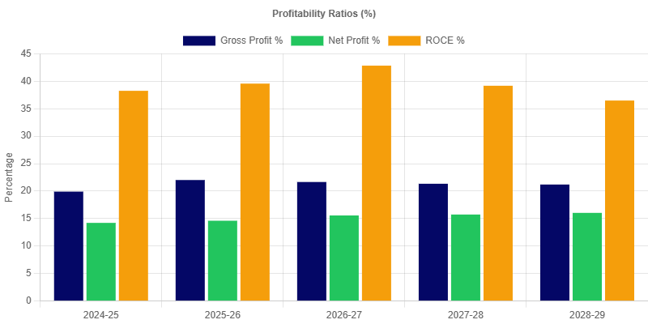
Leverage Ratios  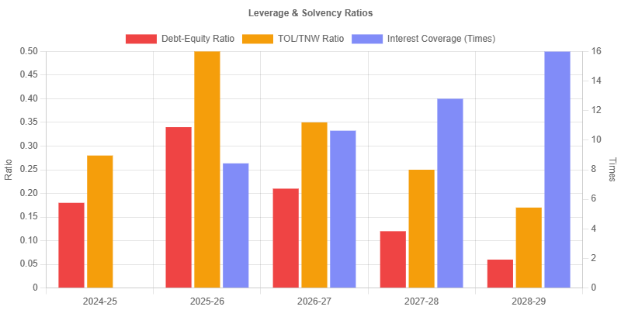 | Working Capital Turnover  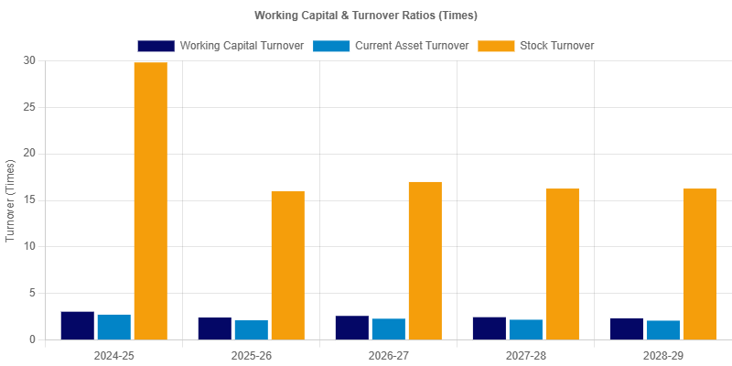
Solvency Ratios  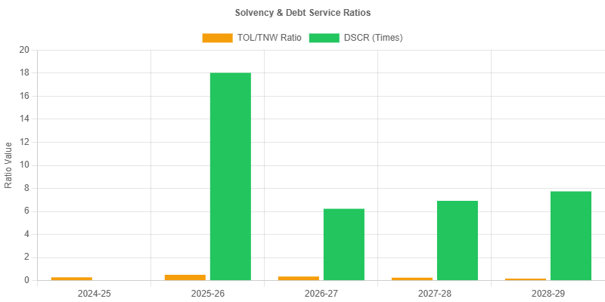 | Efficiency Ratios  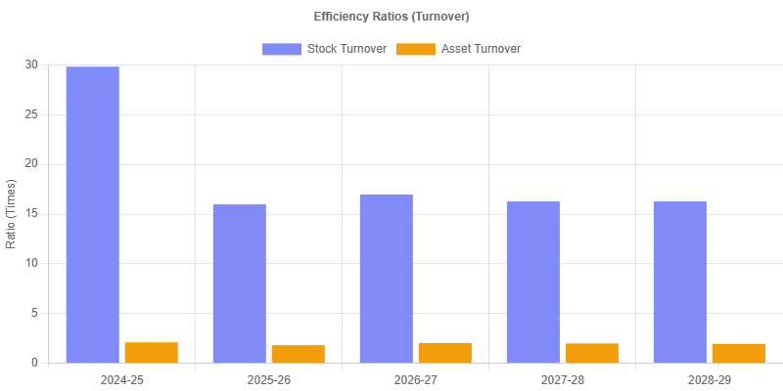

Turnover Method
Particulars | 2024-2025  (audited) | 2025-2026  (provisional) | 2026-2027  (estimated) | 2027-2028  (projected) | 2028-2029  (projected)
A. Turnover | 39,58,600.00 | 45,76,141.60 | 57,47,633.85 | 63,22,397.24 | 69,54,636.96
B. 25.00% of (A) | 9,89,650.00 | 11,44,035.40 | 14,36,908.46 | 15,80,599.31 | 17,38,659.24
C. Margin Required at 5.00% of (A) | 1,97,930.00 | 2,28,807.08 | 2,87,381.69 | 3,16,119.86 | 3,47,731.85
D. Margin (NWC) | 13,02,765.00 | 18,92,637.07 | 22,16,122.06 | 25,76,299.23 | 29,86,956.35
E. (B - C) | 7,91,720.00 | 9,15,228.32 | 11,49,526.77 | 12,64,479.45 | 13,90,927.39
F. (B - D) | -3,13,115.00 | -7,48,601.67 | -7,79,213.60 | -9,95,699.92 | -12,48,297.11
G. MPBF ( E or F whichever is lower) | -3,13,115.00 | -7,48,601.67 | -7,79,213.60 | -9,95,699.92 | -12,48,297.11
H. Excess borrowing | 0.00 | 0.00 | 0.00 | 0.00 | 0.00

MPBF
Particulars | 2024-2025  (audited) | 2025-2026  (provisional) | 2026-2027  (estimated) | 2027-2028  (projected) | 2028-2029  (projected)
FIRST METHOD OF LENDING
1. Total Current Assets | 14,55,455.00 | 21,56,286.91 | 25,07,362.21 | 28,98,028.49 | 33,42,379.34
2. Other Current Liabilities (Other than Bank Borrowing) | 1,52,690.00 | 2,63,649.84 | 2,91,240.15 | 3,21,729.26 | 3,55,422.99
3. Working Capital Gap | 13,02,765.00 | 18,92,637.07 | 22,16,122.06 | 25,76,299.23 | 29,86,956.35
4. Min stipulated Net working capital (25% of WCG excluding export receivables) | 3,25,691.25 | 4,73,159.27 | 5,54,030.52 | 6,44,074.81 | 7,46,739.09
5. Actual / Projected Net Working Capital | 13,02,765.00 | 18,92,637.07 | 22,16,122.06 | 25,76,299.23 | 29,86,956.35
6. Item 3 minus item 4 | 9,77,073.75 | 14,19,477.80 | 16,62,091.54 | 19,32,224.42 | 22,40,217.26
7. Item 3 minus item 5 | 0.00 | 0.00 | 0.00 | 0.00 | -0.00
8. Maximum Permissible Bank Finance (lower of 6 or 7) | 0.00 | 0.00 | 0.00 | 0.00 | -0.00
9. Excess Borrowing Representing shortfall in NWC | 0.00 | 0.00 | 0.00 | 0.00 | 0.00
SECOND METHOD OF LENDING
1. Total Current Assets | 14,55,455.00 | 21,56,286.91 | 25,07,362.21 | 28,98,028.49 | 33,42,379.34
2. Other Current Liabilities (Other than Bank Borrowing) | 1,52,690.00 | 2,63,649.84 | 2,91,240.15 | 3,21,729.26 | 3,55,422.99
3. Working Capital Gap | 13,02,765.00 | 18,92,637.07 | 22,16,122.06 | 25,76,299.23 | 29,86,956.35
4. Min stipulated Net working capital (25% of Total of Current Assets excluding export receivables) | 3,63,863.75 | 5,39,071.73 | 6,26,840.55 | 7,24,507.12 | 8,35,594.83
5. Actual / Projected Net Working Capital | 13,02,765.00 | 18,92,637.07 | 22,16,122.06 | 25,76,299.23 | 29,86,956.35
6. Item 3 minus item 4 | 9,38,901.25 | 13,53,565.34 | 15,89,281.51 | 18,51,792.11 | 21,51,361.51
7. Item 3 minus item 5 | 0.00 | 0.00 | 0.00 | 0.00 | -0.00
8. Maximum Permissible Bank Finance (lower of 6 or 7) | 0.00 | 0.00 | 0.00 | 0.00 | -0.00
9. Excess Borrowing Representing shortfall in NWC | 0.00 | 0.00 | 0.00 | 0.00 | 0.00

Fund Flow Statement
Particulars | 2025-2026  (provisional) | 2026-2027  (estimated) | 2027-2028  (projected) | 2028-2029  (projected)
1. SOURCES
(a) Net Profit | 6,68,564.28 | 8,95,048.61 | 9,95,427.06 | 11,15,318.01
(b) Depreciation | 56,577.15 | 48,837.49 | 42,184.08 | 36,461.47
(c) Increase in Capital | 2,18,564.28 | 4,00,048.61 | 4,50,927.06 | 5,16,368.01
(d) Increase in term liabilities, including public deposit | 3,14,730.64 | 0.00 | 0.00 | 0.00
(e) Decrease in Other Non Current Assets | 0.00 | 0.00 | 0.00 | 0.00
(f) Other (income tax w/o) | 0.00 | 0.00 | 0.00 | 0.00
(g) Share application refund | 0.00 | 0.00 | 0.00 | 0.00
(h) Total | 12,58,436.35 | 13,43,934.71 | 14,88,538.20 | 16,68,147.49
2. USE
(a) Purchase of Fixed Assets | 0.00 | 0.00 | 0.00 | 0.00
(b) Net loss | 0.00 | 0.00 | 0.00 | 0.00
(c) Decrease in capital | 0.00 | 0.00 | 0.00 | 0.00
(d) Decrease in term liabilities, including public deposits | 0.00 | 1,25,401.11 | 1,32,933.97 | 1,42,172.36
(e) Increase in Other non-current Assets | 0.00 | 0.00 | 0.00 | 0.00
(f) Dividend | 0.00 | 0.00 | 0.00 | 0.00
(g) Others (share application) | 0.00 | 0.00 | 0.00 | 0.00
(h) Decrease in general reserve (net Deferred tax) | 0.00 | 0.00 | 0.00 | 0.00
(i) Total | 0.00 | 1,25,401.11 | 1,32,933.97 | 1,42,172.36
3. LONG TERM SURPLUS/DEFICIT | 12,58,436.35 | 12,18,533.60 | 13,55,604.23 | 15,25,975.13
4. Increase / Decrease in Current Assets | 7,00,831.91 | 3,51,075.30 | 3,90,666.28 | 4,44,350.85
5. Increase / Decrease in Current Liabilities | 1,10,959.84 | 27,590.31 | 30,489.11 | 33,693.73
6. Increase / Decrease in Working Capital gap | 5,89,872.07 | 3,23,484.99 | 3,60,177.17 | 4,10,657.12
7. Net Surplus / Deficit | 6,68,564.28 | 8,95,048.61 | 9,95,427.06 | 11,15,318.01
8. Increase / Decrease in Bank Borrowings | 0.00 | 0.00 | 0.00 | 0.00
INCREASE / DECREASE IN NET SALES | 6,17,541.60 | 11,71,492.25 | 5,74,763.39 | 6,32,239.72
*Break-Up of (4)
(i) Increase / Decrease in Raw Material | 0.00 | 0.00 | 0.00 | 0.00
(ii) Increase / Decrease in Stock in Process | 0.00 | 0.00 | 0.00 | 0.00
(iii) Increase / Decrease in Finished Goods | 41,653.81 | 62,962.43 | 37,009.62 | 40,710.59
(iv) Increase / Decrease in receivables
(a) Domestic | 5,75,041.26 | 1,83,741.83 | 2,30,901.34 | 2,48,772.54
(b) Export | 0.00 | 0.00 | 0.00 | 0.00
(v) Increase / Decrease in consumables
(a) Imported | 0.00 | 0.00 | 0.00 | 0.00
(b) Indigenous | 0.00 | 0.00 | 0.00 | 0.00
(vi) Increase / Decrease in packing Material | 0.00 | 0.00 | 0.00 | 0.00
(vii) Increase / Decrease in other current assets | 7,00,831.91 | 3,51,075.30 | 3,90,666.28 | 4,44,350.85
Total | 13,17,526.98 | 5,97,779.56 | 6,58,577.24 | 7,33,833.98

Cash Flow
Particulars | 2024-2025  (audited) | 2025-2026  (provisional) | 2026-2027  (estimated) | 2027-2028  (projected) | 2028-2029  (projected)
A. Cash Flow from Operating Activities
Net Profit | 5,62,800.00 | 6,68,564.28 | 8,95,048.61 | 9,95,427.06 | 11,15,318.01
Adjustments for non-cash items: | 0.00 | 0.00 | 0.00 | 0.00 | 0.00
Add: Depreciation | 65,585.00 | 56,577.15 | 48,837.49 | 42,184.08 | 36,461.47
Changes in Working Capital: | 0.00 | 0.00 | 0.00 | 0.00 | 0.00
Change in Inventory | 0.00 | -41,653.81 | -62,962.43 | -37,009.62 | -40,710.59
Change in Receivables | 0.00 | -5,75,041.26 | -1,83,741.83 | -2,30,901.34 | -2,48,772.54
Change in Other Current Assets | 0.00 | 0.00 | 0.00 | 0.00 | 0.00
Change in Creditors | 0.00 | 23,819.64 | 17,650.96 | 19,416.06 | 21,357.67
Change in Short-Term Borrowings | 0.00 | 0.00 | 0.00 | 0.00 | 0.00
Net Cash from Operating Activities (A) | 6,28,385.00 | 1,32,266.00 | 7,14,832.80 | 7,89,116.24 | 8,83,654.02
B. Cash Flow from Investing Activities
Purchase of Fixed Assets | 0.00 | 0.00 | 0.00 | 0.00 | 0.00
Net Cash from Investing Activities (B) | 0.00 | 0.00 | 0.00 | 0.00 | 0.00
C. Cash Flow from Financing Activities
Change in WC Bank Borrowing | 0.00 | 0.00 | 0.00 | 0.00 | 0.00
Change in Term Loan / Other Term Liabilities | 0.00 | 4,01,870.84 | -1,15,461.76 | -1,21,860.92 | -1,29,836.30
Drawings | -3,50,000.00 | -4,50,000.00 | -4,95,000.00 | -5,44,500.00 | -5,98,950.00
Net Cash from Financing Activities (C) | -3,50,000.00 | -48,129.16 | -6,10,461.76 | -6,66,360.92 | -7,28,786.30
Net Increase in Cash & Bank (A+B+C) | 2,78,385.00 | 84,136.84 | 1,04,371.04 | 1,22,755.32 | 1,54,867.72
Add: Opening Cash & Bank Balance | 0.00 | 2,65,890.00 | 3,07,368.84 | 3,64,816.08 | 4,35,955.22
Closing Cash & Bank Balance | 2,65,890.00 | 3,07,368.84 | 3,64,816.08 | 4,35,955.22 | 5,34,045.14
Balance Check (Discrepancy) | 12,495.00 | 42,658.00 | 46,923.80 | 51,616.18 | 56,777.80

DSCR Analysis
Particulars | 2024-2025  (audited) | 2025-2026  (provisional) | 2026-2027  (estimated) | 2027-2028  (projected) | 2028-2029  (projected)
A. CASH ACCRUALS (Source)
Net Profit After Tax | 5,62,800.00 | 6,68,564.00 | 8,95,049.00 | 9,95,427.00 | 11,15,318.00
Add: Depreciation | 65,585.00 | 56,577.00 | 48,837.00 | 42,184.00 | 36,461.00
Add: Interest on Long Term Loans | 0.00 | 42,577.00 | 42,866.00 | 32,927.00 | 21,854.00
Total (A) | 6,28,385.00 | 7,67,718.00 | 9,86,752.00 | 10,70,538.00 | 11,73,633.00
B. DEBT OBLIGATIONS (Uses)
Interest on Long Term Loans | 0.00 | 42,577.00 | 42,866.00 | 32,927.00 | 21,854.00
Repayment of Long Term Loans | 0.00 | 0.00 | 87,140.00 | 97,080.00 | 1,08,153.00
Total (B) | 0.00 | 42,577.00 | 1,30,006.00 | 1,30,006.00 | 1,30,006.00
DSCR (A / B) | 0.00 | 18.03 | 7.59 | 8.23 | 9.03
Average DSCR |  |  |  |  | 10.72

Breakeven Analysis
Particulars | 2024-2025  (audited) | 2025-2026  (provisional) | 2026-2027  (estimated) | 2027-2028  (projected) | 2028-2029  (projected)
1. Net Sales | 39,58,600.00 | 45,76,141.60 | 57,47,633.85 | 63,22,397.24 | 69,54,636.96
2. Variable Costs
(i) Raw Materials | 0.00 | 0.00 | 0.00 | 0.00 | 0.00
(ii) Other Consumables & Packing | 28,20,095.00 | 35,44,577.41 | 44,86,726.09 | 49,15,657.10 | 54,07,222.81
(iii) Power and Fuel | 0.00 | 0.00 | 0.00 | 0.00 | 0.00
(iv) Direct Labour | 0.00 | 0.00 | 0.00 | 0.00 | 0.00
(v) Variable Mfg & Selling Expenses | 28,410.00 | 32,841.96 | 39,410.35 | 47,292.42 | 56,750.90
Total Variable Costs | 28,48,505.00 | 35,77,419.37 | 45,26,136.44 | 49,62,949.52 | 54,63,973.71
3. Contribution (1 - 2) | 11,10,095.00 | 9,98,722.23 | 12,21,497.41 | 13,59,447.72 | 14,90,663.25
4. Fixed Costs
(i) Admin & Fixed Selling Exp | 1,88,230.00 | 2,17,657.81 | 2,42,707.79 | 2,70,919.60 | 3,02,740.80
(ii) Depreciation | 65,585.00 | 56,577.15 | 48,837.49 | 42,184.08 | 36,461.47
Total Fixed Costs | 2,53,815.00 | 2,74,234.96 | 2,91,545.28 | 3,13,103.68 | 3,39,202.28
5. Breakeven Point (Sales Value) | 9,05,104.57 | 12,56,543.58 | 13,71,837.15 | 14,56,154.45 | 15,82,536.29
6. Breakeven % (on Net Sales) | 22.86 | 27.46 | 23.87 | 23.03 | 22.76

Sensitivity Analysis
Particulars | 2024-2025  (audited) | 2025-2026  (provisional) | 2026-2027  (estimated) | 2027-2028  (projected) | 2028-2029  (projected)
1. BASE CASE (PROJECTIONS)
Net Sales | 39,58,600.00 | 45,76,141.60 | 57,47,633.85 | 63,22,397.24 | 69,54,636.96
Net Profit After Tax | 5,62,800.00 | 6,68,564.28 | 8,95,048.61 | 9,95,427.06 | 11,15,318.01
DSCR | 0.00 | 18.03 | 7.59 | 8.23 | 9.03
2. SALES DECREASE BY 10%
Revised Net Sales | 35,62,740.00 | 41,18,527.44 | 51,72,870.46 | 56,90,157.52 | 62,59,173.26
Revised Net Profit | 4,48,949.50 | 5,65,407.86 | 7,68,957.83 | 8,54,753.05 | 9,60,576.59
Revised DSCR | 0.00 | 15.61 | 6.62 | 7.15 | 7.84
3. RAW MATERIAL/CONSUMABLE COST INCREASE BY 10%
Net Sales (Unchanged) | 39,58,600.00 | 45,76,141.60 | 57,47,633.85 | 63,22,397.24 | 69,54,636.96
Revised Net Profit | 5,62,800.00 | 6,68,564.28 | 8,95,048.61 | 9,95,427.06 | 11,15,318.01
Revised DSCR | 0.00 | 18.03 | 7.59 | 8.23 | 9.03
4. INTEREST RATE INCREASE BY 2%
Net Sales (Unchanged) | 39,58,600.00 | 45,76,141.60 | 57,47,633.85 | 63,22,397.24 | 69,54,636.96
Revised Net Profit | 5,62,800.00 | 6,51,595.67 | 8,78,029.72 | 9,80,136.62 | 11,01,953.18
Revised DSCR | 0.00 | 15.17 | 7.11 | 7.82 | 8.70

EMI Repayment Schedule
Month | Payment Date | Opening Bal. | EMI | Principal | Interest | Closing Bal.
1 | 01 Jun 2025 | 5,00,000.00 | 10,833.85 | 6,313.01 | 4,520.83 | 4,93,686.99
2 | 01 Jul 2025 | 4,93,686.99 | 10,833.85 | 6,370.09 | 4,463.75 | 4,87,316.89
3 | 01 Aug 2025 | 4,87,316.89 | 10,833.85 | 6,427.69 | 4,406.16 | 4,80,889.21
4 | 01 Sept 2025 | 4,80,889.21 | 10,833.85 | 6,485.81 | 4,348.04 | 4,74,403.40
5 | 01 Oct 2025 | 4,74,403.40 | 10,833.85 | 6,544.45 | 4,289.40 | 4,67,858.95
6 | 01 Nov 2025 | 4,67,858.95 | 10,833.85 | 6,603.62 | 4,230.22 | 4,61,255.33
7 | 01 Dec 2025 | 4,61,255.33 | 10,833.85 | 6,663.33 | 4,170.52 | 4,54,592.00
8 | 01 Jan 2026 | 4,54,592.00 | 10,833.85 | 6,723.58 | 4,110.27 | 4,47,868.43
9 | 01 Feb 2026 | 4,47,868.43 | 10,833.85 | 6,784.37 | 4,049.48 | 4,41,084.06
10 | 01 Mar 2026 | 4,41,084.06 | 10,833.85 | 6,845.71 | 3,988.14 | 4,34,238.35
11 | 01 Apr 2026 | 4,34,238.35 | 10,833.85 | 6,907.61 | 3,926.24 | 4,27,330.74
12 | 01 May 2026 | 4,27,330.74 | 10,833.85 | 6,970.06 | 3,863.78 | 4,20,360.67
13 | 01 Jun 2026 | 4,20,360.67 | 10,833.85 | 7,033.08 | 3,800.76 | 4,13,327.59
14 | 01 Jul 2026 | 4,13,327.59 | 10,833.85 | 7,096.68 | 3,737.17 | 4,06,230.91
15 | 01 Aug 2026 | 4,06,230.91 | 10,833.85 | 7,160.84 | 3,673.00 | 3,99,070.07
16 | 01 Sept 2026 | 3,99,070.07 | 10,833.85 | 7,225.59 | 3,608.26 | 3,91,844.49
17 | 01 Oct 2026 | 3,91,844.49 | 10,833.85 | 7,290.92 | 3,542.93 | 3,84,553.57
18 | 01 Nov 2026 | 3,84,553.57 | 10,833.85 | 7,356.84 | 3,477.01 | 3,77,196.73
19 | 01 Dec 2026 | 3,77,196.73 | 10,833.85 | 7,423.36 | 3,410.49 | 3,69,773.37
20 | 01 Jan 2027 | 3,69,773.37 | 10,833.85 | 7,490.48 | 3,343.37 | 3,62,282.89
21 | 01 Feb 2027 | 3,62,282.89 | 10,833.85 | 7,558.20 | 3,275.64 | 3,54,724.69
22 | 01 Mar 2027 | 3,54,724.69 | 10,833.85 | 7,626.54 | 3,207.30 | 3,47,098.14
23 | 01 Apr 2027 | 3,47,098.14 | 10,833.85 | 7,695.50 | 3,138.35 | 3,39,402.64
24 | 01 May 2027 | 3,39,402.64 | 10,833.85 | 7,765.08 | 3,068.77 | 3,31,637.56
25 | 01 Jun 2027 | 3,31,637.56 | 10,833.85 | 7,835.29 | 2,998.56 | 3,23,802.27
26 | 01 Jul 2027 | 3,23,802.27 | 10,833.85 | 7,906.13 | 2,927.71 | 3,15,896.14
27 | 01 Aug 2027 | 3,15,896.14 | 10,833.85 | 7,977.62 | 2,856.23 | 3,07,918.52
28 | 01 Sept 2027 | 3,07,918.52 | 10,833.85 | 8,049.75 | 2,784.10 | 2,99,868.77
29 | 01 Oct 2027 | 2,99,868.77 | 10,833.85 | 8,122.53 | 2,711.31 | 2,91,746.24
30 | 01 Nov 2027 | 2,91,746.24 | 10,833.85 | 8,195.97 | 2,637.87 | 2,83,550.27
31 | 01 Dec 2027 | 2,83,550.27 | 10,833.85 | 8,270.08 | 2,563.77 | 2,75,280.19
32 | 01 Jan 2028 | 2,75,280.19 | 10,833.85 | 8,344.85 | 2,488.99 | 2,66,935.33
33 | 01 Feb 2028 | 2,66,935.33 | 10,833.85 | 8,420.31 | 2,413.54 | 2,58,515.03
34 | 01 Mar 2028 | 2,58,515.03 | 10,833.85 | 8,496.44 | 2,337.41 | 2,50,018.59
35 | 01 Apr 2028 | 2,50,018.59 | 10,833.85 | 8,573.26 | 2,260.58 | 2,41,445.33
36 | 01 May 2028 | 2,41,445.33 | 10,833.85 | 8,650.78 | 2,183.07 | 2,32,794.55
37 | 01 Jun 2028 | 2,32,794.55 | 10,833.85 | 8,729.00 | 2,104.85 | 2,24,065.55
38 | 01 Jul 2028 | 2,24,065.55 | 10,833.85 | 8,807.92 | 2,025.93 | 2,15,257.63
39 | 01 Aug 2028 | 2,15,257.63 | 10,833.85 | 8,887.56 | 1,946.29 | 2,06,370.08
40 | 01 Sept 2028 | 2,06,370.08 | 10,833.85 | 8,967.92 | 1,865.93 | 1,97,402.16
41 | 01 Oct 2028 | 1,97,402.16 | 10,833.85 | 9,049.00 | 1,784.84 | 1,88,353.16
42 | 01 Nov 2028 | 1,88,353.16 | 10,833.85 | 9,130.82 | 1,703.03 | 1,79,222.34
43 | 01 Dec 2028 | 1,79,222.34 | 10,833.85 | 9,213.38 | 1,620.47 | 1,70,008.96
44 | 01 Jan 2029 | 1,70,008.96 | 10,833.85 | 9,296.68 | 1,537.16 | 1,60,712.28
45 | 01 Feb 2029 | 1,60,712.28 | 10,833.85 | 9,380.74 | 1,453.11 | 1,51,331.54
46 | 01 Mar 2029 | 1,51,331.54 | 10,833.85 | 9,465.56 | 1,368.29 | 1,41,865.99
47 | 01 Apr 2029 | 1,41,865.99 | 10,833.85 | 9,551.14 | 1,282.70 | 1,32,314.85
48 | 01 May 2029 | 1,32,314.85 | 10,833.85 | 9,637.50 | 1,196.35 | 1,22,677.35
49 | 01 Jun 2029 | 1,22,677.35 | 10,833.85 | 9,724.64 | 1,109.21 | 1,12,952.71
50 | 01 Jul 2029 | 1,12,952.71 | 10,833.85 | 9,812.57 | 1,021.28 | 1,03,140.14
51 | 01 Aug 2029 | 1,03,140.14 | 10,833.85 | 9,901.29 | 932.56 | 93,238.86
52 | 01 Sept 2029 | 93,238.86 | 10,833.85 | 9,990.81 | 843.03 | 83,248.05
53 | 01 Oct 2029 | 83,248.05 | 10,833.85 | 10,081.14 | 752.70 | 73,166.90
54 | 01 Nov 2029 | 73,166.90 | 10,833.85 | 10,172.30 | 661.55 | 62,994.61
55 | 01 Dec 2029 | 62,994.61 | 10,833.85 | 10,264.27 | 569.58 | 52,730.34
56 | 01 Jan 2030 | 52,730.34 | 10,833.85 | 10,357.08 | 476.77 | 42,373.26
57 | 01 Feb 2030 | 42,373.26 | 10,833.85 | 10,450.72 | 383.12 | 31,922.54
58 | 01 Mar 2030 | 31,922.54 | 10,833.85 | 10,545.21 | 288.63 | 21,377.33
59 | 01 Apr 2030 | 21,377.33 | 10,833.85 | 10,640.56 | 193.29 | 10,736.77
60 | 01 May 2030 | 10,736.77 | 10,833.85 | 10,736.77 | 97.08 | 0.00

