
Credit Monitoring Analysis (C M A)
Of
FINXORA PACKAGING PRIVATE LIMITED
GST No.: 23AAACF0000A1Z5
UDYAM No.: UDYAM-MP-00-0000000
For Term Loan of 68,40,000.00 /- and CC of 19,80,000.00 /-

INDEX

COMPANY PROFILE
I. Company Information
Name of the Company/Firm | FINXORA PACKAGING PRIVATE LIMITED
Director 1 | Aarav Mehta (Male, General)
Director 2 | Neha Kapoor (Female, General)
Constitution | private_limited
Address | Plot 12, Industrial Area, Indore, Madhya Pradesh 452001
PAN No. | AAACF0000A
Date of Incorporation/Birth | 01-Apr-2020
Industry | Corrugated box manufacturing
Type of Business | manufacturing
Father/Spouse/Guardian Name | Dev Mehta
Marital Status | Married
Educational Qualification | Graduate with sector training
Profession/Occupation | Corrugated box manufacturing
Contact Number | 0000000000
Email | sample@finxora.com
Aadhaar No. | 0000 0000 0000
Business description | Corrugated box manufacturing serving institutional and retail customers in Indore and neighbouring districts of Madhya Pradesh. Operations combine documented customer orders, supplier evaluation, quality checks and regular collection follow-up. Management reviews stock, receivables and cash flow monthly to maintain service standards and timely debt repayment.
Incorporation / establishment | 01-Apr-2020
Bank and branch | XYZ Bank Ltd., Indore Main Branch
Proposed facilities | Cash credit Rs. 19.8 lakh and term loan Rs. 68.4 lakh
Ownership / management | Aarav Mehta: 50% (director); Neha Kapoor: 50% (director)
Market and operations | Diversified local customers; documented orders; monthly stock and debtor review.

II. Project & Financial Overview
Report Period | 2024 - 2028
Currency | INR
Amount In | Actual
Total Project Cost | INR 1,99,80,000.00
Term Loan Bank | XYZ Bank Ltd.
Term Loan | INR 68,40,000.00
Term Loan Interest Rate (%) | 9.5%
Term Loan Installment (monthly) | INR 1,43,652.73
Repayment Frequency | Monthly
WC (CC/OD) Bank | XYZ Bank Ltd.
Working Capital Loan | INR 19,80,000.00
WC Loan Interest Rate (%) | 10%
Own Contribution | INR 1,11,60,000.00

Introduction
FINXORA PACKAGING PRIVATE LIMITED operates a corrugated box manufacturing business in Indore, Madhya Pradesh. The proposal covers renewal of cash credit and continued servicing of asset finance, supported by the historical, provisional and projected periods identified in the schedules. The company manufactures three-ply and five-ply corrugated boxes, printed cartons and protective inserts. Orders are specified by board strength, dimensions and print requirements; pricing is based on paper consumption, conversion costs and the agreed delivery schedule. Repeat institutional orders provide the core revenue stream, with smaller customised orders filling available machine time.
Local manufacturing activity and demand for transport-ready packaging support repeat orders. Short delivery distances allow smaller replenishment batches and faster response to specification changes. Management will prioritise repeat customers with reliable payment behaviour rather than accept low-margin volume that consumes disproportionate working capital.
The funding schedule provides a total outlay of Rs. 199.80 lakh, promoter contribution of Rs. 111.60 lakh, term finance of Rs. 68.40 lakh and cash credit of Rs. 19.80 lakh. The term facility is modelled at 9.5% over five years; working-capital interest is modelled at 10%. Security documentation and final repayment terms remain subject to the bank's appraisal and sanction. For the first reporting year, FY 2024-25, the computed schedules show sales of Rs. 360.00 lakh and net profit of Rs. 38.17 lakh. The first-year current ratio is 1.91 times and the arithmetic average of the annual DSCR values in the repayment schedule is 4.24 times. Final-year sales are Rs. 489.78 lakh with net profit of Rs. 68.76 lakh; these highlights reproduce the report's calculations rather than a separate earnings estimate.

Management and Expertise
Aarav Mehta brings twelve years of experience in corrugated packaging procurement and production planning. Neha Kapoor oversees accounts, costing and customer collections, drawing on eight years of commercial administration. The directors divide responsibility between shop-floor delivery and financial control, with major capital purchases requiring joint approval.
The staffing plan provides for twenty-two production and handling employees and six staff in supervision, sales and administration. A production supervisor coordinates preventive maintenance and safety training. Supplier arrangements for kraft paper are spread across more than one mill or distributor to reduce interruption risk; reorder levels are reviewed alongside bank drawing power. Responsibilities should be supported by written authority limits for purchases, customer credit and payments. Bank reconciliations and statutory compliance are to be reviewed monthly, and changes in key personnel should be accompanied by a documented handover.
Incoming kraft paper is checked for grade, moisture and visible damage. Finished cartons are inspected for dimensions, compression strength, print alignment and joint integrity before dispatch. Rejected output is recorded and scrap is sold through documented invoices; recurring defects trigger a review of machine settings and operator training. The reporting plan calls for consistent accounting policies, periodic physical verification and management review of exceptions. Forecast growth is an operating target and should be measured against demonstrated execution rather than treated as an assured result.

Operational Plan
The unit at Plot 12, Industrial Area, Indore uses corrugation, slotting, printing and stitching equipment with provision for adhesive finishing. The operating plan is based on one regular production shift, with overtime used only against confirmed orders. Paper storage is segregated from finished cartons, and daily production sheets record input weight, usable output, rejects and dispatches.
The staffing plan provides for twenty-two production and handling employees and six staff in supervision, sales and administration. A production supervisor coordinates preventive maintenance and safety training. Supplier arrangements for kraft paper are spread across more than one mill or distributor to reduce interruption risk; reorder levels are reviewed alongside bank drawing power.
The company manufactures three-ply and five-ply corrugated boxes, printed cartons and protective inserts. Orders are specified by board strength, dimensions and print requirements; pricing is based on paper consumption, conversion costs and the agreed delivery schedule. Repeat institutional orders provide the core revenue stream, with smaller customised orders filling available machine time. Monthly management review should compare orders, realised prices, direct costs and collections with the financial schedules. Stock and debtor statements must reconcile with the books before submission to the bank. Any adverse movement in margin or overdue accounts should lead to a revised cash-flow forecast and corrective action before additional credit commitments are accepted.

Market Analysis and Opportunity
Target customers include food processors, pharmaceutical distributors, engineering suppliers and consumer-goods manufacturers in the Indore industrial belt. The sales plan avoids dependence on a single buyer by maintaining separate customer groups and setting account-wise credit limits. Dispatch is supported by purchase orders and signed delivery records, while disputed invoices are reviewed separately from routine collections.
Local manufacturing activity and demand for transport-ready packaging support repeat orders. Short delivery distances allow smaller replenishment batches and faster response to specification changes. Management will prioritise repeat customers with reliable payment behaviour rather than accept low-margin volume that consumes disproportionate working capital.
The forecast assumes disciplined expansion of existing product and service lines, supported by the annual growth and collection assumptions in the schedules. Local competition, customer bargaining power and input-cost changes require regular review of quotations. Before expanding into another territory or customer group, management should compare incremental gross contribution with delivery, staffing and credit costs and retain only business that supports the repayment plan.

Quality Assurance and Control
Incoming kraft paper is checked for grade, moisture and visible damage. Finished cartons are inspected for dimensions, compression strength, print alignment and joint integrity before dispatch. Rejected output is recorded and scrap is sold through documented invoices; recurring defects trigger a review of machine settings and operator training.
The unit at Plot 12, Industrial Area, Indore uses corrugation, slotting, printing and stitching equipment with provision for adhesive finishing. The operating plan is based on one regular production shift, with overtime used only against confirmed orders. Paper storage is segregated from finished cartons, and daily production sheets record input weight, usable output, rejects and dispatches. Operating records should link purchases or inputs to completed output and customer billing, allowing exceptions to be traced promptly. Responsibility for acceptance checks, stock custody and payment approval should be separated wherever staffing permits.
Management should retain supplier documents, maintenance records, customer complaints and corrective-action logs. Quality controls are intended to prevent avoidable returns and interruption as well as meet customer specifications. Periodic review of losses, rework and complaints should feed into costing and training; certifications or approvals should be claimed only after the applicable requirements have been met.

Risk Assessment and Mitigation
Kraft-paper price volatility and delayed institutional collections are the principal risks. Short quotation validity, paper-grade alternatives agreed with customers and periodic price revision protect contribution margins. Customer concentration is controlled through exposure limits; fire precautions, insurance and preventive maintenance address stock and production interruption risks.
Local manufacturing activity and demand for transport-ready packaging support repeat orders. Short delivery distances allow smaller replenishment batches and faster response to specification changes. Management will prioritise repeat customers with reliable payment behaviour rather than accept low-margin volume that consumes disproportionate working capital. These strengths are balanced by the need to manage utilisation, cost discipline and collection performance. The projection should be stress-tested for lower sales, higher input prices and a longer collection cycle, with repayment reviewed against the resulting cash accruals rather than solely against the base-case margin.
Repayment capacity is assessed from operating cash accruals after the scheduled interest charge and with principal obligations considered in the debt-service schedule. Accounting profit alone does not establish available bank cash: inventory growth, receivable delays and capital expenditure can absorb accruals. Management should maintain a rolling cash forecast and reserve funds for instalments before discretionary expenditure or distributions. Insurance, supplier continuity arrangements and timely statutory renewals should be reviewed annually. The bank should receive prompt explanations for material deviations from the sanctioned operating assumptions.

Financial Analysis
For the first reporting year, FY 2024-25, the computed schedules show sales of Rs. 360.00 lakh and net profit of Rs. 38.17 lakh. The first-year current ratio is 1.91 times and the arithmetic average of the annual DSCR values in the repayment schedule is 4.24 times. Final-year sales are Rs. 489.78 lakh with net profit of Rs. 68.76 lakh; these highlights reproduce the report's calculations rather than a separate earnings estimate.
The funding schedule provides a total outlay of Rs. 199.80 lakh, promoter contribution of Rs. 111.60 lakh, term finance of Rs. 68.40 lakh and cash credit of Rs. 19.80 lakh. The term facility is modelled at 9.5% over five years; working-capital interest is modelled at 10%. Security documentation and final repayment terms remain subject to the bank's appraisal and sanction.
Repayment capacity is assessed from operating cash accruals after the scheduled interest charge and with principal obligations considered in the debt-service schedule. Accounting profit alone does not establish available bank cash: inventory growth, receivable delays and capital expenditure can absorb accruals. Management should maintain a rolling cash forecast and reserve funds for instalments before discretionary expenditure or distributions. Monthly management review should compare orders, realised prices, direct costs and collections with the financial schedules. Stock and debtor statements must reconcile with the books before submission to the bank. Any adverse movement in margin or overdue accounts should lead to a revised cash-flow forecast and corrective action before additional credit commitments are accepted.

Conclusion and Recommendations
FINXORA PACKAGING PRIVATE LIMITED's proposal connects corrugated box manufacturing activity with an identified operating plan, a defined promoter contribution and scheduled bank finance. Local manufacturing activity and demand for transport-ready packaging support repeat orders. Short delivery distances allow smaller replenishment batches and faster response to specification changes. Management will prioritise repeat customers with reliable payment behaviour rather than accept low-margin volume that consumes disproportionate working capital. The computed liquidity and debt-service indicators support consideration of the proposal under the stated assumptions; they should be read with the detailed operating, balance-sheet and repayment schedules.
Kraft-paper price volatility and delayed institutional collections are the principal risks. Short quotation validity, paper-grade alternatives agreed with customers and periodic price revision protect contribution margins. Customer concentration is controlled through exposure limits; fire precautions, insurance and preventive maintenance address stock and production interruption risks. Prior to sanction or renewal, the bank should examine promoter contribution, premises arrangements, equipment quotations, customer demand, statutory permissions and the proposed security. Disbursement should follow documented end use and completion of the agreed conditions.
Management should provide periodic stock, debtor and operating statements and discuss material deviations with the lender. Expansion should remain within demonstrated operational capacity and available working capital. This assessment is conditional on execution of the operating plan and timely collections; it does not constitute a guarantee of sanction, future profit or uninterrupted debt service.
This is a sample report prepared with Finxora; the business and its figures are illustrative.

Operating Statement
Particulars | 2024-2025  (actual) | 2025-2026  (provisional) | 2026-2027  (projected) | 2027-2028  (projected) | 2028-2029  (projected)
1. Gross Sales
Manufactured product sales | 3,60,00,000.00 | 3,88,80,000.00 | 4,19,90,400.00 | 4,53,49,632.00 | 4,89,77,602.56
(ii) Export Sales | 0.00 | 0.00 | 0.00 | 0.00 | 0.00
(iii) Add other revenue income | 0.00 | 0.00 | 0.00 | 0.00 | 0.00
Total | 3,60,00,000.00 | 3,88,80,000.00 | 4,19,90,400.00 | 4,53,49,632.00 | 4,89,77,602.56
2. Less excise duty | 0.00 | 0.00 | 0.00 | 0.00 | 0.00
Deduct other items | 0.00 | 0.00 | 0.00 | 0.00 | 0.00
3. Net Sales (item 1 - item 2) | 3,60,00,000.00 | 3,88,80,000.00 | 4,19,90,400.00 | 4,53,49,632.00 | 4,89,77,602.56
4. % age rise (+) or fall (-) in net sales | 0.00 | 8.00 | 8.00 | 8.00 | 8.00
5. Cost of Sales
(i) Raw Material | 2,32,52,054.79 | 2,16,60,164.38 | 2,33,92,977.53 | 2,52,64,415.74 | 2,72,85,569.00
(a) Imported | 0.00 | 0.00 | 0.00 | 0.00 | 0.00
Raw material purchases | 2,32,52,054.79 | 2,16,60,164.38 | 2,33,92,977.53 | 2,52,64,415.74 | 2,72,85,569.00
(ii) Other Consumables | 0.00 | 0.00 | 0.00 | 0.00 | 0.00
(a) Imported | 0.00 | 0.00 | 0.00 | 0.00 | 0.00
(b) Indigenous | 0.00 | 0.00 | 0.00 | 0.00 | 0.00
(iii) Direct Expenses | 0.00 | 0.00 | 0.00 | 0.00 | 0.00
(a) Imported | 0.00 | 0.00 | 0.00 | 0.00 | 0.00
(b) Indigenous | 0.00 | 0.00 | 0.00 | 0.00 | 0.00
(iv) Power and Fuel | 10,80,000.00 | 11,66,400.00 | 12,59,712.00 | 13,60,488.96 | 14,69,328.08
Production wages | 28,80,000.00 | 31,10,400.00 | 33,59,232.00 | 36,27,970.56 | 39,18,208.20
Factory overheads | 7,20,000.00 | 7,77,600.00 | 8,39,808.00 | 9,06,992.64 | 9,79,552.05
(vii) Depreciation | 21,60,000.00 | 18,63,000.00 | 16,07,850.00 | 13,88,542.51 | 11,99,944.12
(viii) Sub Total (i to vii) | 3,00,92,054.79 | 2,85,77,564.38 | 3,04,59,579.53 | 3,25,48,410.41 | 3,48,52,601.45
(ix) Add: Opening stocks-in-Process | 0.00 | 0.00 | 0.00 | 0.00 | 0.00
(x) Deduct: Closing stocks-in-Process | 0.00 | 0.00 | 0.00 | 0.00 | 0.00
(xi) Cost of Production | 3,00,92,054.79 | 2,85,77,564.38 | 3,04,59,579.53 | 3,25,48,410.41 | 3,48,52,601.45
(xii) Add : Opening Stock of Finished Goods | 0.00 | 34,52,054.79 | 37,28,219.18 | 40,26,476.71 | 43,48,594.85
(xiii) Deduct: Closing stocks of Finished Goods | 34,52,054.79 | 37,28,219.18 | 40,26,476.71 | 43,48,594.85 | 46,96,482.44
Sub-Total (Total Cost of Sales) | 2,66,40,000.00 | 2,83,01,399.99 | 3,01,61,322.00 | 3,22,26,292.27 | 3,45,04,713.86
6. Selling, general and administrative exp.
Salaries & Wages | 10,80,000.00 | 11,66,400.00 | 12,59,712.00 | 13,60,488.96 | 14,69,328.08
Rent | 4,32,000.00 | 4,66,560.00 | 5,03,884.80 | 5,44,195.58 | 5,87,731.23
Advertising & Marketing | 3,60,000.00 | 3,88,800.00 | 4,19,904.00 | 4,53,496.32 | 4,89,776.03
Freight & Transportation | 3,60,000.00 | 3,88,800.00 | 4,19,904.00 | 4,53,496.32 | 4,89,776.03
Electricity & Utilities | 2,88,000.00 | 3,11,040.00 | 3,35,923.20 | 3,62,797.06 | 3,91,820.82
Travel & Conveyance | 2,16,000.00 | 2,33,280.00 | 2,51,942.40 | 2,72,097.79 | 2,93,865.62
Repairs & Maintenance | 2,16,000.00 | 2,33,280.00 | 2,51,942.40 | 2,72,097.79 | 2,93,865.62
Insurance | 1,44,000.00 | 1,55,520.00 | 1,67,961.60 | 1,81,398.53 | 1,95,910.41
Professional & Legal Fees | 1,44,000.00 | 1,55,520.00 | 1,67,961.60 | 1,81,398.53 | 1,95,910.41
Communication (Phone, Internet) | 1,08,000.00 | 1,16,640.00 | 1,25,971.20 | 1,36,048.90 | 1,46,932.81
Office Supplies & Stationery | 1,08,000.00 | 1,16,640.00 | 1,25,971.20 | 1,36,048.90 | 1,46,932.81
Bank Charges | 72,000.00 | 77,760.00 | 83,980.80 | 90,699.26 | 97,955.21
Other Selling Expenses | 72,000.00 | 77,760.00 | 83,980.80 | 90,699.26 | 97,955.21
Total Selling, general and administrative exp. | 36,00,000.00 | 38,88,000.00 | 41,99,040.00 | 45,34,963.20 | 48,97,760.29
7. Sub Total (5+6)(Total Cost of Sales) | 3,02,40,000.00 | 3,21,89,399.99 | 3,43,60,362.00 | 3,67,61,255.47 | 3,94,02,474.15
8. Operating Profit before Interest (3-7) | 57,60,000.00 | 66,90,600.01 | 76,30,038.00 | 85,88,376.53 | 95,75,128.41
9. Interest on WC | 0.00 | 0.00 | 1,98,000.00 | 1,98,000.00 | 1,98,000.00
Interest on TL | 6,01,778.48 | 4,90,417.30 | 3,68,003.79 | 2,33,441.04 | 85,523.26
10. Operating profit after interest (8-9) | 51,58,221.52 | 62,00,182.71 | 70,64,034.21 | 81,56,935.49 | 92,91,605.15
11. (i) Add other non-operating income
(a) Other Income | 0.00 | 0.00 | 0.00 | 0.00 | 0.00
(b)
(c)
(d)
I - Sub Total (Income) | 0.00 | 0.00 | 0.00 | 0.00 | 0.00
(ii) Deduct other non-operation expenses
(a) | 0.00 | 0.00 | 0.00 | 0.00 | 0.00
(b)
(c)
(d)
II - Sub Total (expenses) | 0.00 | 0.00 | 0.00 | 0.00 | 0.00
III - Net of other non-operation income/exp. (I - II) | 0.00 | 0.00 | 0.00 | 0.00 | 0.00
12. Profit before tax [10+11(iii)] | 51,58,221.52 | 62,00,182.71 | 70,64,034.21 | 81,56,935.49 | 92,91,605.15
13. Provision for taxes | 13,41,137.60 | 16,12,047.50 | 18,36,648.89 | 21,20,803.23 | 24,15,817.34
Deferred | 0.00 | 0.00 | 0.00 | 0.00 | 0.00
14. Net Profit/loss (12-13) | 38,17,083.92 | 45,88,135.21 | 52,27,385.32 | 60,36,132.26 | 68,75,787.81
15. (a) Equity dividend paid - amount | 0.00 | 0.00 | 0.00 | 0.00 | 0.00
16. Retained Profit | 38,17,083.92 | 45,88,135.21 | 52,27,385.32 | 60,36,132.26 | 68,75,787.81
17. Retained Profit/Net Profit (% Age) | 100.00 | 100.00 | 100.00 | 100.00 | 100.00
NP Ratio | 10.60 | 11.80 | 12.45 | 13.31 | 14.04

Balance Sheet
Particulars | 2024-2025  (actual) | 2025-2026  (provisional) | 2026-2027  (projected) | 2027-2028  (projected) | 2028-2029  (projected)
CURRENT LIABILITIES
1. Borrowing from Banks
(i) From Applicant Bank | 0.00 | 0.00 | 19,80,000.00 | 19,80,000.00 | 19,80,000.00
(ii) From Other Bank | 0.00 | 0.00 | 0.00 | 0.00 | 0.00
(iii) (of which OCC discount)
Sub Total(a) | 0.00 | 0.00 | 19,80,000.00 | 19,80,000.00 | 19,80,000.00
2. Short Term Borrowings From Others | 0.00 | 0.00 | 0.00 | 0.00 | 0.00
3. Sundry Creditor (Trade) | 13,56,164.38 | 14,64,657.53 | 15,81,830.14 | 17,08,376.55 | 18,45,046.67
4. Advance payments from customers/deposits from dealers | 0.00 | 0.00 | 0.00 | 0.00 | 0.00
5. Provision for taxation | 13,41,137.60 | 16,12,047.50 | 18,36,648.89 | 21,20,803.23 | 24,15,817.35
6. Dividend payable | 0.00 | 0.00 | 0.00 | 0.00 | 0.00
7. Other statutory liabilities (plus within one year) | 0.00 | 0.00 | 0.00 | 0.00 | 0.00
8. Deposits/repayments of term loans (plus within one year) | 12,33,415.48 | 13,55,828.98 | 14,90,391.73 | 16,38,309.51 | 0.00
9. Other current liabilities
(a) Other current liabilities | 0.00 | 0.00 | 0.00 | 0.00 | 0.00
(b)
(c)
(d)
Sub Total (b) | 39,30,717.46 | 44,32,534.01 | 49,08,870.76 | 54,67,489.29 | 42,60,864.02
10. TOTAL CURRENT LIABILITIES | 39,30,717.46 | 44,32,534.01 | 68,88,870.76 | 74,47,489.29 | 62,40,864.02
TERM LIABILITIES
11.Debentures | 0.00 | 0.00 | 0.00 | 0.00 | 0.00
12.Preference shares | 0.00 | 0.00 | 0.00 | 0.00 | 0.00
13.Term loans(excl. old installments payable within one year) | 44,84,530.23 | 31,28,701.24 | 16,38,309.51 | 0.00 | 0.00
14.Deferred Payment Credits | 0.00 | 0.00 | 0.00 | 0.00 | 0.00
15.Long Term Advances (repayable after one year) | 0.00 | 0.00 | 0.00 | 0.00 | 0.00
16.Other Term liabilities | 0.00 | 0.00 | 0.00 | 0.00 | 0.00
17. TOTAL TERM LIABILITIES | 44,84,530.23 | 31,28,701.24 | 16,38,309.51 | 0.00 | 0.00
18. TOTAL OUTSIDE LIABILITIES (10+17) | 84,15,247.69 | 75,61,235.25 | 85,27,180.27 | 74,47,489.29 | 62,40,864.02
NET WORTH
19. Capital | 1,11,60,000.00 | 1,11,60,000.01 | 1,11,59,999.99 | 1,11,59,999.99 | 1,11,59,999.99
20.Other Income | 0.00 | 0.00 | 0.00 | 0.00 | 0.00
21.Share application money | 0.00 | 0.00 | 0.00 | 0.00 | 0.00
22.Other reserves (subsidy) | 0.00 | 0.00 | 0.00 | 0.00 | 0.00
23a. Accumulated Reserves & Surplus (Opening) | 0.00 | 38,17,083.92 | 84,05,219.13 | 1,36,32,604.45 | 1,96,68,736.71
24.Surplus or deficit in Profit and loss A/c | 38,17,083.92 | 45,88,135.21 | 52,27,385.32 | 60,36,132.26 | 68,75,787.81
25.Drawings (Withdrawal) | 0.00 | 0.00 | 0.00 | 0.00 | 0.00
26. NET WORTH | 1,49,77,083.92 | 1,95,65,219.14 | 2,47,92,604.44 | 3,08,28,736.70 | 3,77,04,524.51
27. TOTAL LIABILITIES [18+26] | 2,33,92,331.61 | 2,71,26,454.39 | 3,33,19,784.71 | 3,82,76,225.99 | 4,39,45,388.53
CURRENT ASSETS
28.Cash and bank balances | 1,24,057.07 | 41,28,330.63 | 98,57,976.26 | 1,43,81,760.78 | 1,92,80,667.37
29. Investments (other than long term Investments)
(i) Government and other Trustee Securities
(ii)Fixed deposits with Banks | 0.00 | 0.00 | 0.00 | 0.00 | 0.00
30.(i) Receivables (Debtors < 6 months) other than deferred and exports(including bills purchased and discounted by banks) | 39,45,205.48 | 42,60,821.92 | 46,01,687.67 | 49,69,822.68 | 53,67,408.50
(ii)Export receivables((including bills purchased and discounted by banks) | 0.00 | 0.00 | 0.00 | 0.00 | 0.00
31. Instalments of deferred receivables(due within one year) | 0.00 | 0.00 | 0.00 | 0.00 | 0.00
32. Inventory
(i) Raw Materials( including stores and other items used in the process of manufacture)
(a) Imported Raw Materials | 0.00 | 0.00 | 0.00 | 0.00 | 0.00
(b) Indigenous Raw Materials | 0.00 | 0.00 | 0.00 | 0.00 | 0.00
(ii) Stocks-in-Process | 0.00 | 0.00 | 0.00 | 0.00 | 0.00
(iii) Finished Goods | 34,52,054.79 | 37,28,219.18 | 40,26,476.71 | 43,48,594.85 | 46,96,482.44
(iv) Other Consumables
(a) Imported Consumables | 0.00 | 0.00 | 0.00 | 0.00 | 0.00
(b) Indigenous Consumables | 0.00 | 0.00 | 0.00 | 0.00 | 0.00
(v) Direct Expenses
(a) Imported Direct Expenses | 0.00 | 0.00 | 0.00 | 0.00 | 0.00
(b) Indigenous Direct Expenses | 0.00 | 0.00 | 0.00 | 0.00 | 0.00
Sub-Total Inventory | 34,52,054.79 | 37,28,219.18 | 40,26,476.71 | 43,48,594.85 | 46,96,482.44
33.Advances to suppliers of raw material, stores and expenses | 0.00 | 0.00 | 0.00 | 0.00 | 0.00
34.Advance payment of taxes | 0.00 | 0.00 | 0.00 | 0.00 | 0.00
35. Other current Assets
(a) Excise deposits | 0.00 | 0.00 | 0.00 | 0.00 | 0.00
(b) Int. receivable | 0.00 | 0.00 | 0.00 | 0.00 | 0.00
(c) Misc. | 0.00 | 0.00 | 0.00 | 0.00 | 0.00
Sub-Total Other Current Assets | 0.00 | 0.00 | 0.00 | 0.00 | 0.00
36. TOTAL CURRENT ASSETS [total of 28 to 35] | 75,21,317.34 | 1,21,17,371.73 | 1,84,86,140.64 | 2,37,00,178.31 | 2,93,44,558.31
FIXED ASSETS
37.Gross Block | 1,80,00,000.00 | 1,58,40,000.00 | 1,39,77,000.00 | 1,23,69,150.00 | 1,09,80,607.49
38.Depreciation to date | 21,60,000.00 | 18,63,000.00 | 16,07,850.00 | 13,88,542.51 | 11,99,944.12
39. NET BLOCK (37-38) | 1,58,40,000.00 | 1,39,77,000.00 | 1,23,69,150.00 | 1,09,80,607.49 | 97,80,663.37
OTHER NON-CURRENT ASSETS
40. Investments/book debts/advances/deposits which are not Current Assets
(a) Investments made in subsidiary companies/affiliates
(b) Others | 0.00 | 0.00 | 0.00 | 0.00 | 0.00
(c) Advances to suppliers of capital goods and contractors | 0.00 | 0.00 | 0.00 | 0.00 | 0.00
(d) Deferred receivables (incl.inst due beyond one yr)
(e) Debtors | 0.00 | 0.00 | 0.00 | 0.00 | 0.00
(f) Security Deposit | 0.00 | 0.00 | 0.00 | 0.00 | 0.00
Sub-Total Investments etc. | 0.00 | 0.00 | 0.00 | 0.00 | 0.00
41.Non-consumable stores and spares | 0.00 | 0.00 | 0.00 | 0.00 | 0.00
42.Other non-current assets | 31,014.27 | 10,32,082.66 | 24,64,494.07 | 35,95,440.19 | 48,20,166.84
43. TOTAL OTHER NON-CURRENT ASSETS | 31,014.27 | 10,32,082.66 | 24,64,494.07 | 35,95,440.19 | 48,20,166.84
44. Intangible assets(patents, goodwill, prelim. expenses, bad/doubtful exp.not provided for, etc.) | 0.00 | 0.00 | 0.00 | 0.00 | 0.00
45. TOTAL ASSETS [36+39+43+44] | 2,33,92,331.61 | 2,71,26,454.39 | 3,33,19,784.71 | 3,82,76,225.99 | 4,39,45,388.52
46. TANGIBLE NET WORTH [26-44] | 1,49,77,083.92 | 1,95,65,219.14 | 2,47,92,604.44 | 3,08,28,736.70 | 3,77,04,524.51
47. NET WORKING CAPITAL [(17+26)-(39+43+44)] | 35,90,599.88 | 76,84,837.72 | 1,15,97,269.88 | 1,62,52,689.02 | 2,31,03,694.30
48. Current Ratio [36/10] | 1.91 | 2.73 | 2.68 | 3.18 | 4.70
49. Total Outside Liabilities/Tangible Net Worth [18/46] | 0.56 | 0.39 | 0.34 | 0.24 | 0.17
50. Total Term Liabilities/Tangible Net Worth [17/46] | 0.30 | 0.16 | 0.07 | 0.00 | 0.00
Difference [27-45] | 0.00 | 0.00 | 0.00 | -0.00 | 0.01

Depreciation Chart
Particulars | Rate | 2024-2025  (actual) | 2025-2026  (provisional) | 2026-2027  (projected) | 2027-2028  (projected) | 2028-2029  (projected)
Land | 0% | 18,00,000.00 | 18,00,000.00 | 18,00,000.00 | 18,00,000.00 | 18,00,000.00
During the Year (>= 180 days)
During the Year (< 180 days)
Total During the Year |  | 0.00 | 0.00 | 0.00 | 0.00 | 0.00
Total |  | 18,00,000.00 | 18,00,000.00 | 18,00,000.00 | 18,00,000.00 | 18,00,000.00
Less Depreciation |  | 0.00 | 0.00 | 0.00 | 0.00 | 0.00
Adjust (Dep) (Add/Less)
Written down value |  | 18,00,000.00 | 18,00,000.00 | 18,00,000.00 | 18,00,000.00 | 18,00,000.00
Building | 10% | 45,00,000.00 | 40,50,000.00 | 36,45,000.00 | 32,80,500.00 | 29,52,450.00
During the Year (>= 180 days)
During the Year (< 180 days)
Total During the Year |  | 0.00 | 0.00 | 0.00 | 0.00 | 0.00
Total |  | 45,00,000.00 | 40,50,000.00 | 36,45,000.00 | 32,80,500.00 | 29,52,450.00
Less Depreciation |  | 4,50,000.00 | 4,05,000.00 | 3,64,500.00 | 3,28,050.00 | 2,95,245.00
Adjust (Dep) (Add/Less)
Written down value |  | 40,50,000.00 | 36,45,000.00 | 32,80,500.00 | 29,52,450.00 | 26,57,205.00
Furniture & Fixtures | 10% | 9,00,000.00 | 8,10,000.00 | 7,29,000.00 | 6,56,100.00 | 5,90,490.00
During the Year (>= 180 days)
During the Year (< 180 days)
Total During the Year |  | 0.00 | 0.00 | 0.00 | 0.00 | 0.00
Total |  | 9,00,000.00 | 8,10,000.00 | 7,29,000.00 | 6,56,100.00 | 5,90,490.00
Less Depreciation |  | 90,000.00 | 81,000.00 | 72,900.00 | 65,610.00 | 59,049.00
Adjust (Dep) (Add/Less)
Written down value |  | 8,10,000.00 | 7,29,000.00 | 6,56,100.00 | 5,90,490.00 | 5,31,441.00
Plant & Machinery | 15% | 81,00,000.00 | 68,85,000.00 | 58,52,250.00 | 49,74,412.50 | 42,28,250.63
During the Year (>= 180 days)
During the Year (< 180 days)
Total During the Year |  | 0.00 | 0.00 | 0.00 | 0.00 | 0.00
Total |  | 81,00,000.00 | 68,85,000.00 | 58,52,250.00 | 49,74,412.50 | 42,28,250.63
Less Depreciation |  | 12,15,000.00 | 10,32,750.00 | 8,77,837.50 | 7,46,161.88 | 6,34,237.59
Adjust (Dep) (Add/Less)
Written down value |  | 68,85,000.00 | 58,52,250.00 | 49,74,412.50 | 42,28,250.63 | 35,94,013.04
Vehicles | 15% | 27,00,000.00 | 22,95,000.00 | 19,50,750.00 | 16,58,137.50 | 14,09,416.88
During the Year (>= 180 days)
During the Year (< 180 days)
Total During the Year |  | 0.00 | 0.00 | 0.00 | 0.00 | 0.00
Total |  | 27,00,000.00 | 22,95,000.00 | 19,50,750.00 | 16,58,137.50 | 14,09,416.88
Less Depreciation |  | 4,05,000.00 | 3,44,250.00 | 2,92,612.50 | 2,48,720.63 | 2,11,412.53
Adjust (Dep) (Add/Less)
Written down value |  | 22,95,000.00 | 19,50,750.00 | 16,58,137.50 | 14,09,416.88 | 11,98,004.35
Opening |  | 1,80,00,000.00 | 1,58,40,000.00 | 1,39,77,000.00 | 1,23,69,150.00 | 1,09,80,607.51
Total During the Year |  | 0.00 | 0.00 | 0.00 | 0.00 | 0.00
Gross Block |  | 1,80,00,000.00 | 1,58,40,000.00 | 1,39,77,000.00 | 1,23,69,150.00 | 1,09,80,607.51
Total less depreciation |  | 21,60,000.00 | 18,63,000.00 | 16,07,850.00 | 13,88,542.51 | 11,99,944.12
Total Adjust (Dep) (Add/Less) |  | 0.00 | 0.00 | 0.00 | 0.00 | 0.00
Total written down value |  | 1,58,40,000.00 | 1,39,77,000.00 | 1,23,69,150.00 | 1,09,80,607.51 | 97,80,663.39

Comparative Statement
Particulars | 2024-2025  (actual) | 2025-2026  (provisional) | 2026-2027  (projected) | 2027-2028  (projected) | 2028-2029  (projected)
A. CURRENT ASSETS
1. Raw Materials( including stores and other used in the process of mfg)
(a) Imported
Amount | 0.00 | 0.00 | 0.00 | 0.00 | 0.00
(b) Indigenous :
Amount | 0.00 | 0.00 | 0.00 | 0.00 | 0.00
2. Other Consumables
(a) Imported
Amount | 0.00 | 0.00 | 0.00 | 0.00 | 0.00
(b) Indigenous :
Amount | 0.00 | 0.00 | 0.00 | 0.00 | 0.00
3. Direct Expenses
(a) Imported
Amount | 0.00 | 0.00 | 0.00 | 0.00 | 0.00
(b) Indigenous :
Amount | 0.00 | 0.00 | 0.00 | 0.00 | 0.00
4. Stocks-in-process
Amount | 0.00 | 0.00 | 0.00 | 0.00 | 0.00
5. Finished goods:
Amount | 34,52,054.79 | 37,28,219.18 | 40,26,476.71 | 43,48,594.85 | 46,96,482.44
6. Receivables other than export and deferred receivables(Including bill purchased and discounted by banks)
Amount | 39,45,205.48 | 42,60,821.92 | 46,01,687.67 | 49,69,822.68 | 53,67,408.50
7. Export receivables(include bill purchased and discount)
Amount | 0.00 | 0.00 | 0.00 | 0.00 | 0.00
8. Advances to Supplier | 0.00 | 0.00 | 0.00 | 0.00 | 0.00
9. Other Current Assets (specify major Items)
Cash and Bank Balance | 1,24,057.07 | 41,28,330.63 | 98,57,976.26 | 1,43,81,760.78 | 1,92,80,667.37
Investment except long term | 0.00 | 0.00 | 0.00 | 0.00 | 0.00
Installment of Deferred receivables | 0.00 | 0.00 | 0.00 | 0.00 | 0.00
Advance Payment of Taxes | 0.00 | 0.00 | 0.00 | 0.00 | 0.00
Other | 0.00 | 0.00 | 0.00 | 0.00 | 0.00
10. TOTAL CURRENT ASSETS | 75,21,317.34 | 1,21,17,371.73 | 1,84,86,140.64 | 2,37,00,178.31 | 2,93,44,558.31
B. CURRENT LIABILITIES
(Other than bank borrowings for WC)
11. Creditors for purchase of raw materials, stores and consumable spares | 13,56,164.38 | 14,64,657.53 | 15,81,830.14 | 17,08,376.55 | 18,45,046.67
12. Advance from Customers/ SD | 0.00 | 0.00 | 0.00 | 0.00 | 0.00
13. Statutory liabilities | 13,41,137.60 | 16,12,047.50 | 18,36,648.89 | 21,20,803.23 | 24,15,817.35
14. Other Current liabilities-specify major items | 12,33,415.48 | 13,55,828.98 | 14,90,391.73 | 16,38,309.51
(a) S.T. borrowings others | 0.00 | 0.00 | 0.00 | 0.00 | 0.00
(b) Dividend Payable | 0.00 | 0.00 | 0.00 | 0.00 | 0.00
(c) Installment of TL,DGP and Public Deposits | 12,33,415.48 | 13,55,828.98 | 14,90,391.73 | 16,38,309.51 | 0.00
(d) Other
(a) Other current liabilities | 0.00 | 0.00 | 0.00 | 0.00 | 0.00
(b) | 0.00 | 0.00 | 0.00 | 0.00 | 0.00
(c) | 0.00 | 0.00 | 0.00 | 0.00 | 0.00
(d) | 0.00 | 0.00 | 0.00 | 0.00 | 0.00
15. TOTAL CURRENT LIABILITIES | 39,30,717.46 | 44,32,534.01 | 49,08,870.76 | 54,67,489.29 | 42,60,864.02

Ratio Analysis
Particulars | 2024-2025  (actual) | 2025-2026  (provisional) | 2026-2027  (projected) | 2027-2028  (projected) | 2028-2029  (projected)
GROSS PROFIT RATIO | 32.00 | 32.00 | 32.00 | 32.00 | 32.00
NET PROFIT RATIO | 10.60 | 11.80 | 12.45 | 13.31 | 14.04
STOCK
Stock | 34,52,054.79 | 37,28,219.18 | 40,26,476.71 | 43,48,594.85 | 46,96,482.44
Add: Debtors | 39,45,205.48 | 42,60,821.92 | 46,01,687.67 | 49,69,822.68 | 53,67,408.50
Less: Creditors | 13,56,164.38 | 14,64,657.53 | 15,81,830.14 | 17,08,376.55 | 18,45,046.67
NET PAID STOCK | 60,41,095.89 | 65,24,383.57 | 70,46,334.24 | 76,10,040.98 | 82,18,844.27
Margin
DP | 60,41,095.89 | 65,24,383.57 | 70,46,334.24 | 76,10,040.98 | 82,18,844.27
Bank Loan | 0.00 | 0.00 | 19,80,000.00 | 19,80,000.00 | 19,80,000.00
Export Debtors
Margin
DP | 0.00 | 0.00 | 0.00 | 0.00 | 0.00
Total DP | 60,41,095.89 | 65,24,383.57 | 70,46,334.24 | 76,10,040.98 | 82,18,844.27
CURRENT RATIO | 1.91 | 2.73 | 2.68 | 3.18 | 4.70
MPBF | 0.00 | 0.00 | 19,80,000.00 | 19,80,000.00 | 19,79,999.99
Total of Liabilities | 2,33,92,331.61 | 2,71,26,454.39 | 3,33,19,784.71 | 3,82,76,225.99 | 4,39,45,388.53
Total of Assets | 2,33,92,331.61 | 2,71,26,454.39 | 3,33,19,784.71 | 3,82,76,225.99 | 4,39,45,388.52
Difference in B/S | 0.00 | 0.00 | 0.00 | 0.00 | 0.01
TOL/TNW | 0.56 | 0.39 | 0.34 | 0.24 | 0.17
TTL/TNW | 0.30 | 0.16 | 0.07 | 0.00 | 0.00
KEY RATIO
Growth in Net Sales (%) | N/A | 8.00 | 8.00 | 8.00 | 8.00
Growth in Net Profit (%) | N/A | 20.20 | 13.93 | 15.47 | 13.91
Growth in Net Worth (%) | N/A | 30.63 | 26.72 | 24.35 | 22.30
LIQUIDITY RATIO
Current Ratio | 1.91 | 2.73 | 2.68 | 3.18 | 4.70
Quick Ratio | 1.04 | 1.89 | 2.10 | 2.60 | 3.95
EFFICIENCY RATIO
Stock TurnOver Ratio | 20.86 | 10.83 | 10.83 | 10.83 | 10.83
Total Assets TurnOver Ratio | 1.54 | 1.43 | 1.26 | 1.18 | 1.11
Fixed Assets TurnOver Ratio | 2.27 | 2.78 | 3.39 | 4.13 | 5.01
Current Assets TurnOver Ratio | 4.79 | 3.21 | 2.27 | 1.91 | 1.67
Working Capital TurnOver Ratio | 10.03 | 5.06 | 3.62 | 2.79 | 2.12
Capital TurnOver Ratio | 2.40 | 1.99 | 1.69 | 1.47 | 1.30
PROFITABILITY RATIO
Expenses Ratio (%)
Manufacturing Expenses Ratio (%) | 13.00 | 13.00 | 13.00 | 13.00 | 13.00
Indirect Expenses Ratio (%) | 10.00 | 10.00 | 10.00 | 10.00 | 10.00
Finance Expenses Ratio (%) | 1.67 | 1.26 | 1.35 | 0.95 | 0.58
Non Operating Expenses Ratio (%) | 0.00 | 0.00 | 0.00 | 0.00 | 0.00
Net Profit Ratio (%) | 10.60 | 11.80 | 12.45 | 13.31 | 14.04
Return on Capital Employed (%) | 25.49 | 23.45 | 21.08 | 19.58 | 18.24
SOLVENCY RATIO
Debt-Equity Ratio | 0.30 | 0.16 | 0.15 | 0.06 | 0.05
Interest coverage ratio | 13.16 | 17.44 | 16.32 | 23.12 | 38.00
DSCR (Debt Service Coverage Ratio) | 3.82 | 4.03 | 4.18 | 4.44 | 4.73
ADDITIONAL INFORMATION
Tangible Net Worth | 1,49,77,083.92 | 1,95,65,219.14 | 2,47,92,604.44 | 3,08,28,736.70 | 3,77,04,524.51
Total Long Term Liabilities | 44,84,530.23 | 31,28,701.24 | 16,38,309.51 | 0.00 | 0.00
Net Block of Fixed assets | 1,58,40,000.00 | 1,39,77,000.00 | 1,23,69,150.00 | 1,09,80,607.49 | 97,80,663.37
Total Non Current Assets | 31,014.27 | 10,32,082.66 | 24,64,494.07 | 35,95,440.19 | 48,20,166.84
Net Working Capital | 35,90,599.88 | 76,84,837.72 | 1,15,97,269.88 | 1,62,52,689.02 | 2,31,03,694.30
Other Income | 0.00 | 0.00 | 0.00 | 0.00 | 0.00
Total Sales | 3,60,00,000.00 | 3,88,80,000.00 | 4,19,90,400.00 | 4,53,49,632.00 | 4,89,77,602.56
Net Profit After Tax | 38,17,083.92 | 45,88,135.21 | 52,27,385.32 | 60,36,132.26 | 68,75,787.81
Cash Accruals | 59,77,083.92 | 64,51,135.21 | 68,35,235.32 | 74,24,674.77 | 80,75,731.93

Graphical Analysis
Sales And Profitability  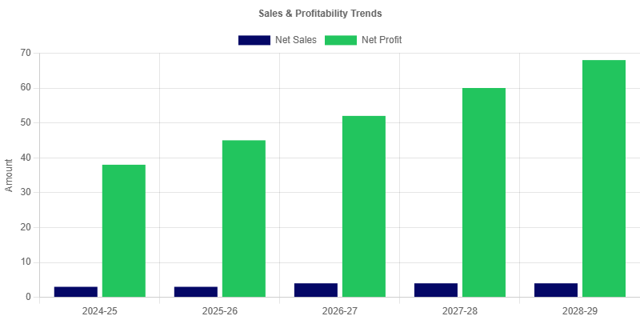 | Balance Sheet Strength  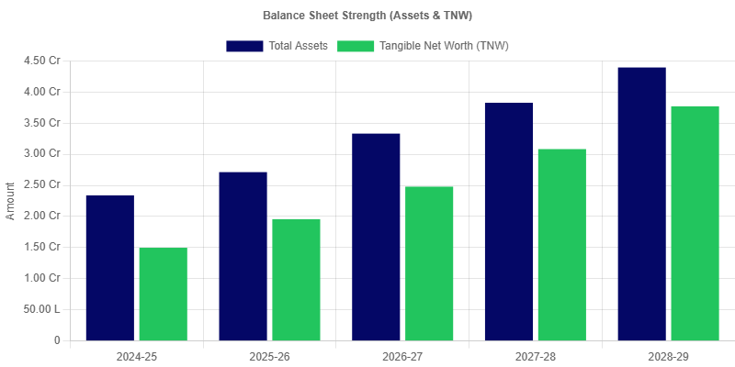
Liquidity Ratios  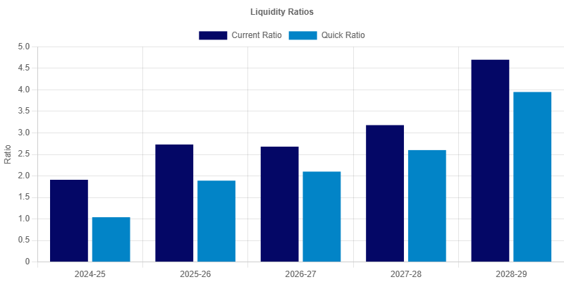 | Profitability Ratios  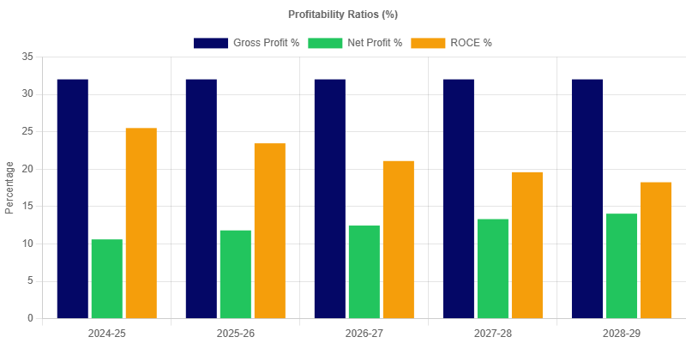
Leverage Ratios  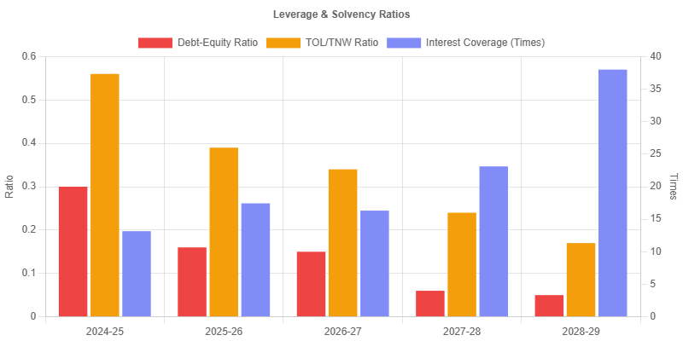 | Working Capital Turnover  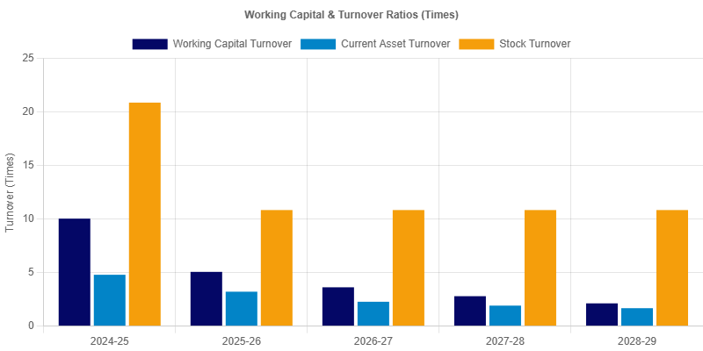
Solvency Ratios  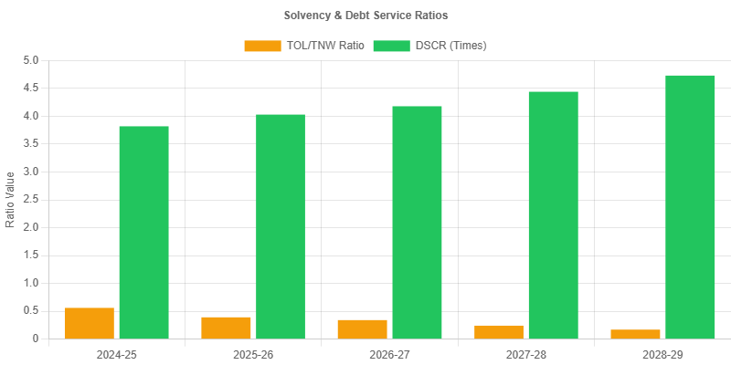 | Efficiency Ratios  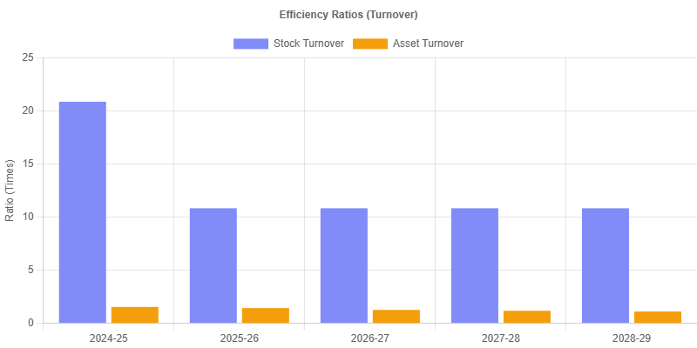

Turnover Method
Particulars | 2024-2025  (actual) | 2025-2026  (provisional) | 2026-2027  (projected) | 2027-2028  (projected) | 2028-2029  (projected)
A. Turnover | 3,60,00,000.00 | 3,88,80,000.00 | 4,19,90,400.00 | 4,53,49,632.00 | 4,89,77,602.56
B. 25.00% of (A) | 90,00,000.00 | 97,20,000.00 | 1,04,97,600.00 | 1,13,37,408.00 | 1,22,44,400.64
C. Margin Required at 5.00% of (A) | 18,00,000.00 | 19,44,000.00 | 20,99,520.00 | 22,67,481.60 | 24,48,880.13
D. Margin (NWC) | 35,90,599.88 | 76,84,837.72 | 1,15,97,269.88 | 1,62,52,689.02 | 2,31,03,694.30
E. (B - C) | 72,00,000.00 | 77,76,000.00 | 83,98,080.00 | 90,69,926.40 | 97,95,520.51
F. (B - D) | 54,09,400.12 | 20,35,162.28 | -10,99,669.88 | -49,15,281.02 | -1,08,59,293.66
G. Permissible Bank Finance under Turnover Method (B - C) | 72,00,000.00 | 77,76,000.00 | 83,98,080.00 | 90,69,926.40 | 97,95,520.51
H. Proposed / Existing Bank Borrowing | 0.00 | 0.00 | 19,80,000.00 | 19,80,000.00 | 19,80,000.00
I. Excess Borrowing over Turnover Method Finance | 0.00 | 0.00 | 0.00 | 0.00 | 0.00

MPBF
Particulars | 2024-2025  (actual) | 2025-2026  (provisional) | 2026-2027  (projected) | 2027-2028  (projected) | 2028-2029  (projected)
FIRST METHOD OF LENDING
1. Total Current Assets | 75,21,317.34 | 1,21,17,371.73 | 1,84,86,140.64 | 2,37,00,178.31 | 2,93,44,558.31
2. Other Current Liabilities (Other than Bank Borrowing) | 39,30,717.46 | 44,32,534.01 | 49,08,870.76 | 54,67,489.29 | 42,60,864.02
3. Working Capital Gap | 35,90,599.88 | 76,84,837.72 | 1,35,77,269.88 | 1,82,32,689.02 | 2,50,83,694.29
4. Min stipulated Net working capital (25% of WCG excluding export receivables) | 8,97,649.97 | 19,21,209.43 | 33,94,317.47 | 45,58,172.25 | 62,70,923.57
5. Actual / Projected Net Working Capital | 35,90,599.88 | 76,84,837.72 | 1,15,97,269.88 | 1,62,52,689.02 | 2,31,03,694.30
6. Item 3 minus item 4 | 26,92,949.91 | 57,63,628.29 | 1,01,82,952.41 | 1,36,74,516.77 | 1,88,12,770.72
7. Item 3 minus item 5 | 0.00 | 0.00 | 19,80,000.00 | 19,80,000.00 | 19,79,999.99
8. Maximum Permissible Bank Finance (lower of 6 or 7) | 0.00 | 0.00 | 19,80,000.00 | 19,80,000.00 | 19,79,999.99
9. Excess Borrowing Representing shortfall in NWC | 0.00 | 0.00 | 0.00 | 0.00 | 0.00
SECOND METHOD OF LENDING
1. Total Current Assets | 75,21,317.34 | 1,21,17,371.73 | 1,84,86,140.64 | 2,37,00,178.31 | 2,93,44,558.31
2. Other Current Liabilities (Other than Bank Borrowing) | 39,30,717.46 | 44,32,534.01 | 49,08,870.76 | 54,67,489.29 | 42,60,864.02
3. Working Capital Gap | 35,90,599.88 | 76,84,837.72 | 1,35,77,269.88 | 1,82,32,689.02 | 2,50,83,694.29
4. Min stipulated Net working capital (25% of Total of Current Assets excluding export receivables) | 18,80,329.33 | 30,29,342.93 | 46,21,535.16 | 59,25,044.58 | 73,36,139.58
5. Actual / Projected Net Working Capital | 35,90,599.88 | 76,84,837.72 | 1,15,97,269.88 | 1,62,52,689.02 | 2,31,03,694.30
6. Item 3 minus item 4 | 17,10,270.54 | 46,55,494.79 | 89,55,734.72 | 1,23,07,644.44 | 1,77,47,554.71
7. Item 3 minus item 5 | 0.00 | 0.00 | 19,80,000.00 | 19,80,000.00 | 19,79,999.99
8. Maximum Permissible Bank Finance (lower of 6 or 7) | 0.00 | 0.00 | 19,80,000.00 | 19,80,000.00 | 19,79,999.99
9. Excess Borrowing Representing shortfall in NWC | 0.00 | 0.00 | 0.00 | 0.00 | 0.00

Fund Flow Statement
Particulars | 2025-2026  (provisional) | 2026-2027  (projected) | 2027-2028  (projected) | 2028-2029  (projected)
1. SOURCES
(a) Net Profit | 45,88,135.21 | 52,27,385.32 | 60,36,132.26 | 68,75,787.81
(b) Depreciation | 18,63,000.00 | 16,07,850.00 | 13,88,542.51 | 11,99,944.12
(c) Increase in Capital | 0.01 | 0.00 | 0.00 | 0.00
(d) Increase in term liabilities, including public deposit | 0.00 | 0.00 | 0.00 | 0.00
(e) Decrease in Other Non Current Assets | 0.00 | 0.00 | 0.00 | 0.00
(f) Other (income tax w/o) | 0.00 | 0.00 | 0.00 | 0.00
(g) Share application refund | 0.00 | 0.00 | 0.00 | 0.00
(h) Total | 64,51,135.22 | 68,35,235.32 | 74,24,674.77 | 80,75,731.93
2. USE
(a) Purchase of Fixed Assets | 0.00 | 0.00 | 0.00 | 0.00
(b) Net loss | 0.00 | 0.00 | 0.00 | 0.00
(c) Decrease in capital | 0.00 | 0.02 | 0.00 | 0.00
(d) Decrease in term liabilities, including public deposits | 13,55,828.99 | 14,90,391.73 | 16,38,309.51 | 0.00
(e) Increase in Other non-current Assets | 10,01,068.39 | 14,32,411.41 | 11,30,946.12 | 12,24,726.65
(f) Dividend / Drawings / Withdrawals | 0.00 | 0.00 | 0.00 | 0.00
(g) Others (share application) | 0.00 | 0.00 | 0.00 | 0.00
(h) Decrease in general reserve (net Deferred tax) | 0.00 | 0.00 | 0.00 | 0.00
(i) Total | 23,56,897.38 | 29,22,803.16 | 27,69,255.63 | 12,24,726.65
3. LONG TERM SURPLUS/DEFICIT | 40,94,237.84 | 39,12,432.16 | 46,55,419.14 | 68,51,005.28
4. Increase / Decrease in Current Assets | 45,96,054.39 | 63,68,768.91 | 52,14,037.67 | 56,44,380.00
5. Increase / Decrease in Current Liabilities | 5,01,816.55 | 4,76,336.75 | 5,58,618.53 | -12,06,625.27
6. Increase / Decrease in Working Capital gap | 40,94,237.84 | 58,92,432.16 | 46,55,419.14 | 68,51,005.27
7. Net Surplus / Deficit | -0.00 | -19,80,000.00 | -0.00 | 0.01
8. Increase / Decrease in Bank Borrowings | 0.00 | 19,80,000.00 | 0.00 | 0.00
INCREASE / DECREASE IN NET SALES | 28,80,000.00 | 31,10,400.00 | 33,59,232.00 | 36,27,970.56
*Break-Up of (4)
(i) Increase / Decrease in Raw Material | 0.00 | 0.00 | 0.00 | 0.00
(ii) Increase / Decrease in Stock in Process | 0.00 | 0.00 | 0.00 | 0.00
(iii) Increase / Decrease in Finished Goods | 2,76,164.39 | 2,98,257.53 | 3,22,118.14 | 3,47,887.59
(iv) Increase / Decrease in receivables
(a) Domestic | 3,15,616.44 | 3,40,865.75 | 3,68,135.01 | 3,97,585.82
(b) Export | 0.00 | 0.00 | 0.00 | 0.00
(v) Increase / Decrease in consumables
(a) Imported | 0.00 | 0.00 | 0.00 | 0.00
(b) Indigenous | 0.00 | 0.00 | 0.00 | 0.00
(vi) Increase / Decrease in Direct Expenses | 0.00 | 0.00 | 0.00 | 0.00
(vii) Increase / Decrease in other current assets | 40,04,273.56 | 57,29,645.63 | 45,23,784.52 | 48,98,906.59
Total | 45,96,054.39 | 63,68,768.91 | 52,14,037.67 | 56,44,380.00

Cash Flow
Particulars | 2024-2025  (actual) | 2025-2026  (provisional) | 2026-2027  (projected) | 2027-2028  (projected) | 2028-2029  (projected)
A. SOURCES OF FUNDS
1. Net Profit after tax | 38,17,083.92 | 45,88,135.21 | 52,27,385.32 | 60,36,132.26 | 68,75,787.81
2. Depreciation | 21,60,000.00 | 18,63,000.00 | 16,07,850.00 | 13,88,542.51 | 11,99,944.12
3. Deferred Tax Provision | 0.00 | 0.00 | 0.00 | 0.00 | 0.00
3a. Current Tax Provision | 13,41,137.60 | 16,12,047.50 | 18,36,648.89 | 21,20,803.23 | 24,15,817.34
4. Increase in Capital (excl. reserves carry forward) | 1,11,60,000.00 | 0.01 | 0.00 | 0.00 | 0.00
5. Increase in Other Reserves/Surplus | 0.00 | 0.00 | 0.00 | 0.00 | 0.00
6. Increase in Term Liabilities | 57,17,945.71 | 0.00 | 0.00 | 0.00 | 0.00
7. Increase in Bank WC Borrowings | 0.00 | 0.00 | 19,80,000.00 | 0.00 | 0.00
8. Increase in other short term borrowings | 0.00 | 0.00 | 0.00 | 0.00 | 0.00
9. Increase in Creditors (Trade) | 13,56,164.38 | 1,08,493.15 | 1,17,172.61 | 1,26,546.41 | 1,36,670.12
10. Increase in other Current Liabilities | 0.00 | 0.00 | 0.00 | 0.00 | 0.00
11. Decrease in Inventory | 0.00 | 0.00 | 0.00 | 0.00 | 0.00
12. Decrease in Receivables | 0.00 | 0.00 | 0.00 | 0.00 | 0.00
13. Decrease in other current assets | 0.00 | 0.00 | 0.00 | 0.00 | 0.00
14. Decrease in other non-current assets | 0.00 | 0.00 | 0.00 | 0.00 | 0.00
TOTAL SOURCES (A) | 2,55,52,331.61 | 81,71,675.87 | 1,07,69,056.82 | 96,72,024.41 | 1,06,28,219.39
B. USES OF FUNDS
1. Net Loss (if any) | 0.00 | 0.00 | 0.00 | 0.00 | 0.00
2. Increase in Inventory | 34,52,054.79 | 2,76,164.39 | 2,98,257.53 | 3,22,118.14 | 3,47,887.59
3. Increase in Receivables | 39,45,205.48 | 3,15,616.44 | 3,40,865.75 | 3,68,135.01 | 3,97,585.82
4. Increase in other current assets | 0.00 | 0.00 | 0.00 | 0.00 | 0.00
5. Decrease in Capital | 0.00 | 0.00 | 0.02 | 0.00 | 0.00
6. Decrease in Other Reserves/Surplus | 0.00 | 0.00 | 0.00 | 0.00 | 0.00
7. Decrease in Term Liabilities | 0.00 | 12,33,415.49 | 13,55,828.98 | 14,90,391.73 | 16,38,309.51
8. Decrease in Bank WC Borrowings | 0.00 | 0.00 | 0.00 | 0.00 | 0.00
9. Decrease in other short term borrowings | 0.00 | 0.00 | 0.00 | 0.00 | 0.00
10. Decrease in Creditors (Trade) | 0.00 | 0.00 | 0.00 | 0.00 | 0.00
11. Decrease in other Current Liabilities | 0.00 | 0.00 | 0.00 | 0.00 | 0.00
12. Purchase of Fixed Assets | 1,80,00,000.00 | 0.00 | 0.00 | 0.00 | 0.00
13. Increase in other non-current assets | 31,014.27 | 10,01,068.39 | 14,32,411.41 | 11,30,946.12 | 12,24,726.65
14. Drawings / Dividends | 0.00 | 0.00 | 0.00 | 0.00 | 0.00
15. Taxes Paid | 0.00 | 13,41,137.60 | 16,12,047.50 | 18,36,648.89 | 21,20,803.22
TOTAL USES (B) | 2,54,28,274.54 | 41,67,402.31 | 50,39,411.19 | 51,48,239.89 | 57,29,312.79
C. NET CASH FLOW (A - B) | 1,24,057.07 | 40,04,273.56 | 57,29,645.63 | 45,23,784.52 | 48,98,906.60
D. OPENING CASH AND BANK | 0.00 | 1,24,057.07 | 41,28,330.63 | 98,57,976.26 | 1,43,81,760.78
E. CLOSING CASH AND BANK (C + D) | 1,24,057.07 | 41,28,330.63 | 98,57,976.26 | 1,43,81,760.78 | 1,92,80,667.38
F. CASH AS PER BALANCE SHEET | 1,24,057.07 | 41,28,330.63 | 98,57,976.26 | 1,43,81,760.78 | 1,92,80,667.37
G. DIFFERENCE (E - F) | 0.00 | 0.00 | 0.00 | 0.00 | 0.01

DSCR Analysis
Particulars | 2024-2025  (actual) | 2025-2026  (provisional) | 2026-2027  (projected) | 2027-2028  (projected) | 2028-2029  (projected)
A. CASH ACCRUALS (Source)
Net Profit After Tax | 38,17,083.92 | 45,88,135.21 | 52,27,385.32 | 60,36,132.26 | 68,75,787.81
Add: Depreciation | 21,60,000.00 | 18,63,000.00 | 16,07,850.00 | 13,88,542.51 | 11,99,944.12
Add: Interest on Long Term Loans | 6,01,778.48 | 4,90,417.30 | 3,68,003.79 | 2,33,441.04 | 85,523.26
Total (A) | 65,78,862.40 | 69,41,552.51 | 72,03,239.11 | 76,58,115.81 | 81,61,255.19
B. DEBT OBLIGATIONS (Uses)
Interest on Long Term Loans | 6,01,778.48 | 4,90,417.30 | 3,68,003.79 | 2,33,441.04 | 85,523.26
Repayment of Long Term Loans | 11,22,054.29 | 12,33,415.48 | 13,55,828.98 | 14,90,391.73 | 16,38,309.51
Total (B) | 17,23,832.77 | 17,23,832.78 | 17,23,832.77 | 17,23,832.77 | 17,23,832.77
DSCR (A / B) | 3.82 | 4.03 | 4.18 | 4.44 | 4.73
Average DSCR |  |  |  |  | 4.24

Breakeven Analysis
Particulars | 2024-2025  (actual) | 2025-2026  (provisional) | 2026-2027  (projected) | 2027-2028  (projected) | 2028-2029  (projected)
1. Net Sales | 3,60,00,000.00 | 3,88,80,000.00 | 4,19,90,400.00 | 4,53,49,632.00 | 4,89,77,602.56
2. Variable Costs
(i) Raw Materials | 2,32,52,054.79 | 2,16,60,164.38 | 2,33,92,977.53 | 2,52,64,415.74 | 2,72,85,569.00
(ii) Other Consumables & Packing | 0.00 | 0.00 | 0.00 | 0.00 | 0.00
(iii) Power and Fuel | 10,80,000.00 | 11,66,400.00 | 12,59,712.00 | 13,60,488.96 | 14,69,328.08
(iv) Direct Labour | 28,80,000.00 | 31,10,400.00 | 33,59,232.00 | 36,27,970.56 | 39,18,208.20
(v) Variable Mfg & Selling Expenses | 3,60,000.00 | 3,88,800.00 | 4,19,904.00 | 4,53,496.32 | 4,89,776.03
Total Variable Costs | 2,75,72,054.79 | 2,63,25,764.38 | 2,84,31,825.53 | 3,07,06,371.58 | 3,31,62,881.30
3. Contribution (1 - 2) | 84,27,945.21 | 1,25,54,235.62 | 1,35,58,574.47 | 1,46,43,260.42 | 1,58,14,721.26
4. Fixed Costs
(i) Admin & Fixed Selling Exp | 39,60,000.00 | 42,76,800.00 | 46,18,944.00 | 49,88,459.52 | 53,87,536.32
(ii) Depreciation | 21,60,000.00 | 18,63,000.00 | 16,07,850.00 | 13,88,542.51 | 11,99,944.12
Total Fixed Costs | 61,20,000.00 | 61,39,800.00 | 62,26,794.00 | 63,77,002.03 | 65,87,480.44
5. Breakeven Point (Sales Value) | 2,61,41,603.26 | 1,90,14,731.86 | 1,92,84,149.03 | 1,97,49,337.72 | 2,04,01,181.50
6. Breakeven % (on Net Sales) | 72.62 | 48.91 | 45.93 | 43.55 | 41.65

Sensitivity Analysis
Particulars | 2024-2025  (actual) | 2025-2026  (provisional) | 2026-2027  (projected) | 2027-2028  (projected) | 2028-2029  (projected)
1. BASE CASE (PROJECTIONS)
Net Sales | 3,60,00,000.00 | 3,88,80,000.00 | 4,19,90,400.00 | 4,53,49,632.00 | 4,89,77,602.56
Net Profit After Tax | 38,17,083.92 | 45,88,135.21 | 52,27,385.32 | 60,36,132.26 | 68,75,787.81
DSCR | 3.82 | 4.03 | 4.18 | 4.44 | 4.73
2. SALES DECREASE BY 10%
Revised Net Sales | 3,24,00,000.00 | 3,49,92,000.00 | 3,77,91,360.00 | 4,08,14,668.80 | 4,40,79,842.30
Revised Net Profit | 29,38,289.40 | 32,93,831.65 | 38,29,537.47 | 45,26,456.59 | 52,45,338.08
Revised DSCR | 3.31 | 3.28 | 3.37 | 3.57 | 3.79
3. RAW MATERIAL/CONSUMABLE COST INCREASE BY 10%
Net Sales (Unchanged) | 3,60,00,000.00 | 3,88,80,000.00 | 4,19,90,400.00 | 4,53,49,632.00 | 4,89,77,602.56
Revised Net Profit | 14,91,878.44 | 24,22,118.77 | 28,88,087.57 | 35,09,690.69 | 41,47,230.91
Revised DSCR | 2.47 | 2.77 | 2.82 | 2.98 | 3.15
4. INTEREST RATE INCREASE BY 2%
Net Sales (Unchanged) | 3,60,00,000.00 | 3,88,80,000.00 | 4,19,90,400.00 | 4,53,49,632.00 | 4,89,77,602.56
Revised Net Profit | 37,12,434.64 | 45,02,851.64 | 51,28,957.26 | 59,61,104.66 | 68,26,483.12
Revised DSCR | 3.60 | 3.84 | 4.01 | 4.32 | 4.67

EMI Repayment Schedule
Month | Payment Date | Opening Bal. | EMI | Principal | Interest | Closing Bal.
1 | 01 Apr 2024 | 68,40,000.00 | 1,43,652.73 | 89,502.73 | 54,150.00 | 67,50,497.27
2 | 01 May 2024 | 67,50,497.27 | 1,43,652.73 | 90,211.29 | 53,441.44 | 66,60,285.97
3 | 01 Jun 2024 | 66,60,285.97 | 1,43,652.73 | 90,925.47 | 52,727.26 | 65,69,360.51
4 | 01 Jul 2024 | 65,69,360.51 | 1,43,652.73 | 91,645.29 | 52,007.44 | 64,77,715.21
5 | 01 Aug 2024 | 64,77,715.21 | 1,43,652.73 | 92,370.82 | 51,281.91 | 63,85,344.39
6 | 01 Sept 2024 | 63,85,344.39 | 1,43,652.73 | 93,102.09 | 50,550.64 | 62,92,242.31
7 | 01 Oct 2024 | 62,92,242.31 | 1,43,652.73 | 93,839.15 | 49,813.58 | 61,98,403.16
8 | 01 Nov 2024 | 61,98,403.16 | 1,43,652.73 | 94,582.04 | 49,070.69 | 61,03,821.12
9 | 01 Dec 2024 | 61,03,821.12 | 1,43,652.73 | 95,330.81 | 48,321.92 | 60,08,490.30
10 | 01 Jan 2025 | 60,08,490.30 | 1,43,652.73 | 96,085.52 | 47,567.21 | 59,12,404.79
11 | 01 Feb 2025 | 59,12,404.79 | 1,43,652.73 | 96,846.19 | 46,806.54 | 58,15,558.59
12 | 01 Mar 2025 | 58,15,558.59 | 1,43,652.73 | 97,612.89 | 46,039.84 | 57,17,945.70
13 | 01 Apr 2025 | 57,17,945.70 | 1,43,652.73 | 98,385.66 | 45,267.07 | 56,19,560.04
14 | 01 May 2025 | 56,19,560.04 | 1,43,652.73 | 99,164.55 | 44,488.18 | 55,20,395.49
15 | 01 Jun 2025 | 55,20,395.49 | 1,43,652.73 | 99,949.60 | 43,703.13 | 54,20,445.89
16 | 01 Jul 2025 | 54,20,445.89 | 1,43,652.73 | 1,00,740.87 | 42,911.86 | 53,19,705.03
17 | 01 Aug 2025 | 53,19,705.03 | 1,43,652.73 | 1,01,538.40 | 42,114.33 | 52,18,166.63
18 | 01 Sept 2025 | 52,18,166.63 | 1,43,652.73 | 1,02,342.25 | 41,310.49 | 51,15,824.38
19 | 01 Oct 2025 | 51,15,824.38 | 1,43,652.73 | 1,03,152.46 | 40,500.28 | 50,12,671.92
20 | 01 Nov 2025 | 50,12,671.92 | 1,43,652.73 | 1,03,969.08 | 39,683.65 | 49,08,702.85
21 | 01 Dec 2025 | 49,08,702.85 | 1,43,652.73 | 1,04,792.17 | 38,860.56 | 48,03,910.68
22 | 01 Jan 2026 | 48,03,910.68 | 1,43,652.73 | 1,05,621.77 | 38,030.96 | 46,98,288.91
23 | 01 Feb 2026 | 46,98,288.91 | 1,43,652.73 | 1,06,457.94 | 37,194.79 | 45,91,830.96
24 | 01 Mar 2026 | 45,91,830.96 | 1,43,652.73 | 1,07,300.74 | 36,352.00 | 44,84,530.23
25 | 01 Apr 2026 | 44,84,530.23 | 1,43,652.73 | 1,08,150.20 | 35,502.53 | 43,76,380.03
26 | 01 May 2026 | 43,76,380.03 | 1,43,652.73 | 1,09,006.39 | 34,646.34 | 42,67,373.64
27 | 01 Jun 2026 | 42,67,373.64 | 1,43,652.73 | 1,09,869.36 | 33,783.37 | 41,57,504.28
28 | 01 Jul 2026 | 41,57,504.28 | 1,43,652.73 | 1,10,739.16 | 32,913.58 | 40,46,765.12
29 | 01 Aug 2026 | 40,46,765.12 | 1,43,652.73 | 1,11,615.84 | 32,036.89 | 39,35,149.28
30 | 01 Sept 2026 | 39,35,149.28 | 1,43,652.73 | 1,12,499.47 | 31,153.27 | 38,22,649.82
31 | 01 Oct 2026 | 38,22,649.82 | 1,43,652.73 | 1,13,390.09 | 30,262.64 | 37,09,259.73
32 | 01 Nov 2026 | 37,09,259.73 | 1,43,652.73 | 1,14,287.76 | 29,364.97 | 35,94,971.97
33 | 01 Dec 2026 | 35,94,971.97 | 1,43,652.73 | 1,15,192.54 | 28,460.19 | 34,79,779.44
34 | 01 Jan 2027 | 34,79,779.44 | 1,43,652.73 | 1,16,104.48 | 27,548.25 | 33,63,674.96
35 | 01 Feb 2027 | 33,63,674.96 | 1,43,652.73 | 1,17,023.64 | 26,629.09 | 32,46,651.32
36 | 01 Mar 2027 | 32,46,651.32 | 1,43,652.73 | 1,17,950.08 | 25,702.66 | 31,28,701.24
37 | 01 Apr 2027 | 31,28,701.24 | 1,43,652.73 | 1,18,883.85 | 24,768.88 | 30,09,817.40
38 | 01 May 2027 | 30,09,817.40 | 1,43,652.73 | 1,19,825.01 | 23,827.72 | 28,89,992.39
39 | 01 Jun 2027 | 28,89,992.39 | 1,43,652.73 | 1,20,773.62 | 22,879.11 | 27,69,218.76
40 | 01 Jul 2027 | 27,69,218.76 | 1,43,652.73 | 1,21,729.75 | 21,922.98 | 26,47,489.01
41 | 01 Aug 2027 | 26,47,489.01 | 1,43,652.73 | 1,22,693.44 | 20,959.29 | 25,24,795.57
42 | 01 Sept 2027 | 25,24,795.57 | 1,43,652.73 | 1,23,664.77 | 19,987.96 | 24,01,130.80
43 | 01 Oct 2027 | 24,01,130.80 | 1,43,652.73 | 1,24,643.78 | 19,008.95 | 22,76,487.02
44 | 01 Nov 2027 | 22,76,487.02 | 1,43,652.73 | 1,25,630.54 | 18,022.19 | 21,50,856.48
45 | 01 Dec 2027 | 21,50,856.48 | 1,43,652.73 | 1,26,625.12 | 17,027.61 | 20,24,231.36
46 | 01 Jan 2028 | 20,24,231.36 | 1,43,652.73 | 1,27,627.57 | 16,025.16 | 18,96,603.80
47 | 01 Feb 2028 | 18,96,603.80 | 1,43,652.73 | 1,28,637.95 | 15,014.78 | 17,67,965.85
48 | 01 Mar 2028 | 17,67,965.85 | 1,43,652.73 | 1,29,656.34 | 13,996.40 | 16,38,309.51
49 | 01 Apr 2028 | 16,38,309.51 | 1,43,652.73 | 1,30,682.78 | 12,969.95 | 15,07,626.73
50 | 01 May 2028 | 15,07,626.73 | 1,43,652.73 | 1,31,717.35 | 11,935.38 | 13,75,909.38
51 | 01 Jun 2028 | 13,75,909.38 | 1,43,652.73 | 1,32,760.12 | 10,892.62 | 12,43,149.26
52 | 01 Jul 2028 | 12,43,149.26 | 1,43,652.73 | 1,33,811.13 | 9,841.60 | 11,09,338.13
53 | 01 Aug 2028 | 11,09,338.13 | 1,43,652.73 | 1,34,870.47 | 8,782.26 | 9,74,467.66
54 | 01 Sept 2028 | 9,74,467.66 | 1,43,652.73 | 1,35,938.20 | 7,714.54 | 8,38,529.46
55 | 01 Oct 2028 | 8,38,529.46 | 1,43,652.73 | 1,37,014.37 | 6,638.36 | 7,01,515.09
56 | 01 Nov 2028 | 7,01,515.09 | 1,43,652.73 | 1,38,099.07 | 5,553.66 | 5,63,416.02
57 | 01 Dec 2028 | 5,63,416.02 | 1,43,652.73 | 1,39,192.35 | 4,460.38 | 4,24,223.66
58 | 01 Jan 2029 | 4,24,223.66 | 1,43,652.73 | 1,40,294.29 | 3,358.44 | 2,83,929.37
59 | 01 Feb 2029 | 2,83,929.37 | 1,43,652.73 | 1,41,404.96 | 2,247.77 | 1,42,524.41
60 | 01 Mar 2029 | 1,42,524.41 | 1,43,652.73 | 1,42,524.41 | 1,128.32 | 0.00

